vuseal

V I L L A N O V A U N I V E R S I T Y

**ME 8204**

**Project Report**

**MODELING AND CONTROL OF LBR iiwa 7 R800**

**Turki Haj Mohamad**

5/10/2018

**Introduction**

For this project LBR iiwa 7 R800 from KUKA Laboratories was chosen to be studied. The iiwa 7 is an adaptive manipulator that can work in a collaboration with human environment as shown in fig. 1. This light weight robot can be used for handling, machining, and assembly processing. In fig. 2 (a) the main robot assemblies are shown where (1) in-line wrist, (2) joint module and (3) base frame. The iiwa 7 consists of 7 joints (7 degree of freedom) which means it is a redundant robot. The robot axes are shown in Fig.2 (b).

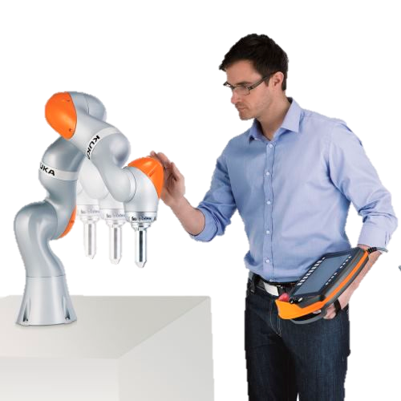

Figure 2: (a) LBR iiwa 7 R800 assemblies.

(b) LBR iiwa 7 R800 7 axes.

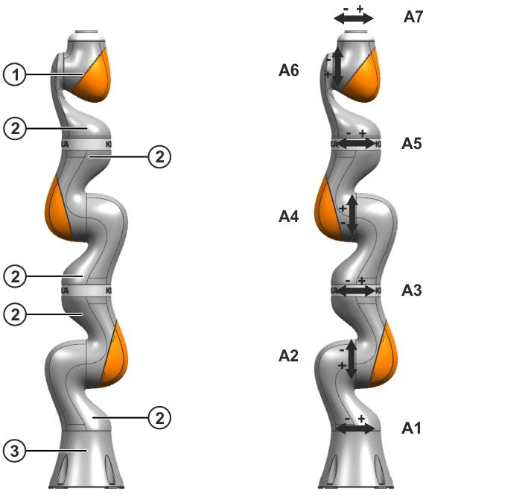

(a)

(b)

Figure 1: LBR iiwa 7 R800-human

collaboration.

Table 1 shows some basic data of the iiwa 7 such as the number of axes and controlled axes, the total robot weight, the maximum robot reach. The working envelope of iiwa 7 and the allowed angle ranges for each axis are shown in fig. 3.

Table 1: Technical data of LBR iiwa 7 R800

|  |  |
| --- | --- |
|  | **LBR iiwa 7 R800** |
| Number of axes | 7 |
| Number of controlled axes | 7 |
| Volume of working envelope | 1.7 m³ |
| Weight | 23.9 kg |
| Maximum reach | 800 mm |
| Mounting position | Floor, Ceiling, Wall |



Figure 3: The working envelope of LBR iiwa 7 R800

This project is divided into three parts: 1) Kinematic and dynamic modeling 2) Trajectory planning 3) Control. In the first part, the DH table will be constructed then the transformation matrices will be determined. This step represent the forward kinematic step in which for any set of joint variable the end effector can be determined. The second step is deriving the equation of motion using Euler Lagrangian dynamics. The second stage of the project is trajectory planning. A circular trajectory was selected to be followed by the end effector with a fixed orientation. To do so, the inverse position solution has to be solved to determine the unknown joint variables. Because we have a redundant robot (7 degree of freedom) the pseudo Jacobian matrix have to be derived to solve for the inverse velocity and acceleration. Finally, a sliding controller is used to achieve the desired motion. Figure 4 summarize the project plan.

Kinematic

Trajectory Planning

Sliding Control

Dynamical Modeling

Inverse Kinematic

Actual Response

DH Table

$$T_{i-1}^{i}$$

Desired path

(position and orientation)

Desired Joint variables ($θ_{i}, \dot{θ_{i}}, \ddot{θ_{i}}$)

Input

$$τ$$

Actual

($θ_{i}, \dot{θ_{i}}, \ddot{θ_{i}}$) and (position/

orientation)

EOM

$$M,c,ϕ$$

Figure 4: A summary of the project plan

**Kinematic Model**

θ3

θ6

X5, X6

X3, X4

X1, X2

X0

Z4

Z0

Z1

Z2

Z3

Z5

Z6

X7

θ1

θ2

θ4

θ5

θ7

Z7

Figure 2: (a) LBR iiwa 7 R800 assemblies.

(b) LBR iiwa 7 R800 7 axes.



(a)

(b)

Forward Kinematic:

The Denavit-Hartenberg representation method is used in this project to derive the forward kinematics equations for the robot manipulator. This representation is based on describing the transformation relationship between link $(i-1)$ and link $i$ by using four parmaeters $θ_{i}$, $d_{i}$, $a_{i}$ and $α_{i}$. Table 1 show the DH table for the iiwa 7 robot manipulator.

Table 1: Denavit-Hartenberg representation for the iiwa robot manipulator.

|  |  |  |  |  |
| --- | --- | --- | --- | --- |
| **Joint** | **θ** | **d** | **a** | **α** |
| $$0-1$$ | $$θ_{1}$$ | $$l_{1}$$ | $$0$$ | $$π/2$$ |
| $$1-2$$ | $$θ_{2}$$ | $$0$$ | $$0$$ | $$-π/2$$ |
| $$2-3$$ | $$θ_{3}$$ | $$l_{2}$$ | $$0$$ | $$-π/2$$ |
| $$3-4$$ | $$θ_{4}$$ | $$0$$ | $$0$$ | $$π/2$$ |
| $$4-5$$ | $$θ_{5}$$ | $$l_{3}$$ | $$0$$ | $$π/2$$ |
| $$5-6$$ | $$θ_{6}$$ | $$0$$ | $$0$$ | $$-π/2$$ |
| $$6-7$$ | $$θ_{7}$$ | $$l_{4}$$ | $$0$$ | $$π/2$$ |

Transformation matrices between each link can be derived using the following relationship:

$$T_{n-1}^{n}=\left[\begin{matrix}cosθ_{n} & -sinθ_{n}cosα_{n} & sinθ_{n}sinα_{n} & a_{n}cosθ_{n} \\ sinθ_{n} & cosθ_{n}cosα_{n} & -cosθ_{n}sinα_{n} & a_{n}sinθ_{n} \\ 0 & sinα_{n} & cosα_{n} & d_{n} \\ 0 & 0 & 0 & 1\end{matrix}\right]$$

Using the above formula, the following transformation matrices are found:

|  |
| --- |
| $$T_{0}^{1}=\left\lfloor \begin{matrix}c_{1} & 0 & s_{1} & 0 \\ s_{1} & 0 & {-c}_{1} & 0 \\ 0 & 1 & 0 & l_{1} \\ 0 & 0 & 0 & 1\end{matrix}\right\rfloor$$ |
| $$T_{0}^{2}=\left\lfloor \begin{matrix}c_{1}c_{2} & -s_{1} & {-c}_{1}s_{2} & 0 \\ c_{2}s_{1} & c_{1} & -s_{1}s_{2} & 0 \\ s_{2} & 0 & c_{2} & l_{1} \\ 0 & 0 & 0 & 1\end{matrix}\right\rfloor$$ |
| $$T_{0}^{3}=\left\lfloor \begin{matrix}c_{1}c_{2}c_{3}-s_{1}s_{3} & c_{1}s_{2} & {-c}_{3}s_{1}-c_{1}c_{2}s_{3} & -l_{2}c_{1}s_{2} \\ c_{1}s_{3}+c_{2}c_{3}s_{1} & s_{1} s_{2} & c_{1} c_{3}-c_{2}s_{1}s_{3} & -l_{2}s_{1}s_{2} \\ c_{3}s_{2} & -c_{2} & -s_{2}s_{3} & l_{1}+l_{2}c_{2} \\ 0 & 0 & 0 & 1\end{matrix}\right\rfloor$$ |
| $$T_{0}^{4}=\left\lfloor \begin{matrix}c_{1}s_{2}s_{4} - c_{4}(s_{1}s_{3} - c_{1}c_{2}c_{3}) & - c_{3}s_{1} - c_{1}c_{2}s_{3} & - s_{4}(s_{1}s_{3} - c_{1}c_{2}c_{3}) - c_{1}c_{4}s_{2} & -l_{2}c_{1}s_{2} \\ c_{4}(c_{1}s_{3} + c_{2}c_{3}s_{1}) + s_{1}s_{2}s_{4} & c_{1}c_{3} - c_{2}s_{1}s_{3} & s_{4}(c_{1}s_{3} + c_{2}c_{3}s_{1}) - c_{4}s_{1}s_{2} & -l_{2}s_{1}s_{2} \\ c_{3}c_{4}s_{2} - c_{2}s_{4} & -s_{2}s_{3} & c_{2}c_{4} + c_{3}s_{2}s_{4} & l_{1} + l_{2}c_{2} \\ 0 & 0 & 0 & 1\end{matrix}\right\rfloor$$ |
| $$T_{0}^{5}=\left[\begin{matrix}μ_{11} & μ_{12} & μ_{13} & μ_{14} \\ μ_{21} & μ_{22} & μ_{23} & μ_{24} \\ μ_{31} & μ_{32} & μ_{33} & μ_{34} \\ 0 & 0 & 0 & 1\end{matrix}\right]$$ $$μ_{11}= - c_{5}(c_{4}(s_{1}s_{3} - c_{1}c_{2}c_{3}) - c_{1}s_{2}s_{4}) - s_{5}(c_{3}s_{1} + c_{1}c_{2}s_{3})$$ $$μ_{12}=- s_{4}(s_{1}s_{3} - c_{1}c_{2}c_{3}) - c_{1}c_{4}s_{2}$$ $$μ_{13}= c_{5}(c_{3}s_{1} + c_{1}c_{2}s_{3}) - s_{5}(c_{4}(s_{1}s_{3} - c_{1}c_{2}c_{3}) - c_{1}s_{2}s_{4})$$ $$μ_{14}=- l_{3}(s_{4}(s_{1}s_{3} - c_{1}c_{2}c_{3}) + c_{1}c_{4}s_{2}) - l_{2}c_{1}s_{2}$$ $$μ_{21}=c_{5}(c_{4}(c_{1}s_{3} + c_{2}c_{3}s_{1}) + s_{1}s_{2}s_{4}) + s_{5}(c_{1}c_{3} - c_{2}s_{1}s_{3})$$ $$μ_{22}=s_{4}(c_{1}s_{3} + c_{2}c_{3}s_{1}) - c_{4}s_{1}s_{2}$$ $$μ_{23}= s_{5}(c_{4}(c_{1}s_{3} + c_{2}c_{3}s_{1}) + s_{1}s_{2}s_{4}) - c_{5}(c_{1}c_{3} - c_{2}s_{1}s_{3})$$ $$μ_{24}= l_{3}(s_{4}(c_{1}s_{3} + c_{2}c_{3}s_{1}) - c_{4}s_{1}s_{2}) - l_{2}s_{1}s_{2}$$ $$μ_{31}= - c_{5}(c_{2}s_{4} - c_{3}c_{4}s_{2}) - s_{2}s_{3}s_{5}$$ $$μ_{32}= c_{2}c_{4} + c_{3}s_{2}s_{4}$$ $$μ_{33}=c_{5}s_{2}s_{3} - s_{5}(c_{2}s_{4} - c_{3}c_{4}s_{2})$$ $$μ_{34}= l_{1} + l_{3}(c_{2}c_{4} + c_{3}s_{2}*s_{4}) + L_{2}c_{2}$$ |
| $$T_{0}^{6}=\left[\begin{matrix}μ_{11} & μ_{12} & μ_{13} & μ_{14} \\ μ_{21} & μ_{22} & μ_{23} & μ_{24} \\ μ_{31} & μ_{32} & μ_{33} & μ_{34} \\ 0 & 0 & 0 & 1\end{matrix}\right]$$ $$μ_{11}= - s_{6}(s_{4}(s_{1}s_{3} - c_{1}c_{2}c_{3}) + c_{1}c_{4}s_{2}) - c_{6}(c_{5}(c_{4}(s_{1}s_{3} - c_{1}c_{2}c_{3}) - c_{1}s_{2}s_{4}) + s_{5}(c_{3}s_{1} + c_{1}c_{2}s_{3}))$$ $$μ_{12}=s_{5}(c_{4}(s_{1}s_{3} - c_{1}c_{2}c_{3}) - c_{1}s_{2}s_{4}) - c_{5}(c_{3}s_{1}+ c_{1}c_{2}s_{3})$$ $$μ_{13}= s_{6}(c_{5}(c_{4}(s_{1}s_{3} - c_{1}c_{2}c_{3}) - c_{1}s_{2}s_{4}) + s_{5}(c_{3}s_{1} + c_{1}c_{2}s_{3})) - c_{6}(s_{4}(s_{1}s_{3} - c_{1}c_{2}c_{3}) + c_{1}c_{4}s_{2})$$ $$μ_{14}=- l_{3}\left(s_{4}\left(s_{1}s_{3} - c_{1}c_{2}c_{3}\right)+ c_{1}c_{4}s_{2}\right)- l_{2}c_{1}s_{2}]$$ $$μ_{21}=s_{6}\left(s_{4}\left(c_{1}s_{3} + c_{2}c_{3}s_{1}\right)- c_{4}s_{1}s_{2}\right)+ c_{6}\left(c_{5}\left(c_{4}\left(c_{1}s_{3} + c_{2}c_{3}s_{1}\right)+ s_{1}s_{2}s_{4}\right)+ s_{5}\left(c_{1}c_{3}- c_{2}s_{1}s_{3}\right)\right)$$ $$μ_{22}=c_{5}(c_{1}c_{3} - c_{2}s_{1}s_{3}) - s_{5}(c_{4}(c_{1}s_{3} + c_{2}c_{3}s_{1}) + s_{1}s_{2}s_{4})$$ $$μ_{23}= c_{6}(s_{4}(c_{1}s_{3} + c_{2}c_{3}s_{1}) - c_{4}s_{1}s_{2}) - s_{6}(c_{5}(c_{4}(c_{1}s_{3} + c_{2}c_{3}s_{1}) + s_{1}s_{2}s_{4}) + s_{5}(c_{1}c_{3} - c_{2}s_{1}s_{3}))$$ $$μ_{24}= l_{3}(s_{4}(c_{1}s_{3}+ c_{2}c_{3}s_{1}) - c_{4}s_{1}s_{2}) - l_{2}s_{1}s_{2}$$ $$μ_{31}= s_{6}(c_{2}c_{4} + c_{3}s_{2}s_{4}) - c_{6}(c_{5}(c_{2}s_{4} - c_{3}c_{4}s_{2}) + s_{2}s_{3}s_{5})$$ $$μ_{32}= s_{5}(c_{2}s_{4} - c_{3}c_{4}s_{2}) - c_{5}s_{2}s_{3}$$ $$μ_{33}=s_{6}(c_{5}(c_{2}s_{4} - c_{3}c_{4}s_{2}) + s_{2}s_{3}s_{5}) + c_{6}(c_{2}c_{4} + c_{3}s_{2}s_{4})$$ $$μ_{34}=l_{1} + l_{3}(c_{2}c_{4} + c_{3}s_{2}s_{4}) + l_{2}c_{2}$$ |
| $$T_{0}^{7}=\left[\begin{matrix}μ_{11} & μ_{12} & μ_{13} & μ_{14} \\ μ_{21} & μ_{22} & μ_{23} & μ_{24} \\ μ_{31} & μ_{32} & μ_{33} & μ_{34} \\ 0 & 0 & 0 & 1\end{matrix}\right]$$ $$μ_{11}=s_{7}(s_{5}(c_{4}(s_{1}s_{3} - c_{1}c_{2}c_{3}) - c_{1}s_{2}s_{4}) - c_{5}(c_{3}s_{1}+ c_{1}c_{2}s_{3})) - c_{7}(s_{6}(s_{4}(s_{1}s_{3} - c_{1}c_{2}c_{3}) + c_{1}c_{4}s_{2}) + c_{6}(c_{5}(c_{4}(s_{1}s_{3} - c_{1}c_{2}c_{3}) - c_{1}s_{2}s_{4}) + s_{5}(c_{3}s_{1} + c_{1}c_{2}s_{3})))$$ $$μ_{12}= s_{6}(c_{5}(c_{4}(s_{1}s_{3} - c_{1}c_{2}c_{3}) - c_{1}s_{2}s_{4}) + s_{5}(c_{3}s_{1} + c_{1}c_{2}s_{3})) - c_{6}(s_{4}(s_{1}s_{3} - c_{1}c_{2}c_{3}) + c_{1}c_{4}s_{2})$$ $$μ_{13}= - c_{7}(s_{5}(c_{4}(s_{1}s_{3} - c_{1}c_{2}c_{3}) - c_{1}s_{2}s_{4}) - c_{5}(c_{3}s_{1} + c_{1}c_{2}s_{3})) - s_{7}(s_{6}(s_{4}(s_{1}s_{3} - c_{1}c_{2}c_{3}) + c_{1}c_{4}s_{2}) + c_{6}(c_{5}(c_{4}\left(s_{1}s_{3} - c_{1}c_{2}c_{3}\right) - c_{1}s_{2}s_{4}) + s_{5}(c_{3}s_{1} + c_{1}c_{2}s_{3})))$$ $$μ_{14}= - l_{4}(c_{6}(s_{4}(s_{1}s_{3} - c_{1}c_{2}c_{3}) + c_{1}c_{4}s_{2}) - s_{6}(c_{5}(c_{4}(s_{1}s_{3} - c_{1}c_{2}c_{3}) - c_{1}s_{2}s_{4}) + s_{5}(c_{3}s_{1} + c_{1}c_{2}s_{3}))) - l_{3}(s_{4}(s_{1}s_{3} - c_{1}c_{2}c_{3}) + c_{1}c_{4}s_{2}) - l_{2}c_{1}s_{2}]$$ $$μ_{21}=c_{7}(s_{6}(s_{4}(c_{1}s_{3} + c_{2}c_{3}s_{1}) - c_{4}s_{1}s_{2}) + c_{6}(c_{5}(c_{4}(c_{1}s_{3} + c_{2}c_{3}s_{1}) + s_{1}s_{2}s_{4} ) + s_{5}(c_{1}c_{3} - c_{2}s_{1}s_{3}))) - s_{7}(s_{5}(c_{4}(c_{1}s_{3} + c_{2}c_{3}s_{1}) + s_{1}s_{2}s_{4}) - c_{5}(c_{1}c_{3} - c_{2}s_{1}s_{3}))$$ $$μ_{22}=c_{6}(s_{4}(c_{1}s_{3} + c_{2}c_{3}s_{1}) - c_{4}s_{1}s_{2}) - s_{6}(c_{5}(c_{4}(c_{1}s_{3} + c_{2}c_{3}s_{1}) + s_{1}s_{2}s_{4}) + s_{5}(c_{1}c_{3} - c_{2}s_{1}s_{3}))$$ $$μ_{23}= c_{7}(s_{5}(c_{4}(c_{1}s_{3} + c_{2}c_{3}s_{1}) + s_{1}s_{2}s_{4}) - c_{5}(c_{1}c_{3} - c_{2}s_{1}s_{3})) + s_{7}(s_{6}(s_{4}(c_{1}s_{3} + c_{2}c_{3}s_{1}) - c_{4}s_{1}s_{2}) + c_{6}(c_{5}(c_{4}(c_{1}s_{3} + c_{2}c_{3}s_{1}) + s_{1}s_{2}s_{4}) + s_{5}(c_{1}c_{3} - c_{2}s_{1}s_{3})))$$ $$μ_{24}=l_{4}(c_{6}(s_{4}(c_{1}s_{3} + c_{2}c_{3}s_{1}) - c_{4}s_{1}s_{2}) - s_{6}(c_{5}(c_{4}(c_{1}s_{3} + c_{2}c_{3}s_{1}) + s_{1}s_{2}s_{4}) + s_{5}(c_{1}c_{3} - c_{2}s_{1}s_{3}))) + l_{3}(s_{4}(c_{1}s_{3} + c_{2}c_{3}s_{1}) - c_{4}s_{1}s_{2}) - l_{2}s_{1}s_{2}]$$ $$μ_{31}=s_{7}(s_{5}(c_{2}s_{4} - c_{3}c_{4}s_{2}) - c_{5}s_{2}s_{3}) - c_{7}(c_{6}(c_{5}(c_{2}s_{4} - c_{3}c_{4}s_{2}) + s_{2}s_{3}s_{5}) - s_{6}(c_{2}c_{4} + c_{3}s_{2}s_{4}))$$ $$μ_{32}= s_{6}(c_{5}(c_{2}s_{4} - c_{3}c_{4}s_{2}) + s_{2}s_{3}s_{5}) + c_{6}(c_{2}c_{4}+ c_{3}s_{2}s_{4})$$ $$μ_{33}=- c_{7}(s_{5}(c_{2}s_{4} - c_{3}c_{4}s_{2}) - c_{5}s_{2}s_{3}) - s_{7}(c_{6}(c_{5}(c_{2}s_{4} - c_{3}c_{4}s_{2}) + s_{2}s_{3}s_{5}) - s_{6}(c_{2}c_{4} + c_{3}s_{2}s_{4}))$$ $$μ_{34}=l_{1} + l_{3}(c_{2}c_{4} + c_{3}s_{2}s_{4}) + l_{4}(s_{6}(c_{5}(c_{2}s_{4} - c_{3}c_{4}s_{2}) + s_{2}s_{3}s_{5}) + c_{6}(c_{2}c_{4} + c_{3}s_{2}s_{4})) + l_{2}c_{2}$$ |

**Desired Trajectory**

Selecting a desired trajectory is a tricky task. The desired trajectory should be in the workspace of the robot and also should have no singularity. The first desired trajectory was selected to be a circle of radius $r$ and center $\left(x_{c},y_{c},z_{c}\right)$. This desired circle is in a fixed $x=x_{c}$ plane. In this project, the following values were selected for the desired trajectory:

$$r=2$$

$$x_{c}=L_{3}+L_{4}$$

$$yc=-r$$

$$z_{c}=L_{1}+L_{2}$$

$$R_{E(desired)}=\left[\begin{matrix}0 & 1 & 0 \\ 0 & 0 & -1 \\ -1 & 0 & 0\end{matrix}\right]$$

Figures below show the desired trajectory:

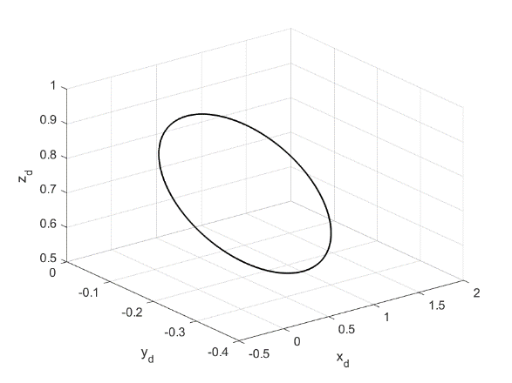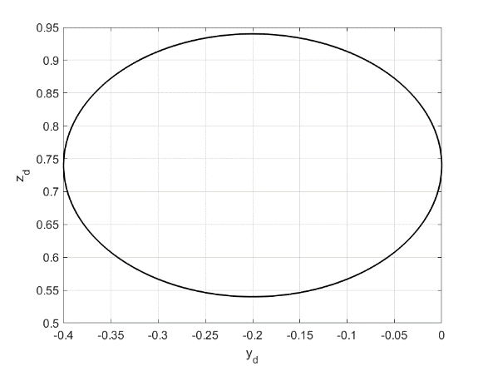

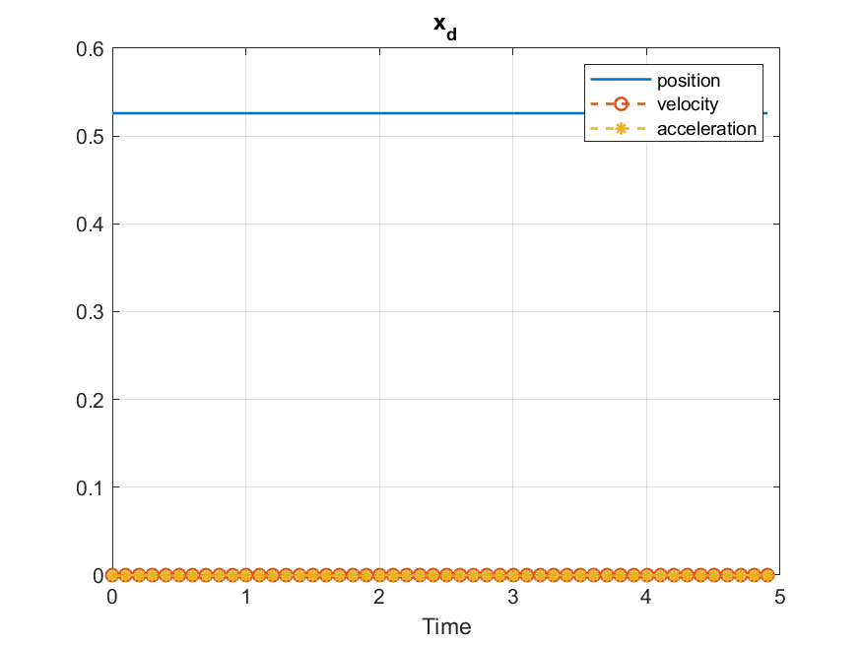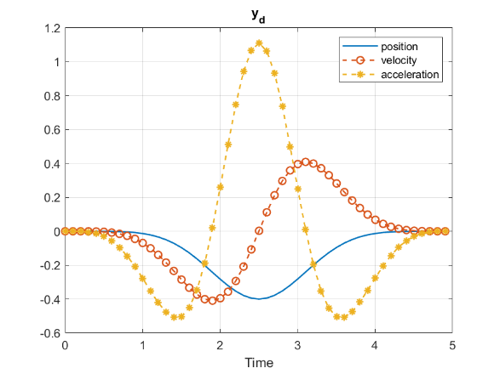

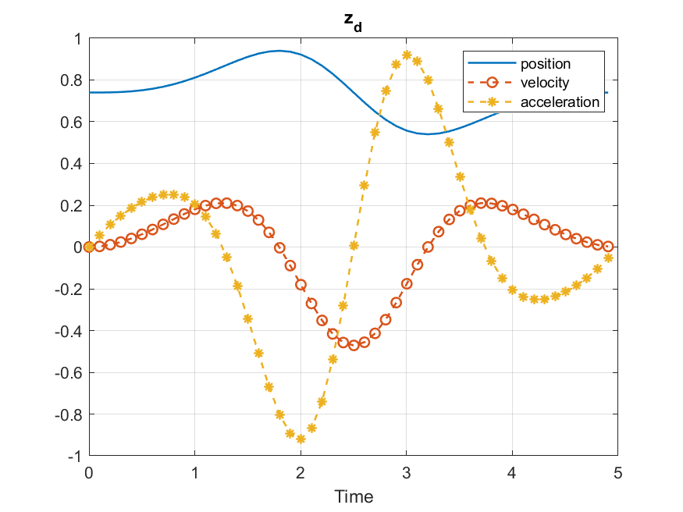

**Inverse Kinematic**

The inverse kinematics problem for a robot manipulator is a method of obtaining the required manipulator joint variable values for any desired endpoint position and orientation. One of the requirement to solve the inverse problem is the existence of the desired solution.

Inverse kinematics problems are tricky and indirect to solve. Redundant manipulators have an infinite number of configurations that lead to the same end-effector desired position and orientation. Some researchers solved the redundant manipulators problem by using iterative (numerical) methods. The following equation has to be solved to achieve the inverse solution.

$$F=\left[\begin{matrix}Actual position -Desired postion \\ Actual orientation -Desired oreintation \end{matrix}\right]$$

Where, $F$ consists of 12 equations; 3 for position and 9 for orientation.

Assume the desired end effector pose at time $i$ has the following formula:

$$T_{Ed}\left(t_{i}\right)= \left[\begin{matrix}n_{xd} & o_{xd} & a_{xd} & x_{d} \\ n_{yd} & o_{yd} & a_{yd} & y_{d} \\ n_{zd} & o_{zd} & a_{zd} & z_{d} \\ 0 & 0 & 0 & 1\end{matrix}\right]$$

And the actual end effector pose at the same time has the following formula:

$$T_{Ea}\left(t_{i}\right)= \left[\begin{matrix}n_{xa} & o_{xa} & a_{xa} & x_{a} \\ n_{ya} & o_{ya} & a_{ya} & y_{a} \\ n_{za} & o_{za} & a_{za} & z_{a} \\ 0 & 0 & 0 & 1\end{matrix}\right]$$

Then,

$$F= \left[\begin{matrix}x_{d}-x_{a} \\ y_{d}-y_{a} \\ z_{d}-z_{a} \\ n_{xd}-n_{xa} \\ n_{yd}-n_{ya} \\ n_{zd}-n_{za} \\ o_{xd}-o_{xa} \\ o_{yd}-o_{ya} \\ o_{zd}-o_{za} \\ a_{xd}-a_{xa} \\ a_{yd}-a_{ya} \\ a_{zd}-a_{za}\end{matrix}\right]$$

To solve the inverse problem the following iterative formula was used

$$θ_{i+1}=Fsolve (F,θ_{i})$$

Where $Fsolve$ is a MATLAB function solve for $F=0$ given $θ_{i}$ as initial point.

The following results were found using the above formula:

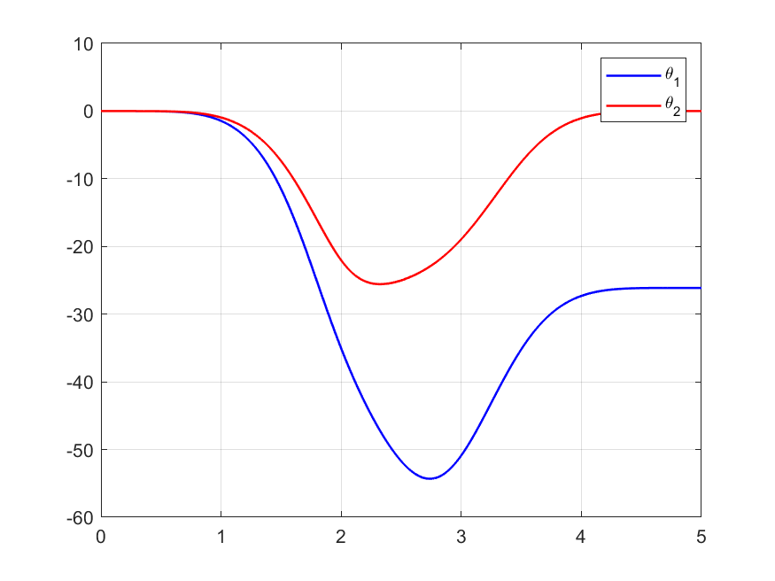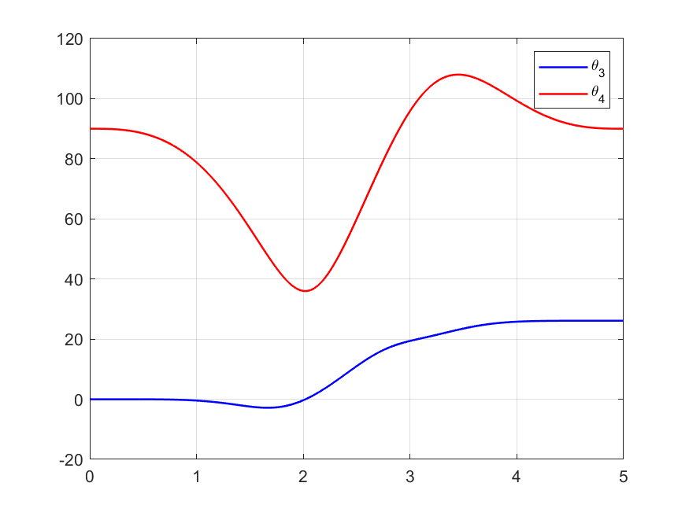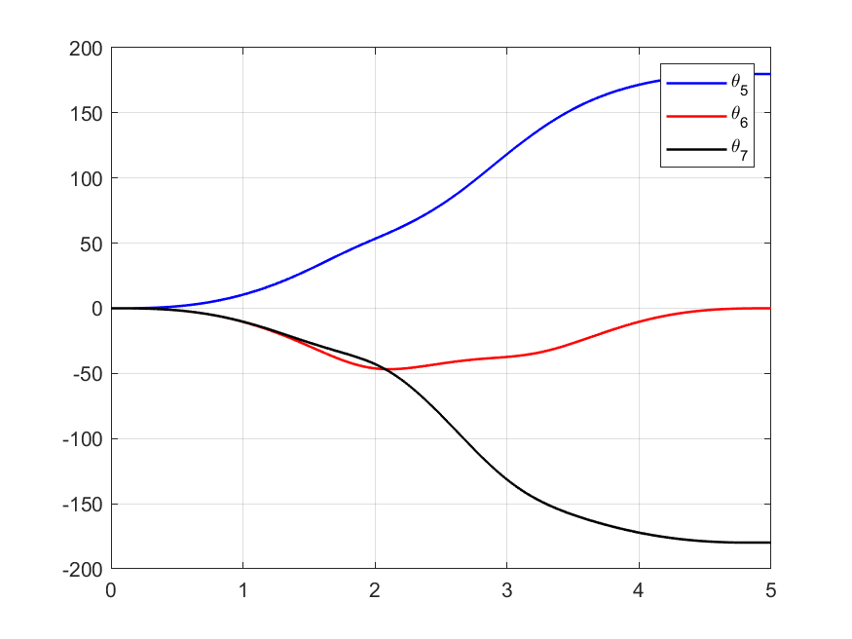

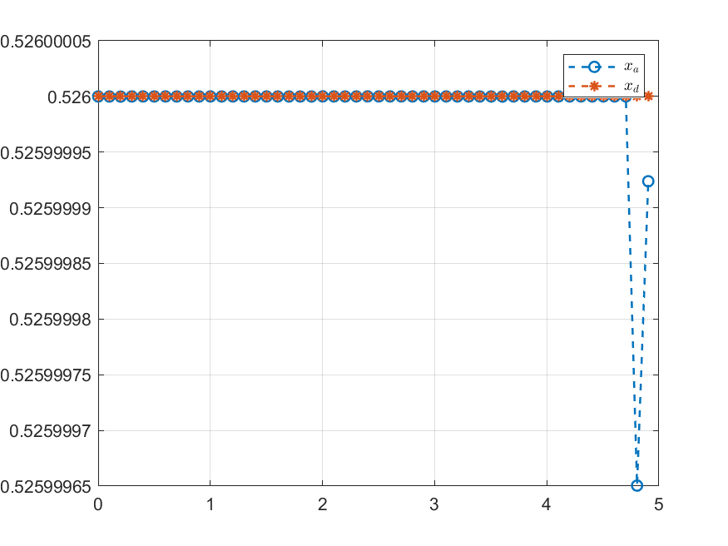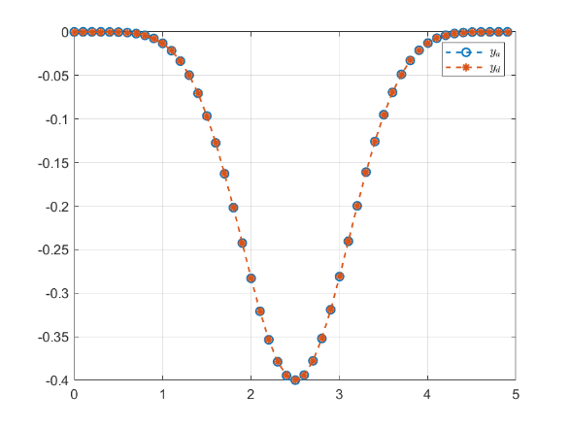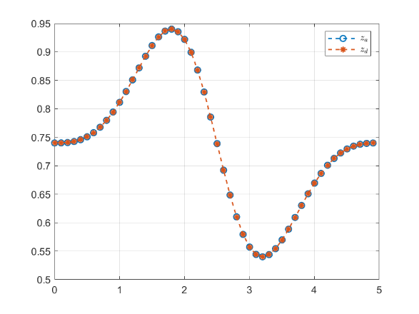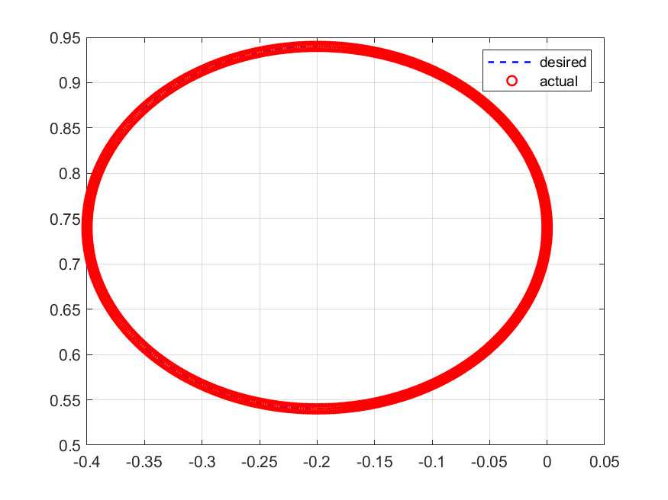

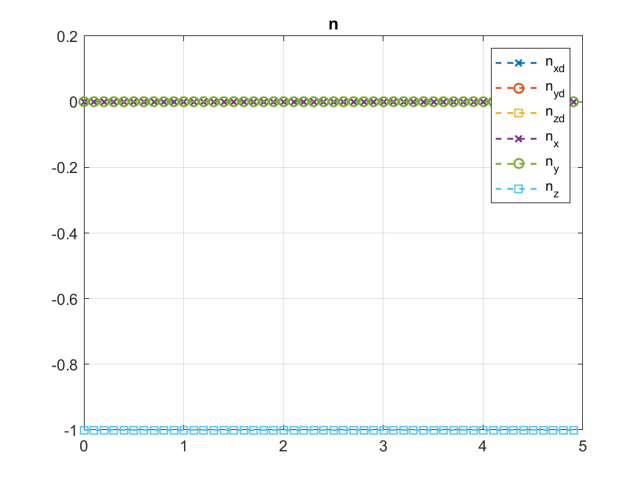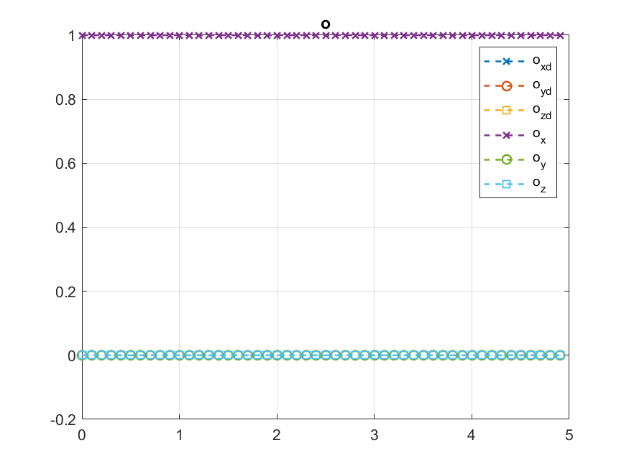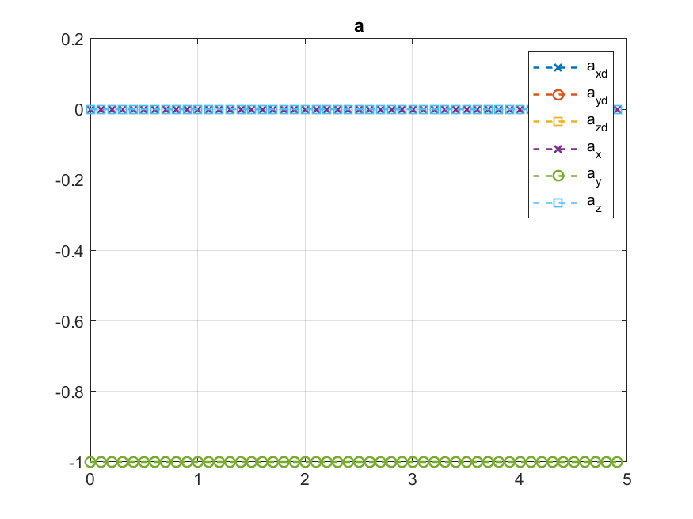

As it can be seen the trajectory is identical to the desired path. Next step is solving for the inverse velocity and acceleration. Results are shown in the following figures:

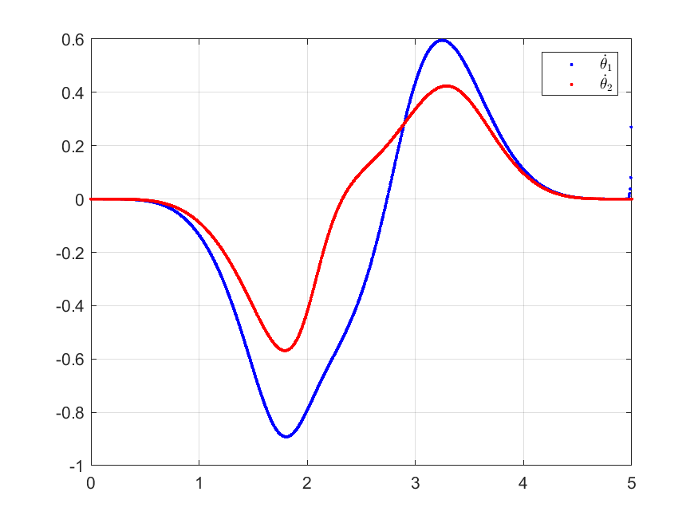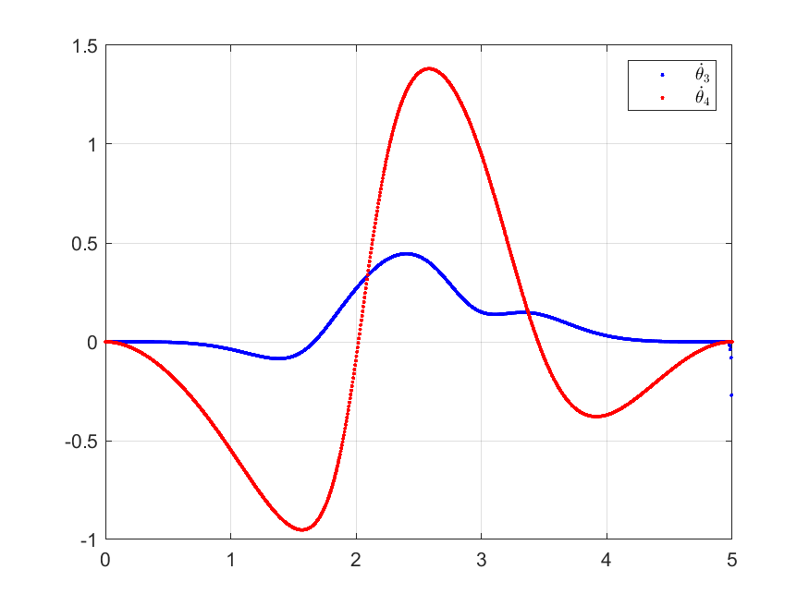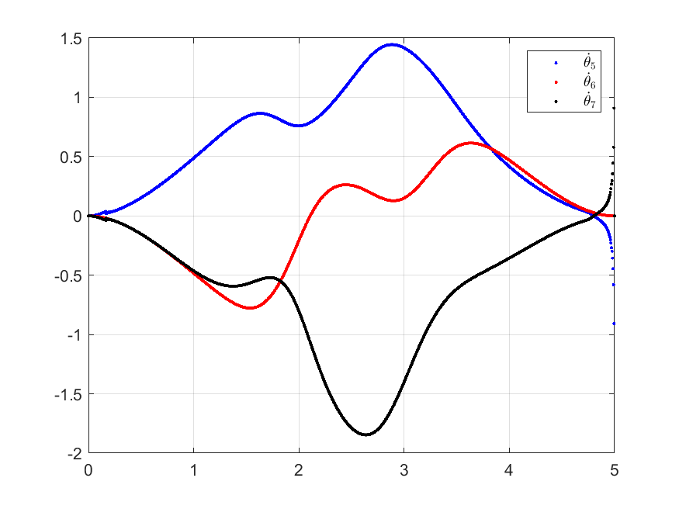

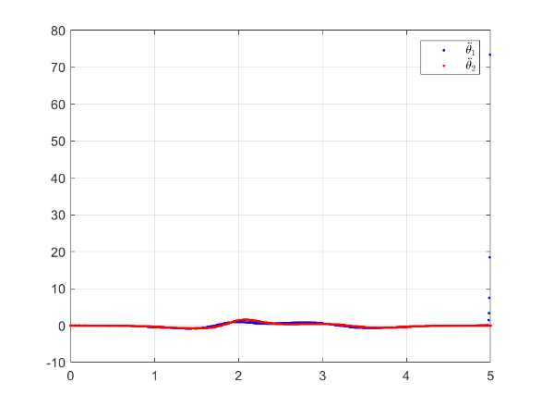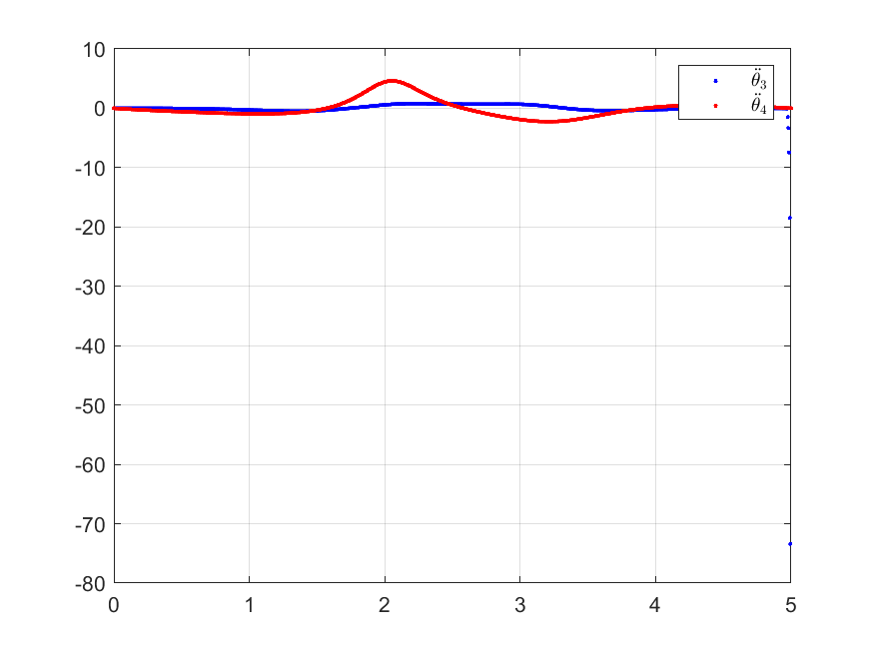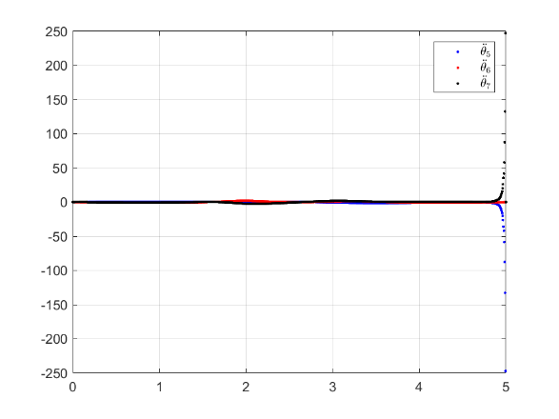

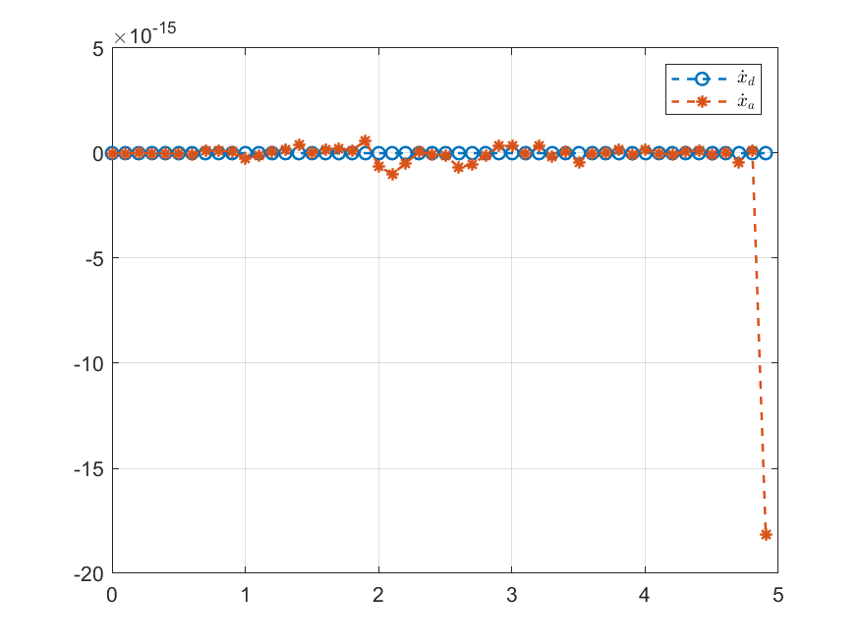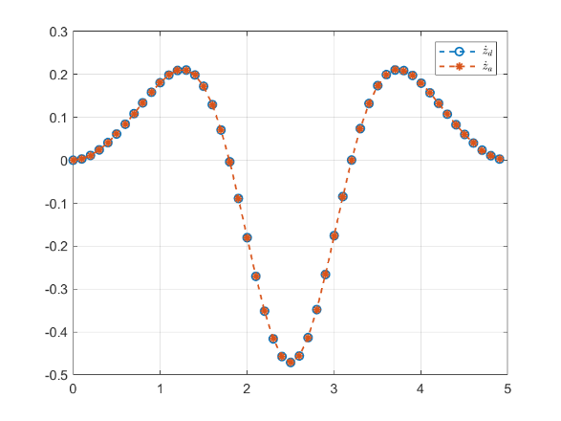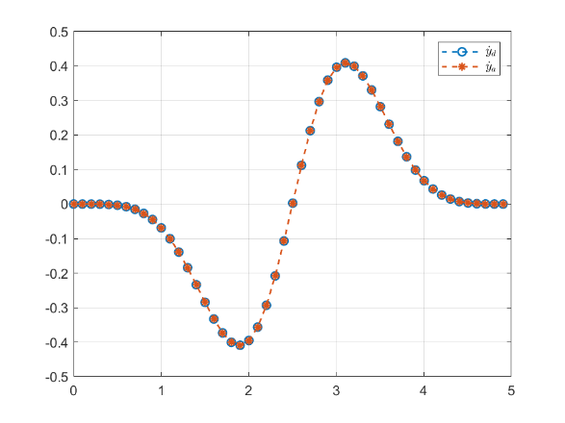

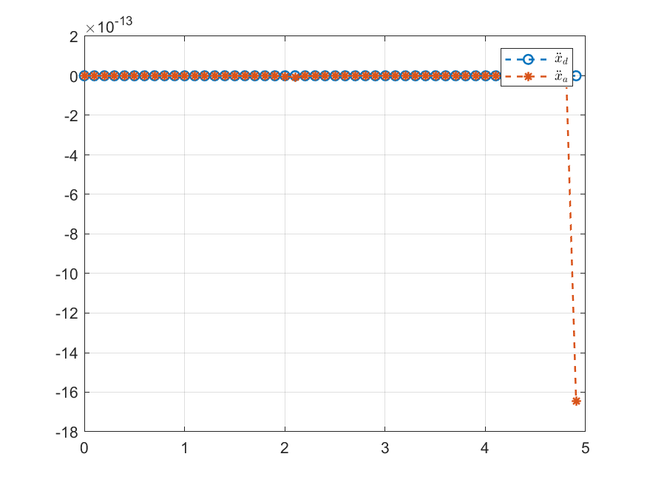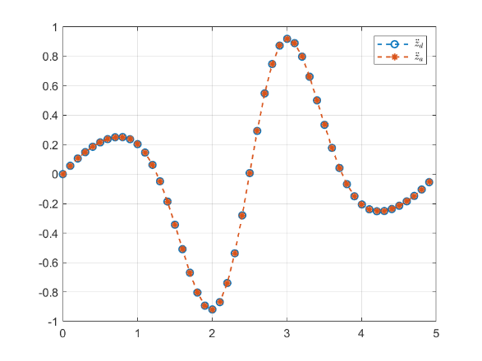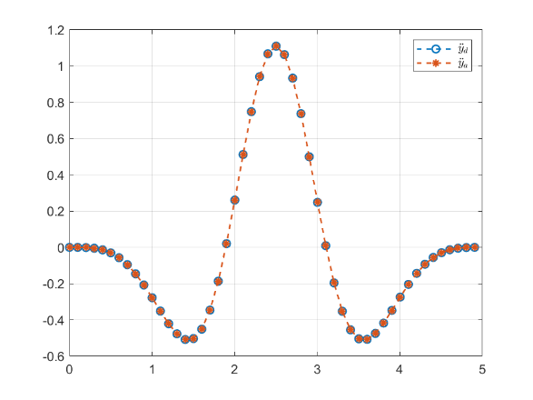

It can be seen that the solution has singularities, this can be checked by using $rank$ or $cond$ MATLAB functions. To avoid singularities another trajectory is proposed using the following formulas:

$$r={(L}_{3}+L_{4}) sin⁡(β)$$

$$x_{c}={(L}_{3}+L_{4}) cos⁡(β)$$

$$yc=0$$

$$z_{c}=L_{1}+L_{2}$$

$$R_{E(desired)}=\left[\begin{matrix}0 & 1 & 0 \\ 0 & 0 & -1 \\ -1 & 0 & 0\end{matrix}\right]$$

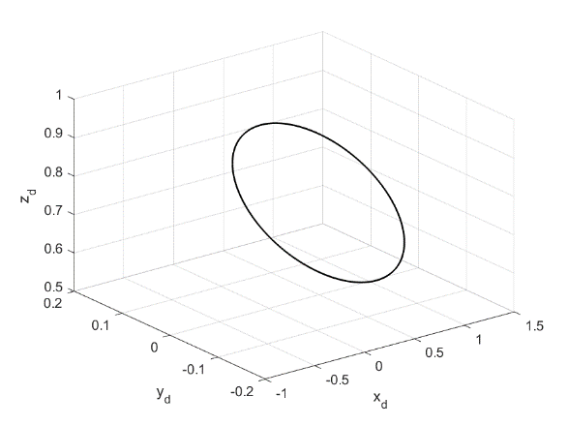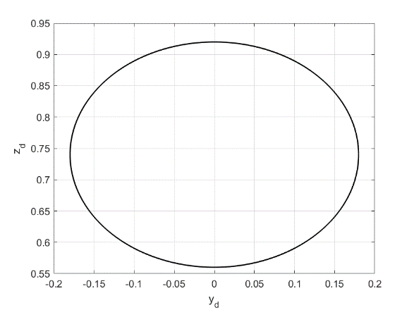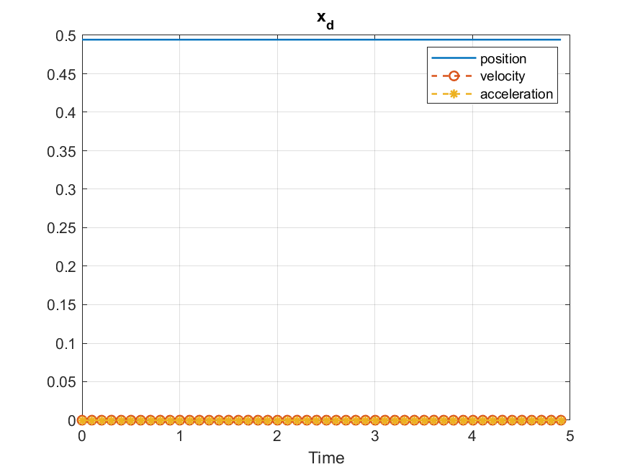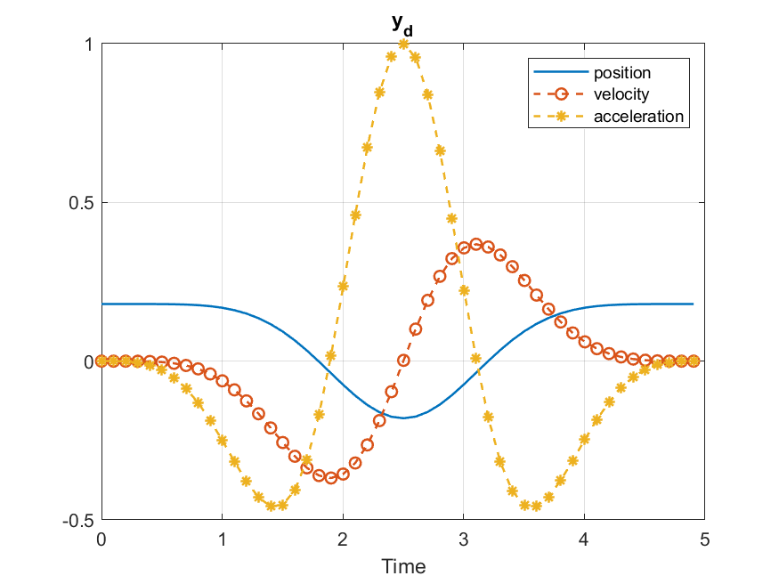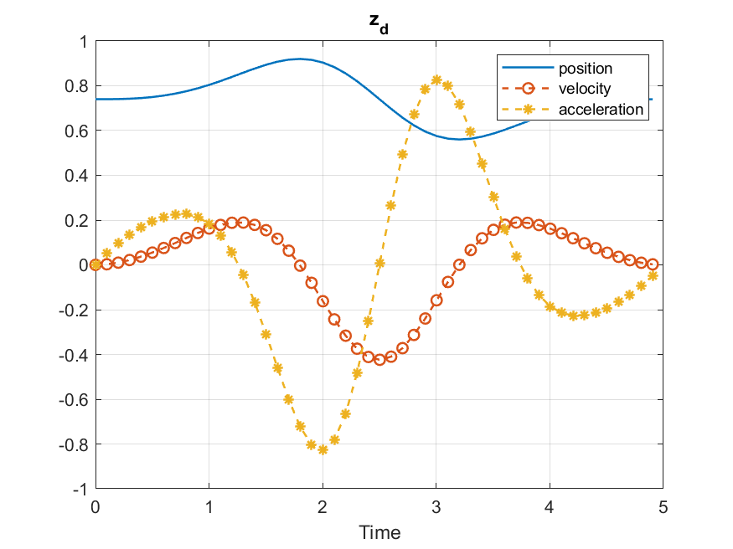

The inverse solution look like:

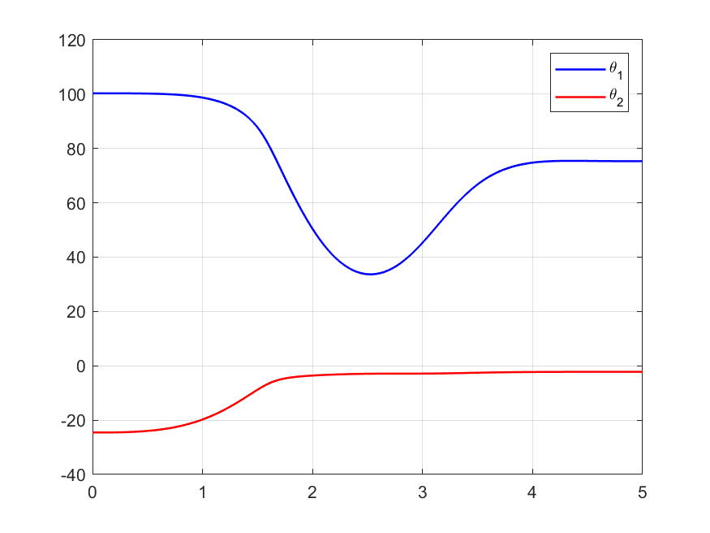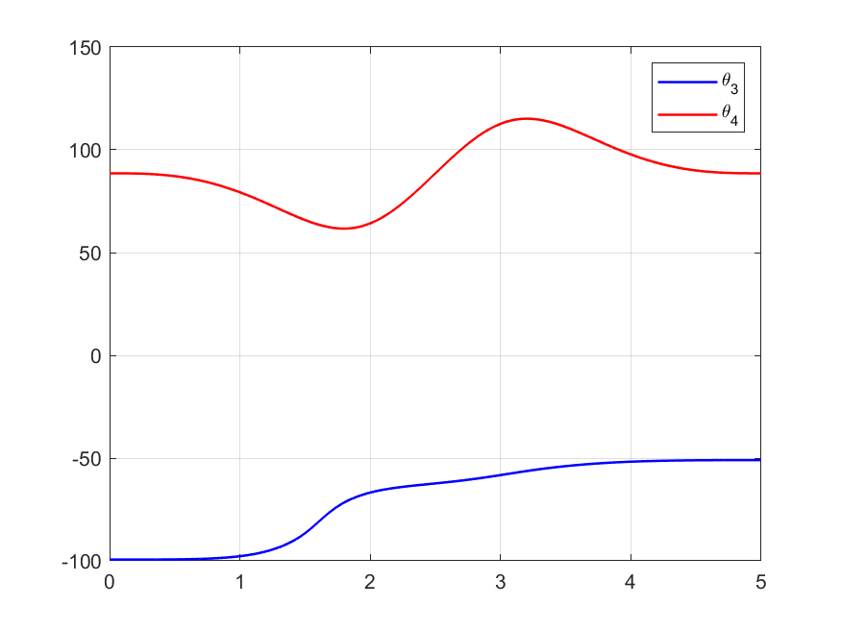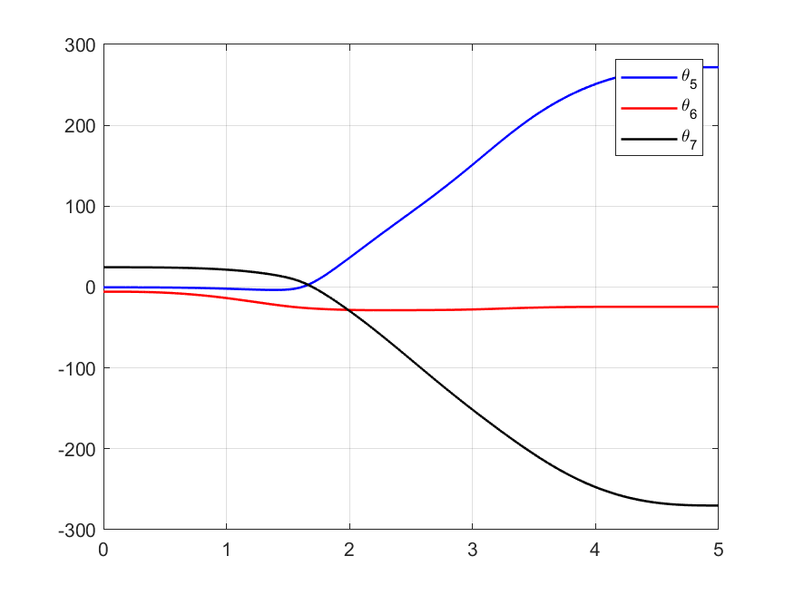

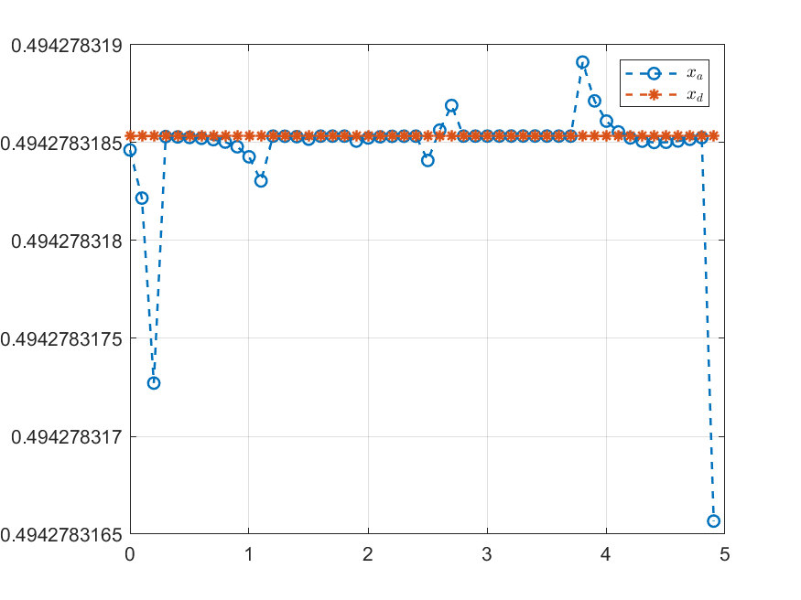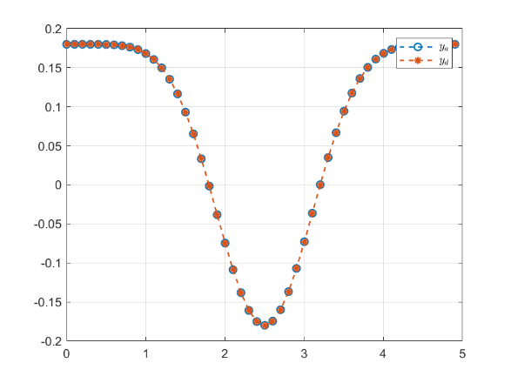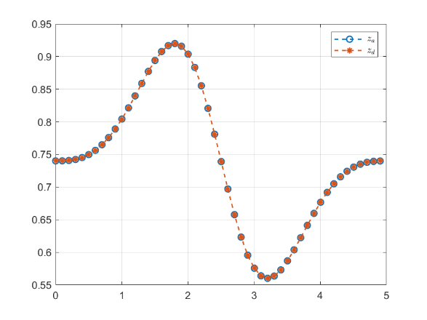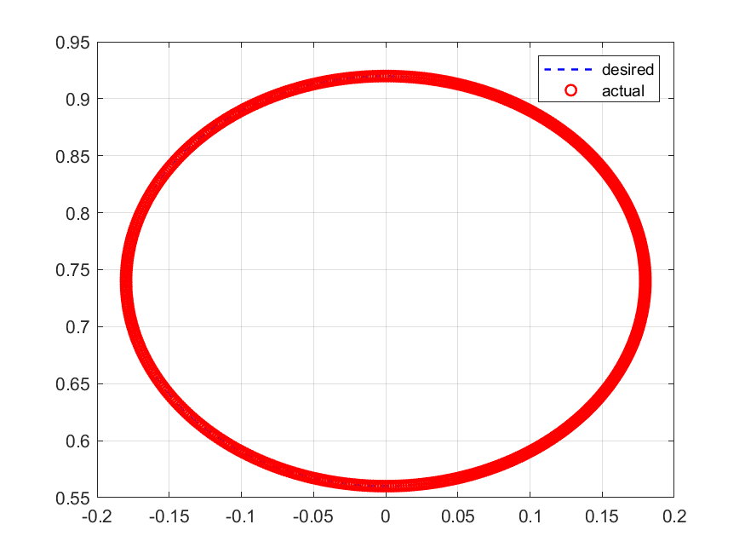

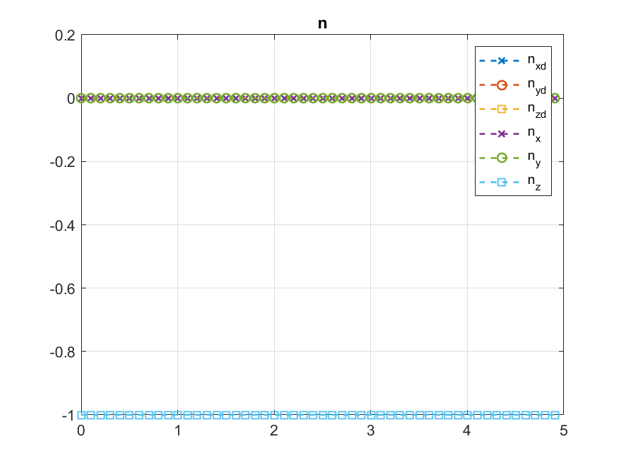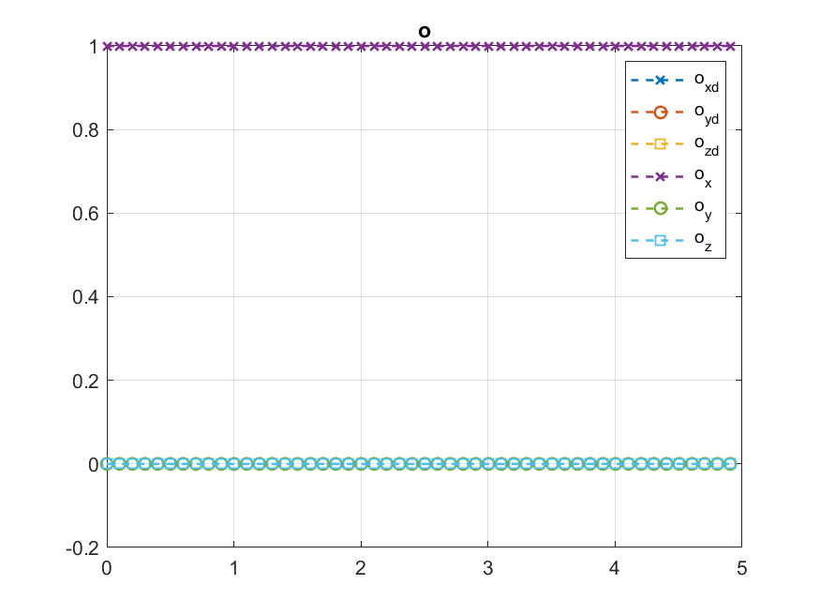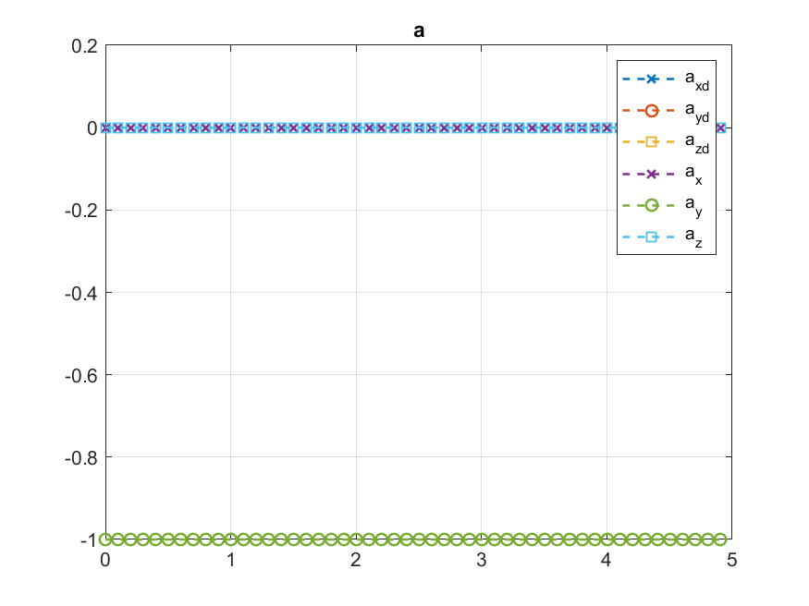

The inverse velocity and acceleration are shown in the following figures:

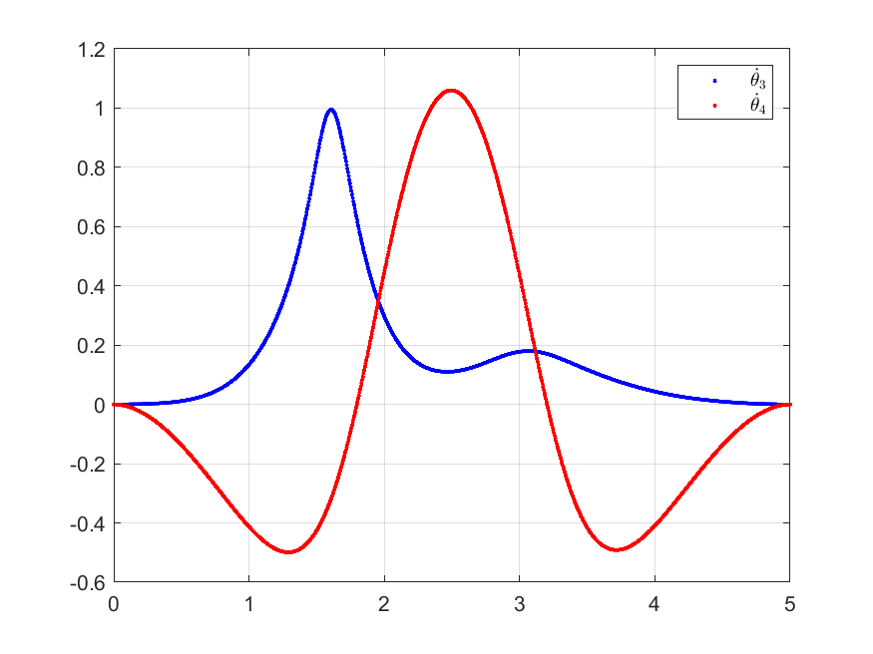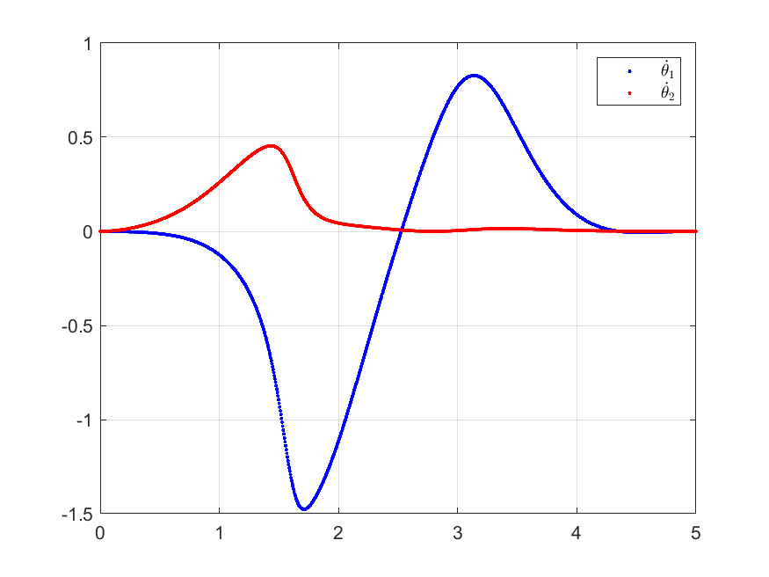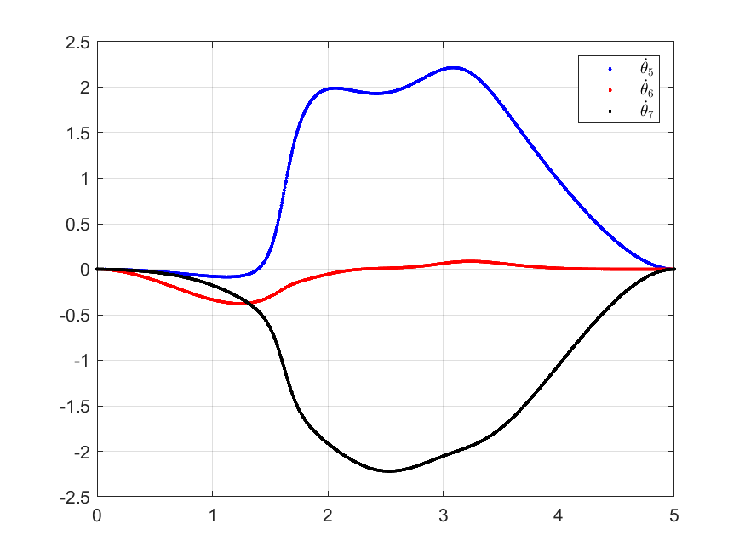

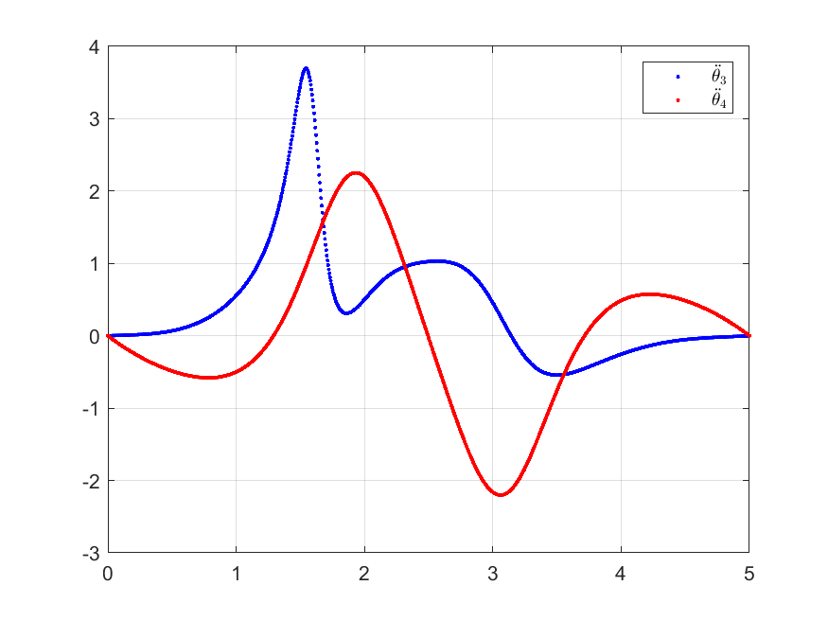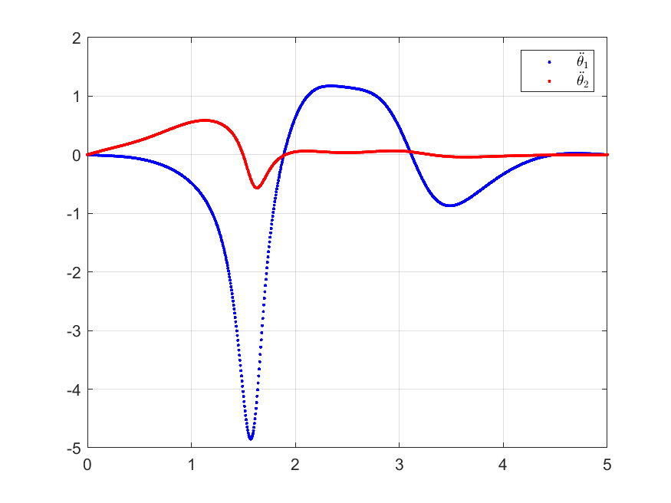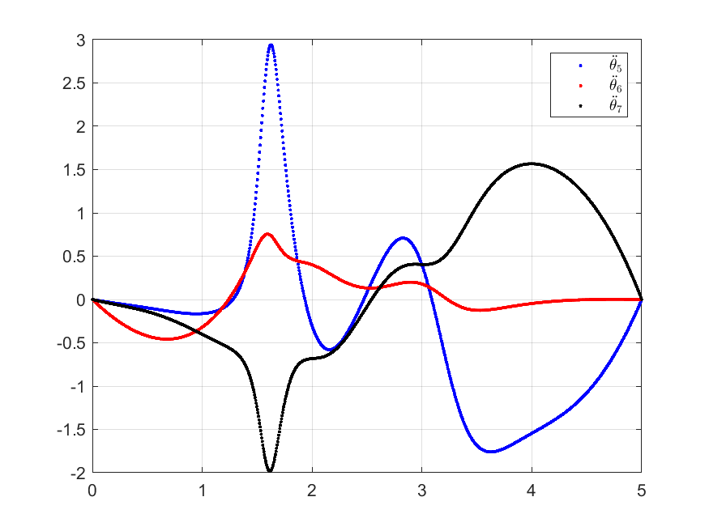

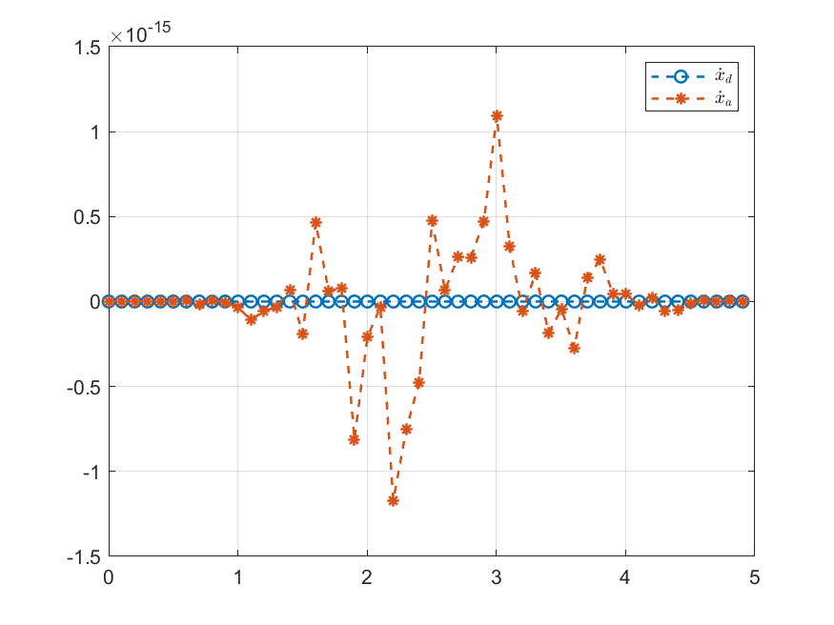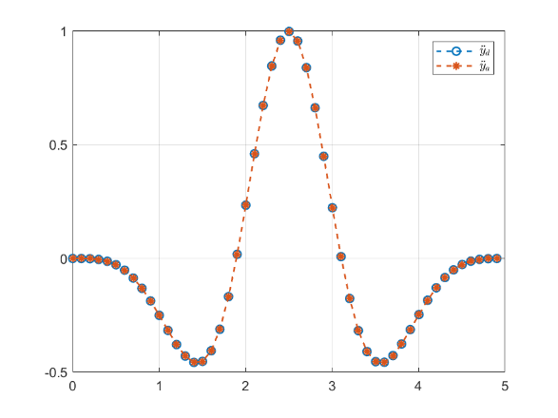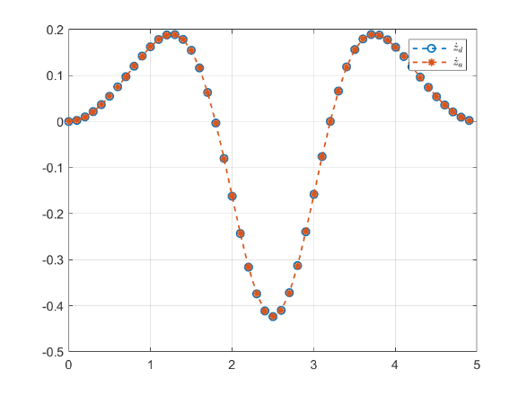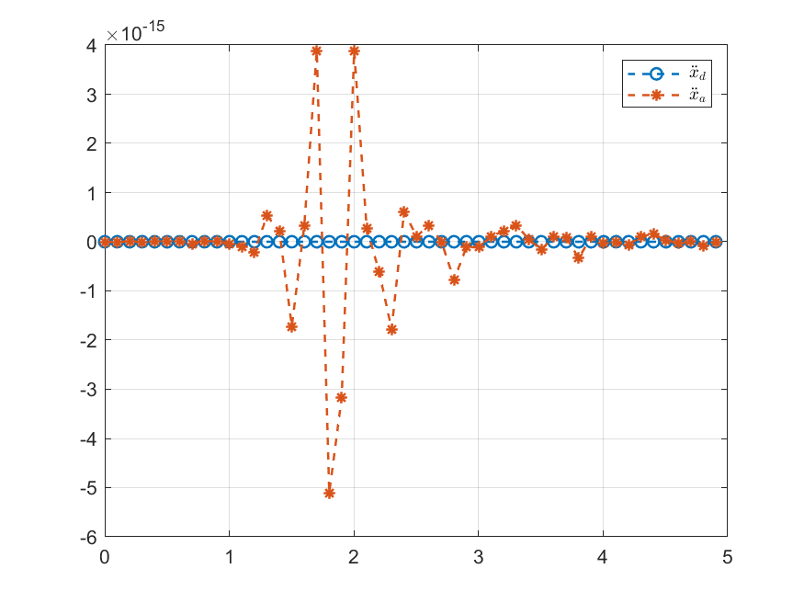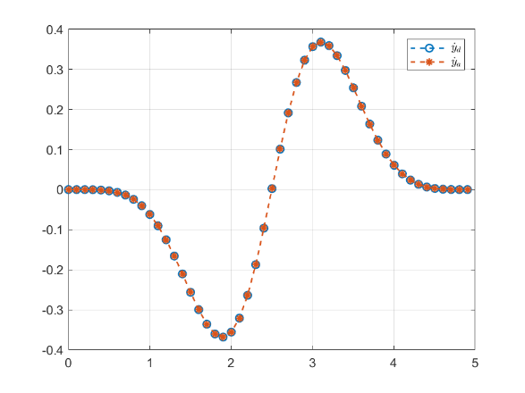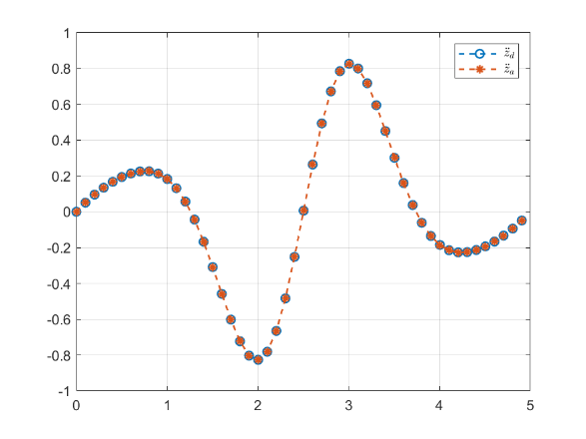

It can be seen that there are no singularities in this particular path. The study will use this path in the following sections. Figures below show a simulation of the robot using the desired trajectory.

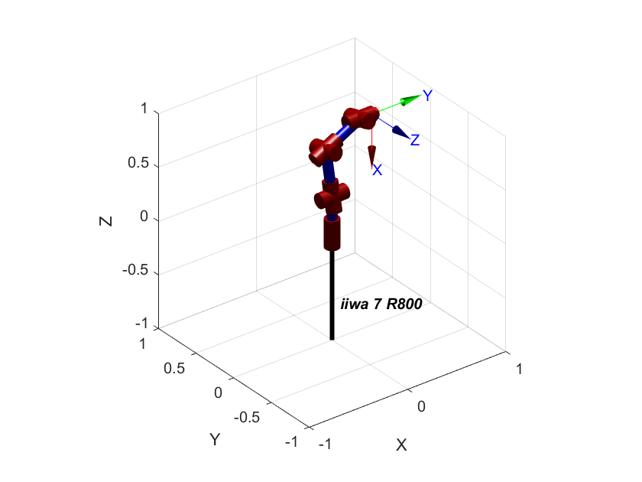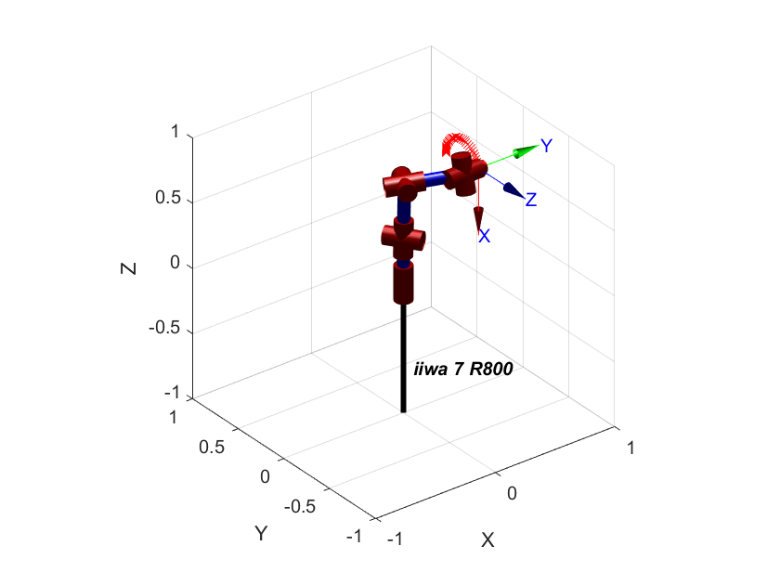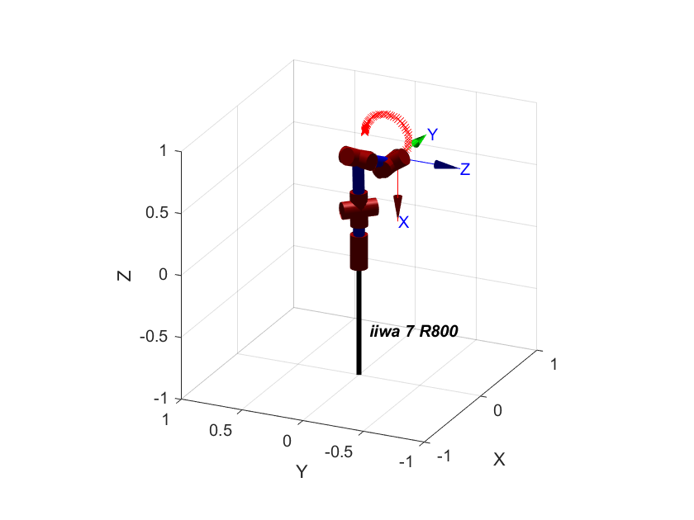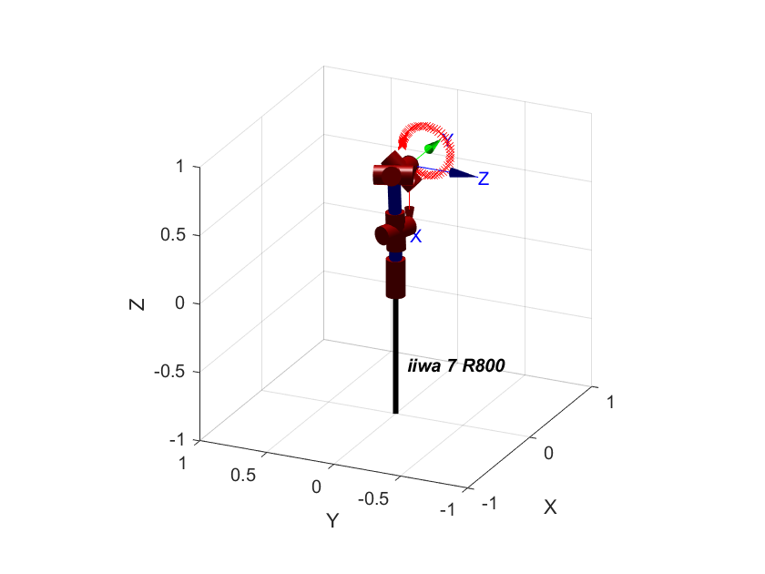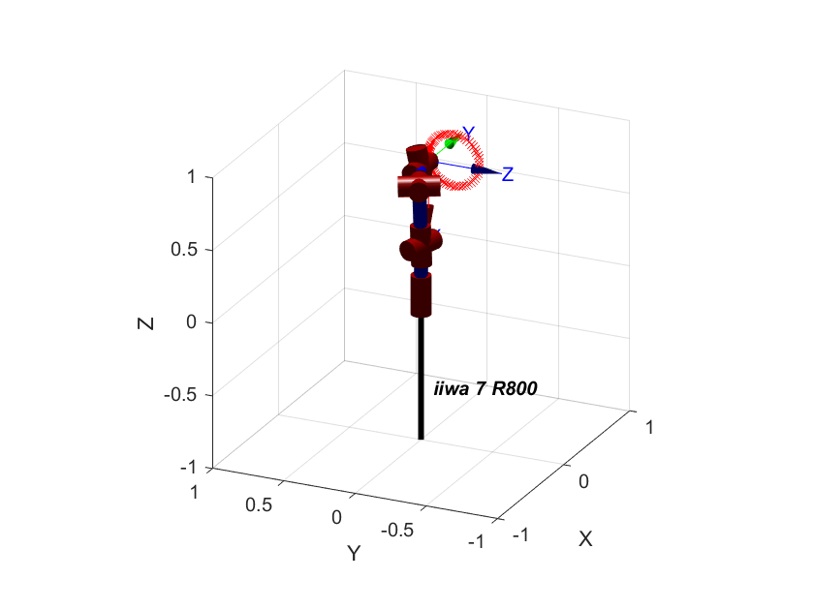

**Dynamical modeling**

The equation of motion (EOM) can be derived as:

$$M\ddot{q}+c+ϕ+B\dot{q}=τ$$

* The inertial parameter of the links for the iiwa 7 model obtained from KUKA website.
* Off diagonal elements in the mass moment of inertia matrix are ignored (rigid body symmetric assumption)
* Center of masses were assumed to be in the center of each link
* No friction

Because of the long expressions the EOM are not shown here.

|  |  |  |  |  |  |  |  |
| --- | --- | --- | --- | --- | --- | --- | --- |
|  | Link | | | | | | |
| Parameter | 1 | 2 | 3 | 4 | 5 | 6 | 7 |
| $$m$$ | $$3.4525$$ | $$3.4821$$ | $$4.0562$$ | $$3.4822$$ | $$2.1633$$ | $$2.3466$$ | $$3.1290$$ |
| $$r_{x}$$ | $$0.0$$ | $$0.0$$ | $$0.0$$ | $$0.0$$ | $$0.0$$ | $$0.0$$ | $$0.0$$ |
| $$r_{y}$$ | $$0.0$$ | $$0.0$$ | $$0.0$$ | $$0.0$$ | $$0.0$$ | $$0.0$$ | $$0.0$$ |
| $$r_{z}$$ | $$L_1/2$$ | 0.0 | $$L_2/2$$ | 0.0 | $$L_3/2$$ | 0.0 | $$L_4/2$$ |
| $$I_{xx}$$ | $$0.02180$$ | $$0.02076$$ | $$0.03200$$ | $$0.02170$$ | $$0.01280$$ | $$0.00650$$ | $$0.01460$$ |
| $$I_{yy}$$ | $$0.00770$$ | $$0.02179$$ | $$0.00970$$ | $$0.02070$$ | $$0.00580$$ | $$0.00620$$ | $$0.01470$$ |
| $$I_{zz}$$ | $$0.02080$$ | $$0.00779$$ | $$0.03040$$ | $$0.00770$$ | $$0.01110$$ | $$0.00450$$ | $$0.00290$$ |

**Sliding Control**

$$τ=c+ϕ+B\dot{q}+M({\ddot{q}}_{d}-λ\left(\dot{q} -{\dot{q}}_{d}\right)-k sat(s/ϵ))$$

Where, $k=F+η$

Three parameter were changed to achieve the desired trajectory

* $ϵ$: boundary layer thickness
* $λ$: speed of convergence
* $η$: control effort

**Case 1: $$ϵ=0.01 λ=1.5 η=4$$**

The following figures show the actual response compared with the desired response. Also, the error for each response is presented.

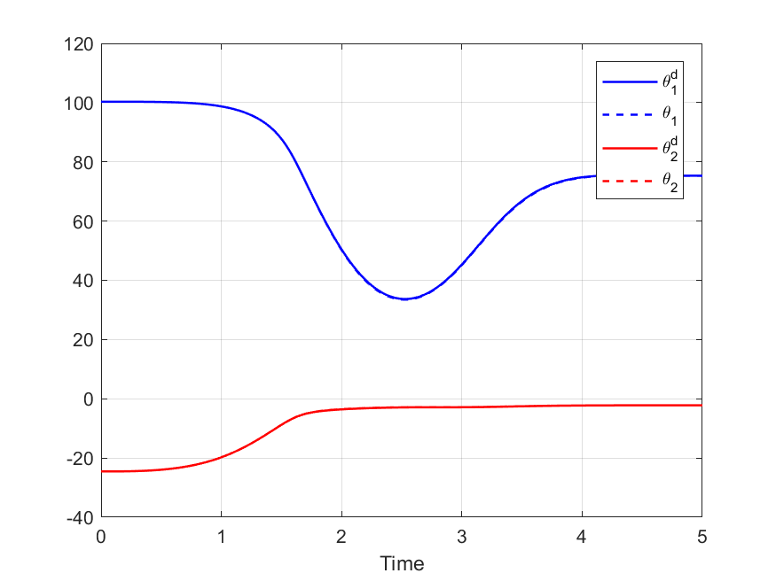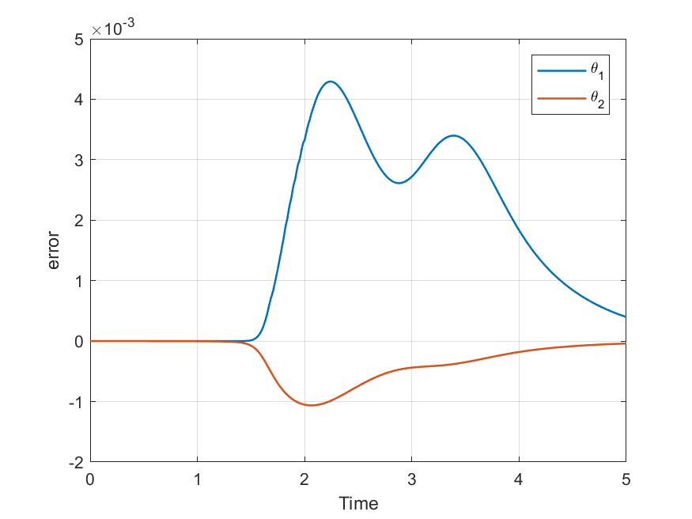

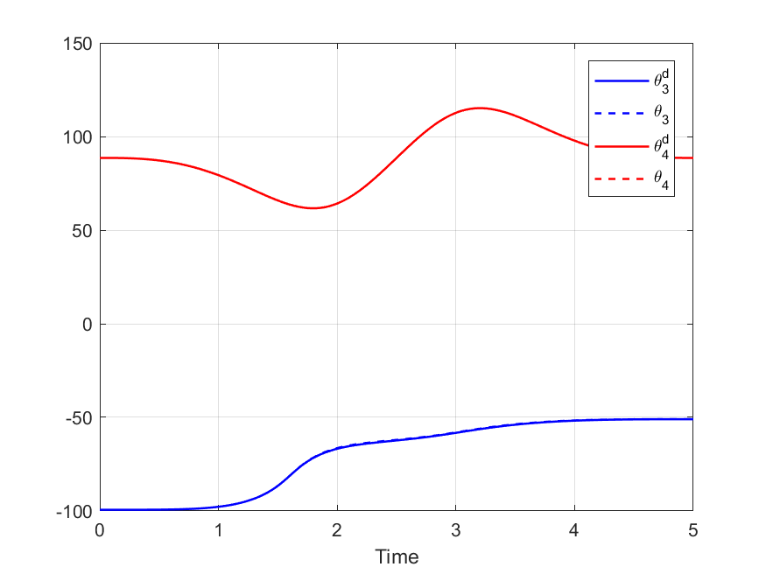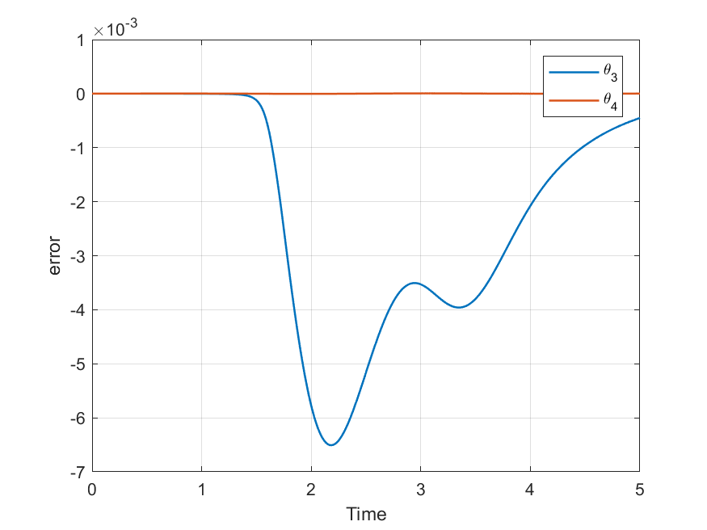

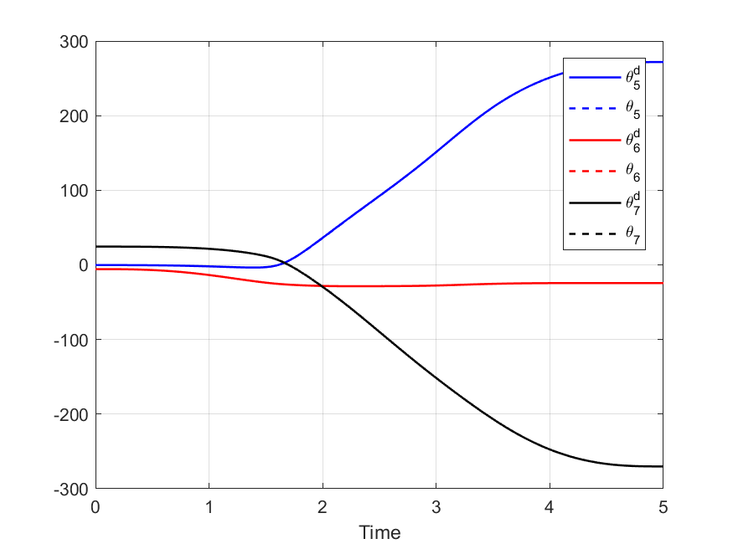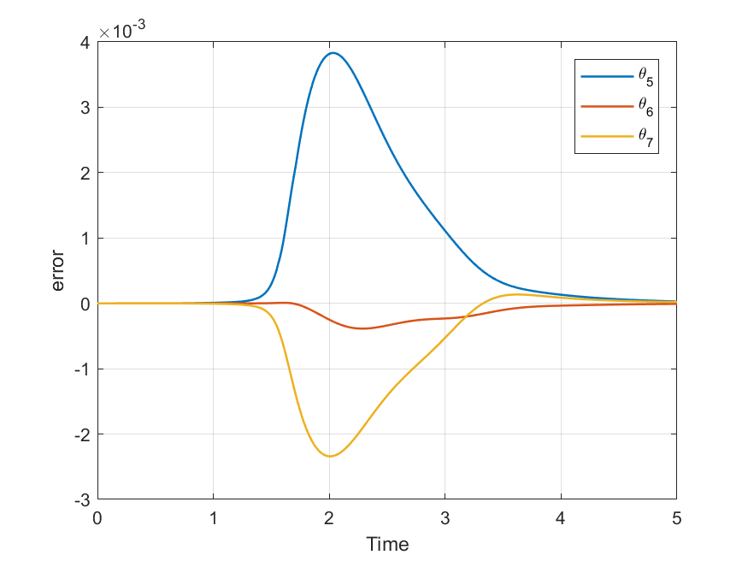

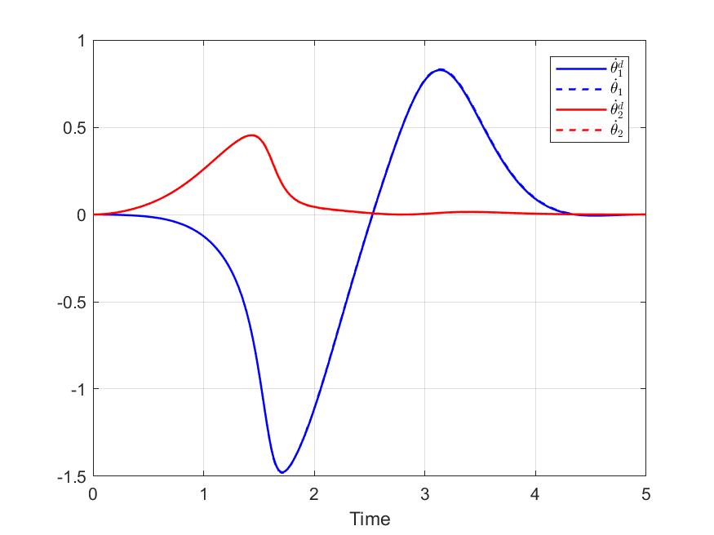 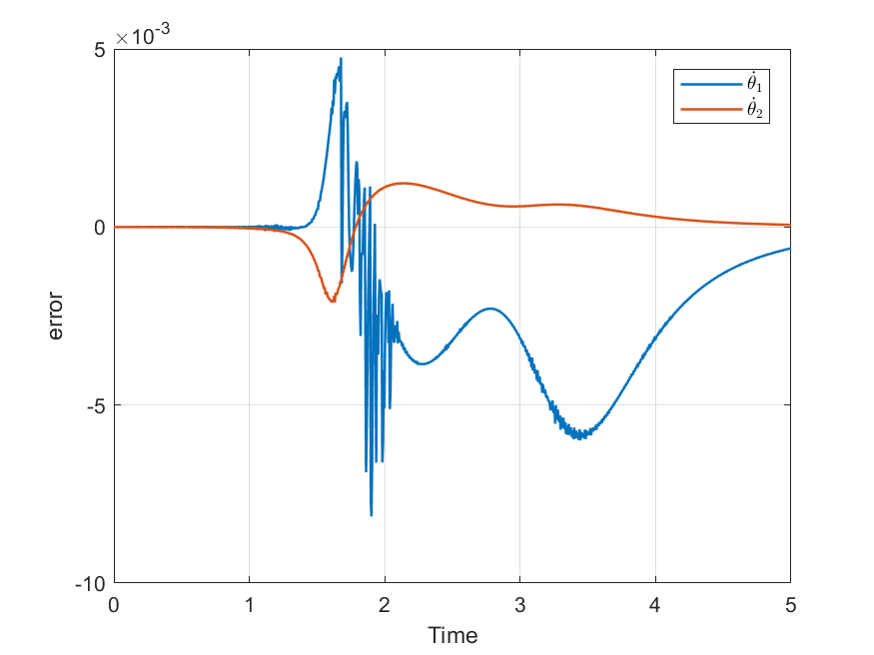

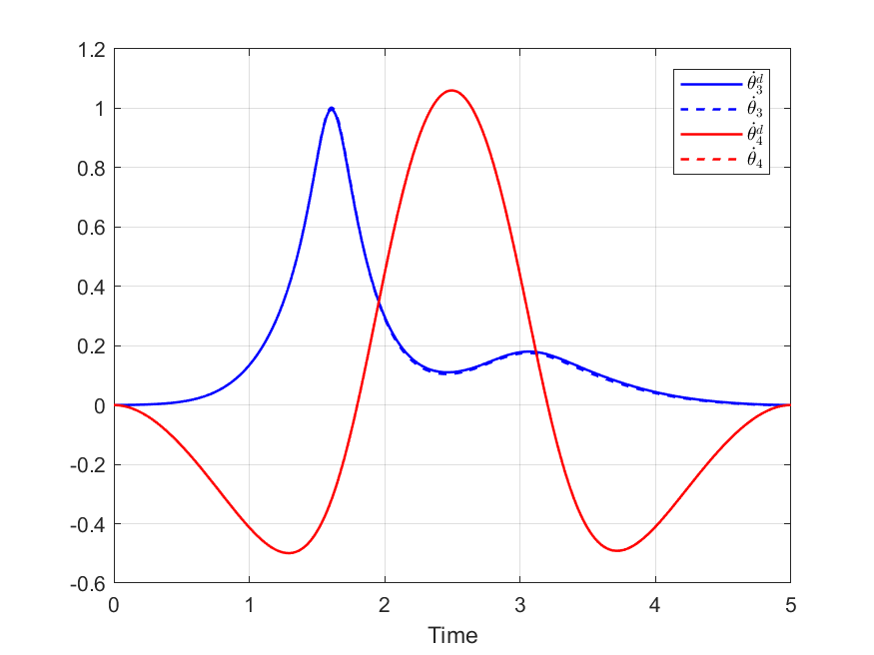 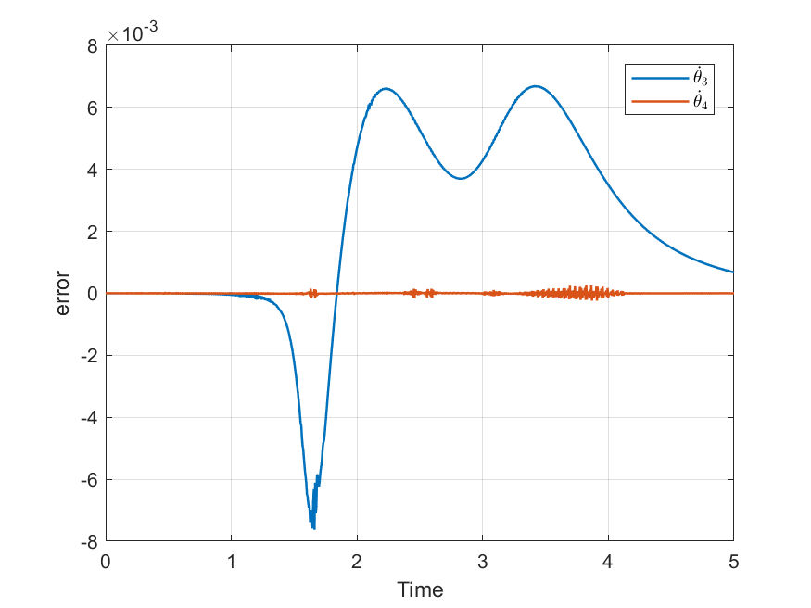

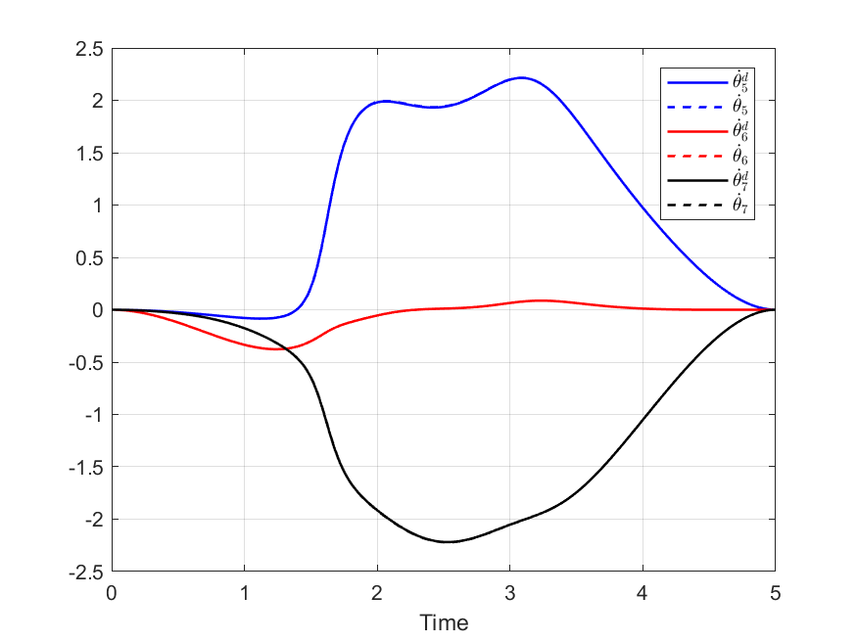 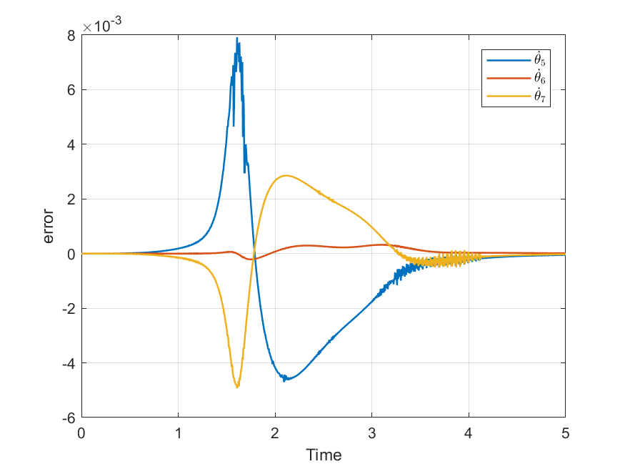

The input of the sliding controller is presented the figures below. The chattering problem is obvious, this can be solved by increasing $ϵ$ which is presented in the following cases.

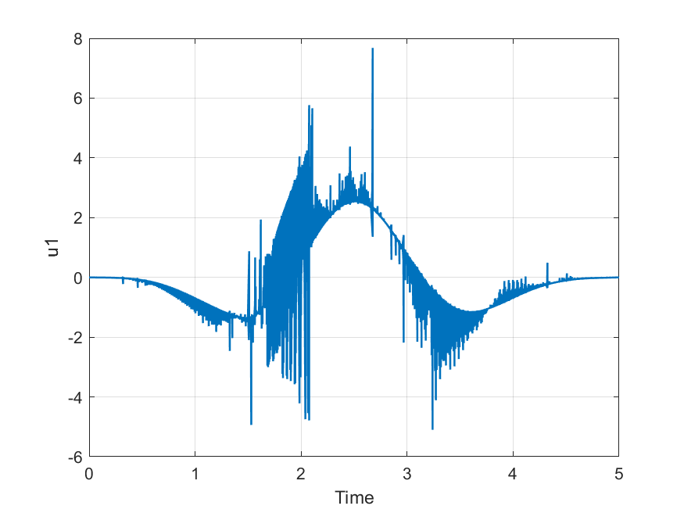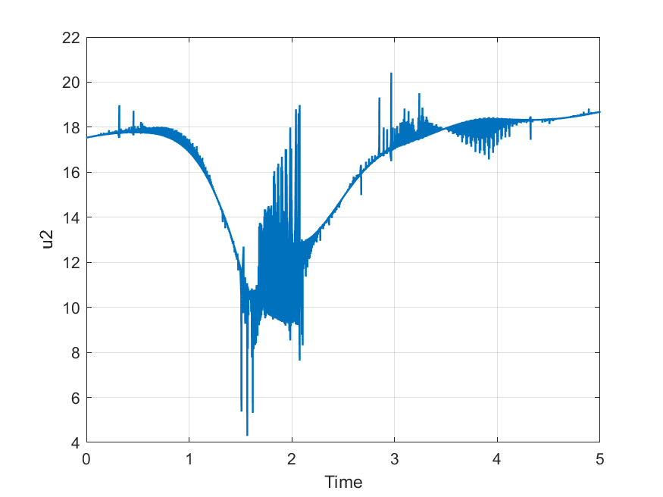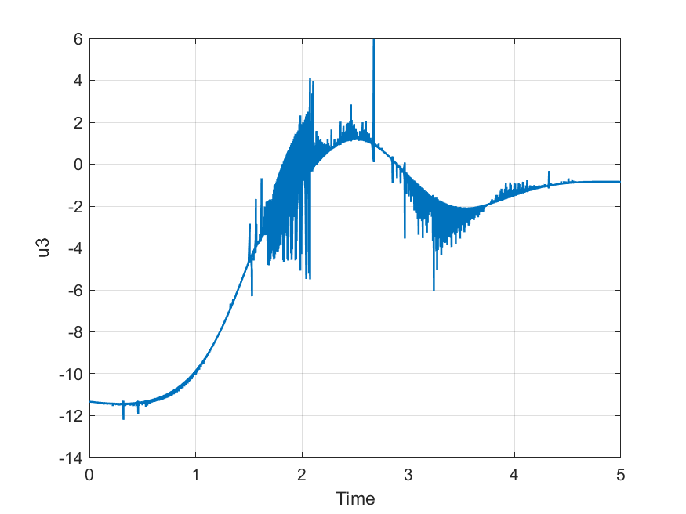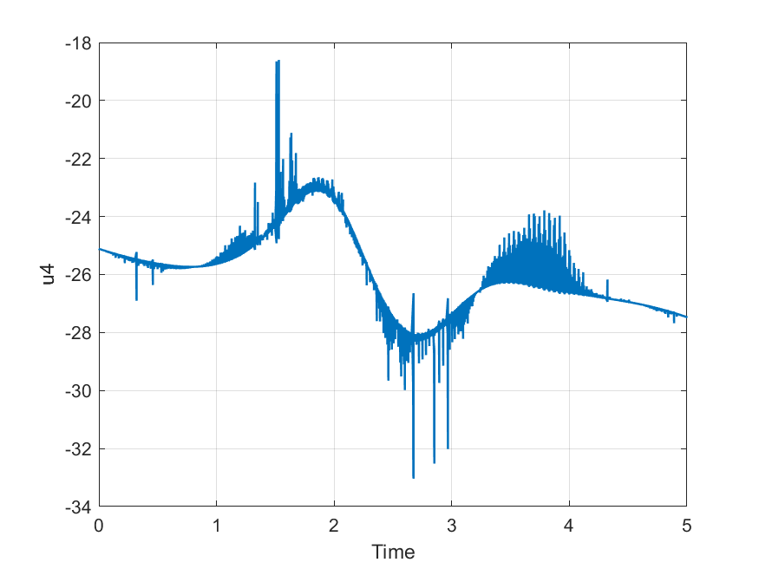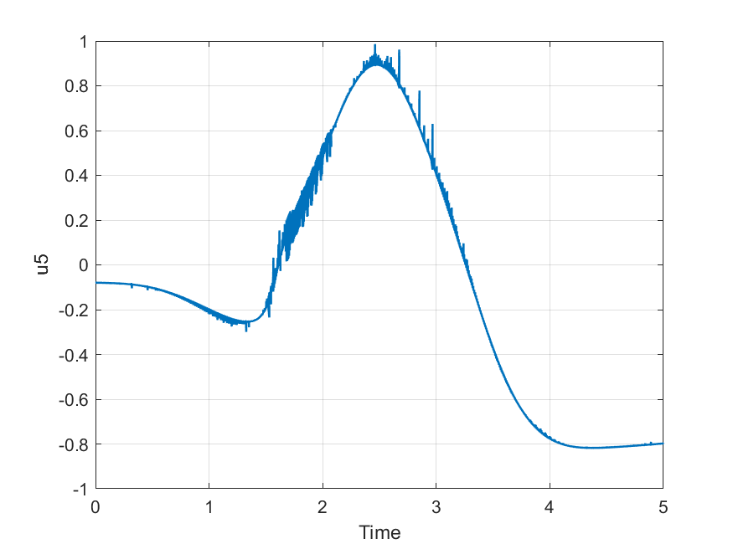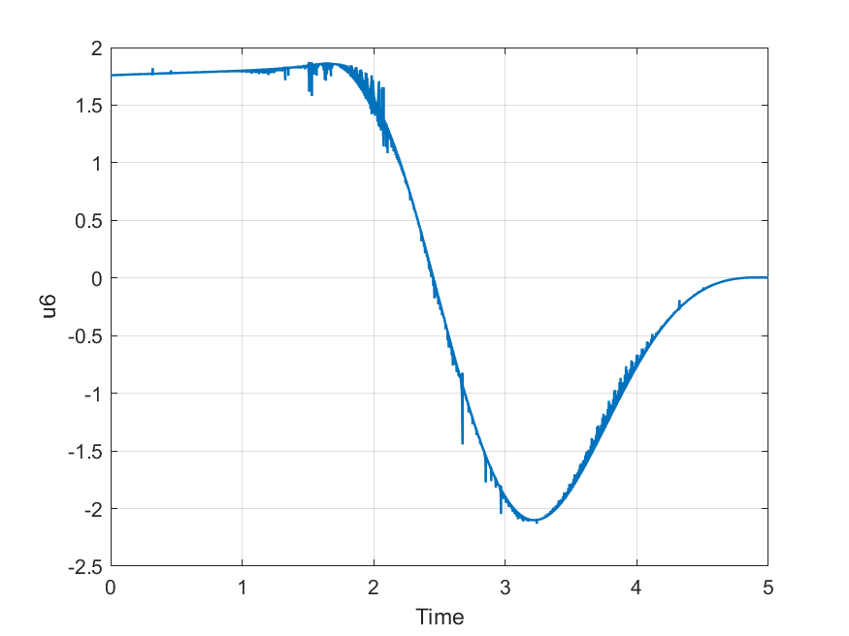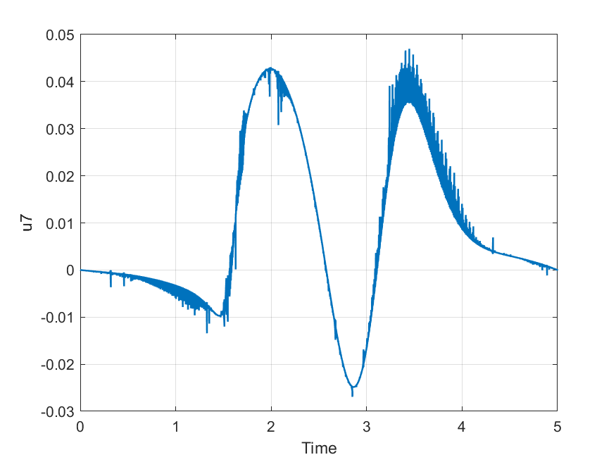

Finally, a comparison between the actual and the desired position and orientation of the end effector are shown below:

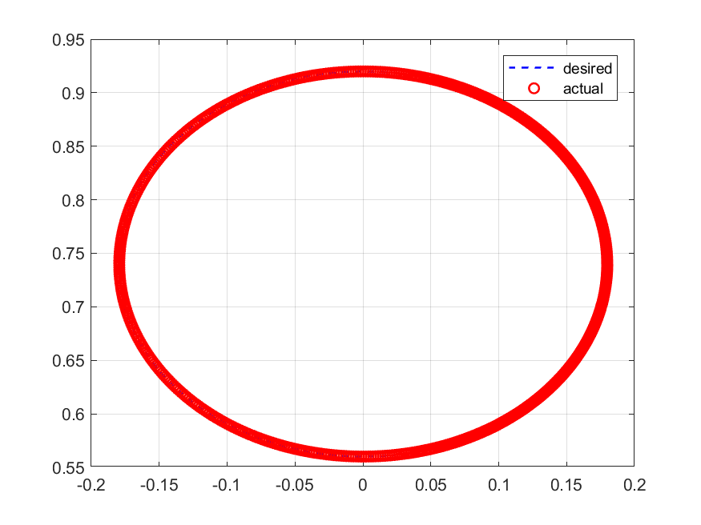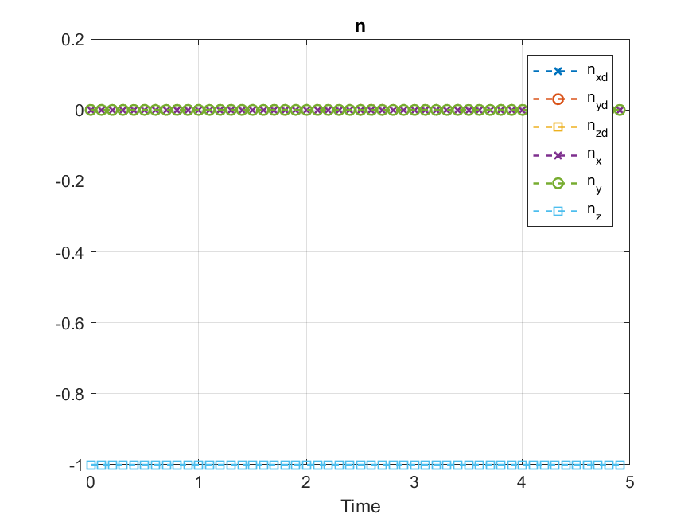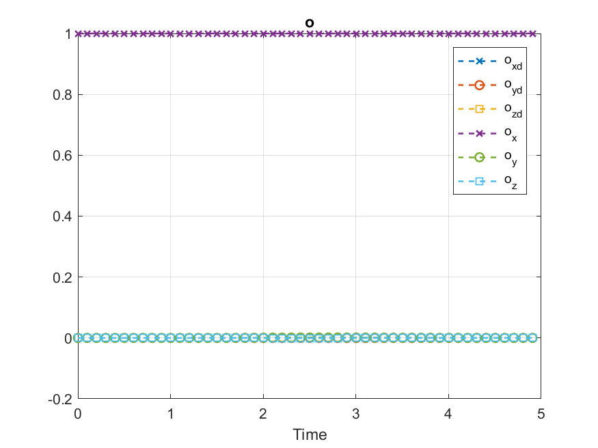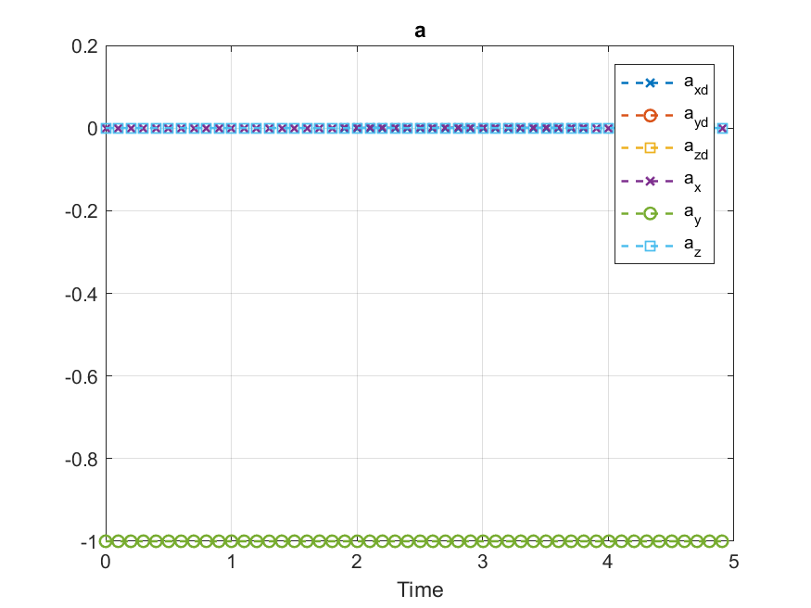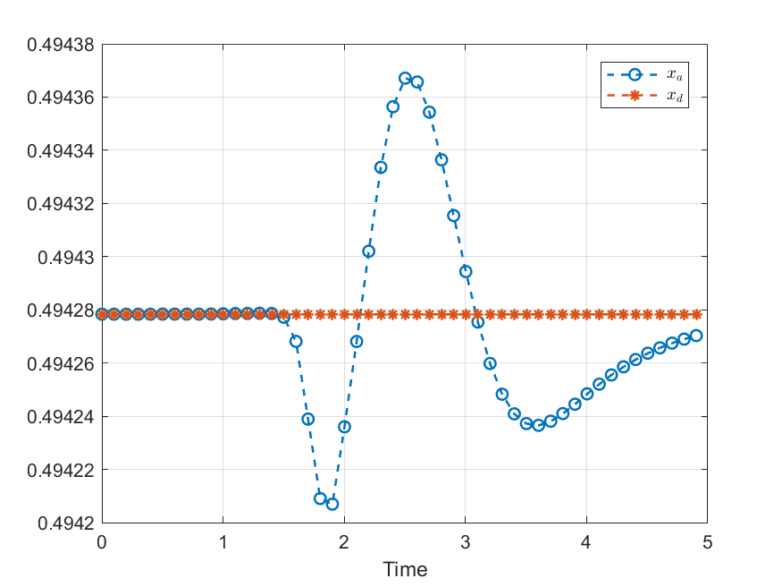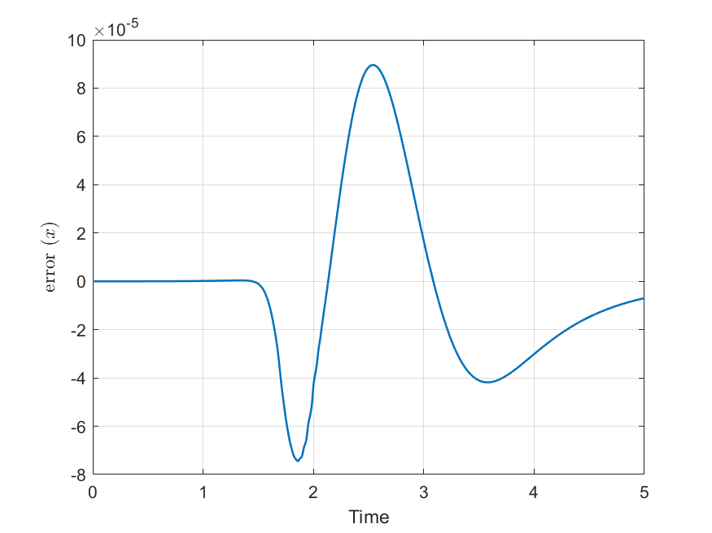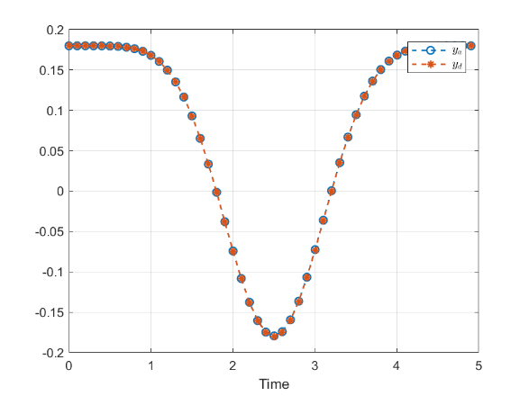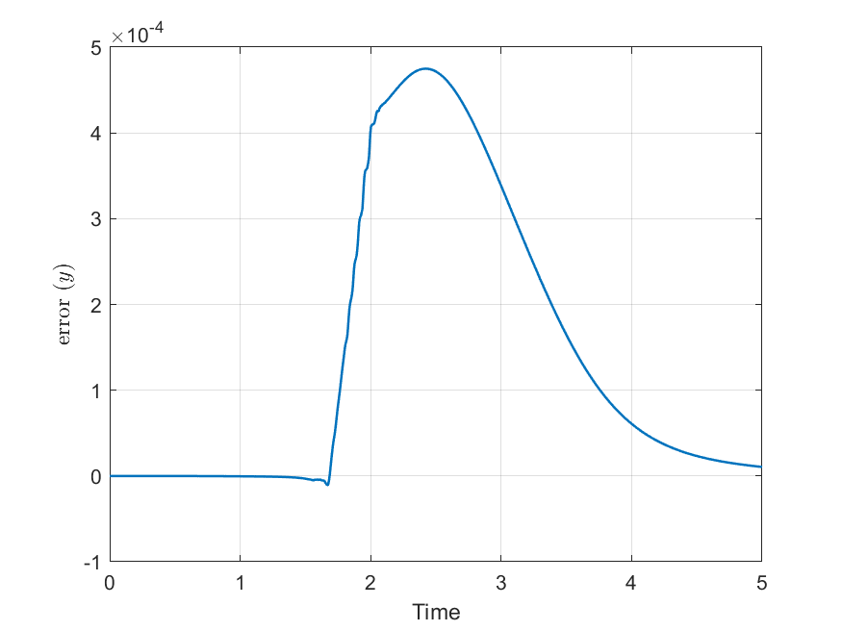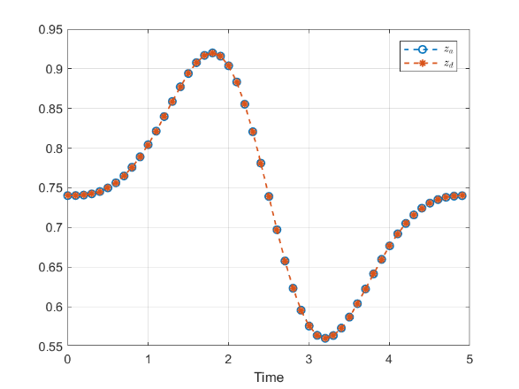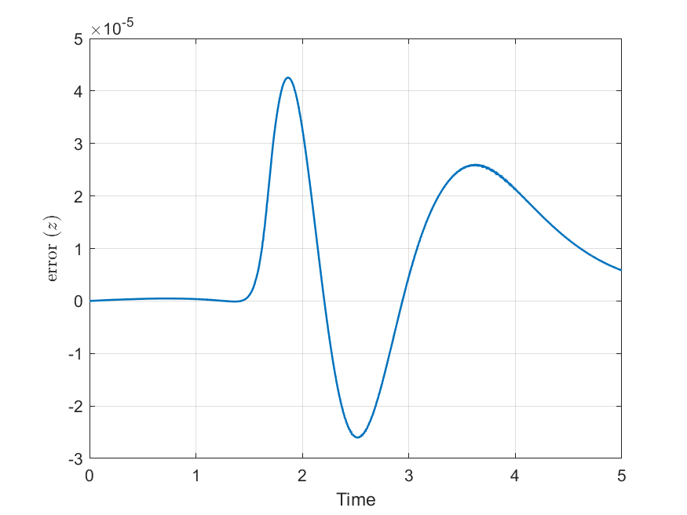

**Case 2: $$ϵ=0.3 λ=1.5 η=4$$**

The following figures show the actual response compared with the desired response. Also, the error for each response is presented.

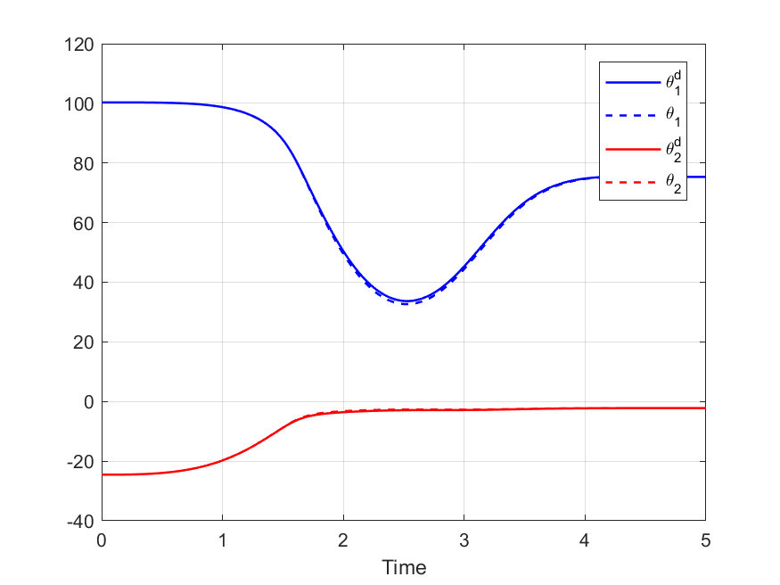 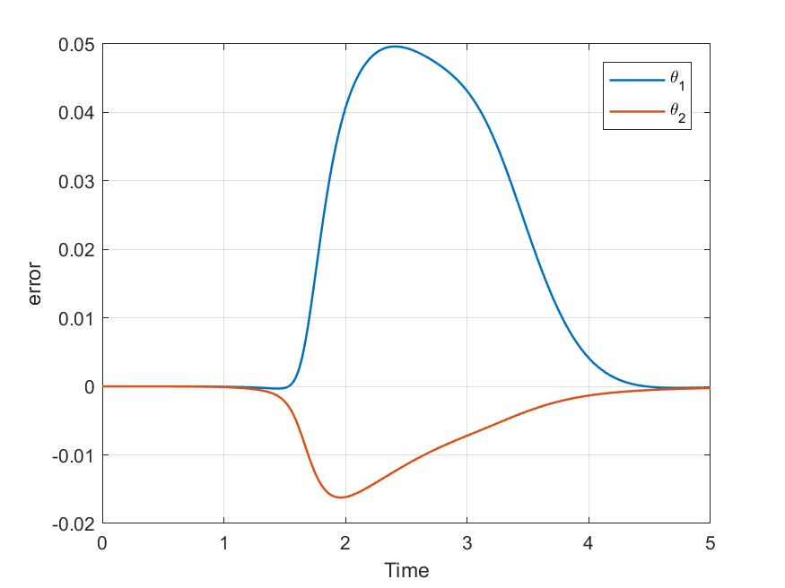

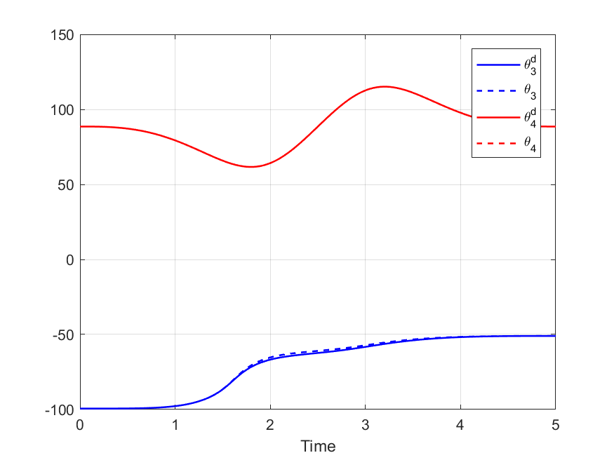 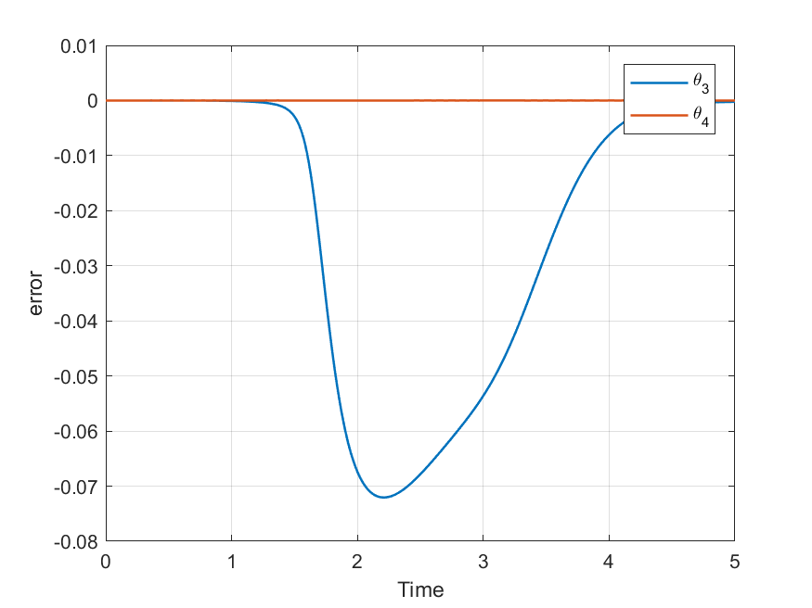

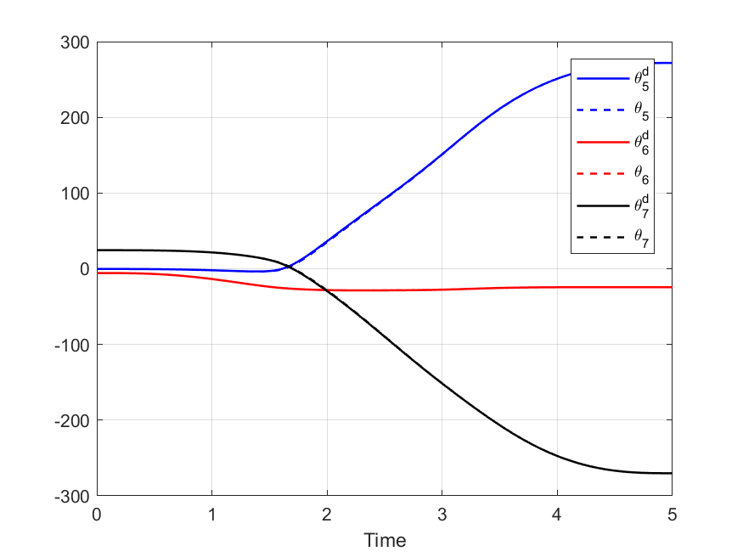 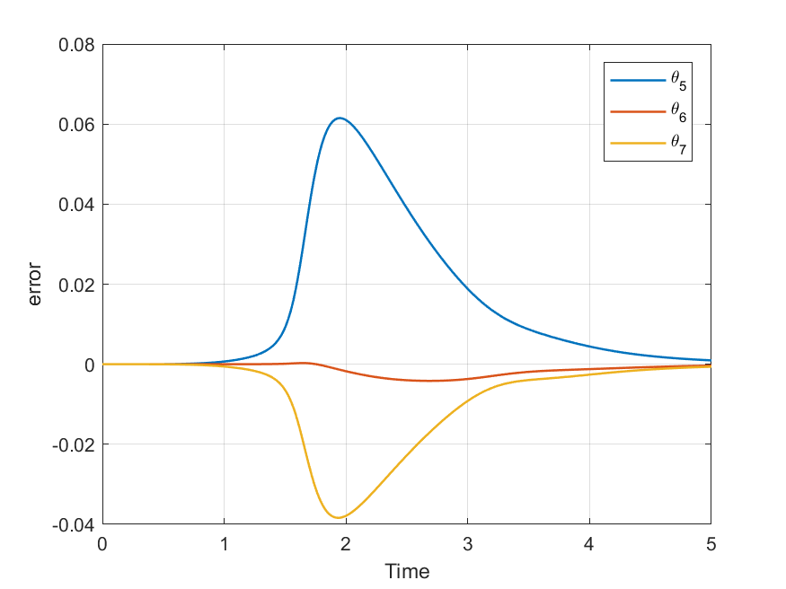

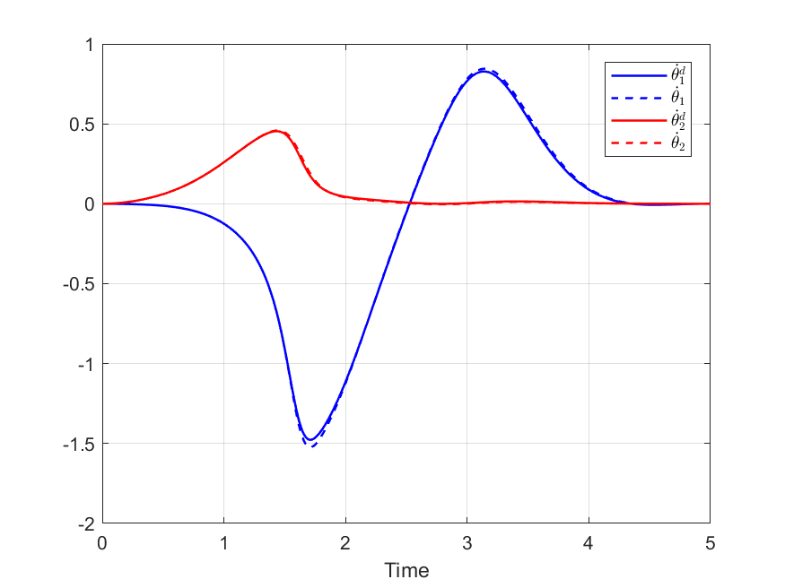 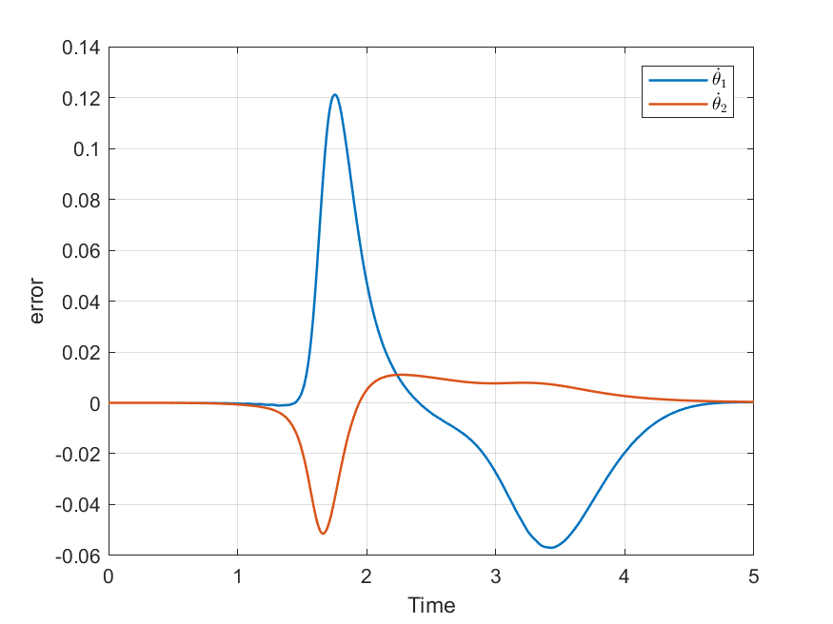

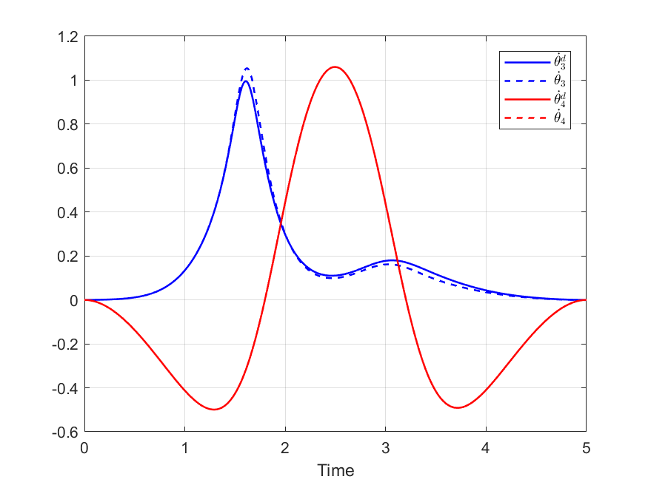 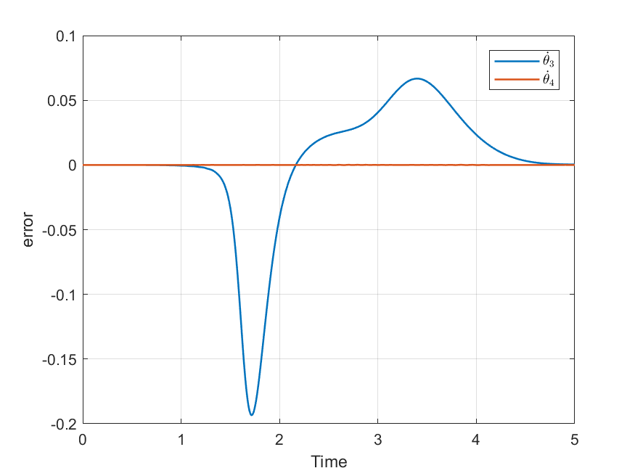

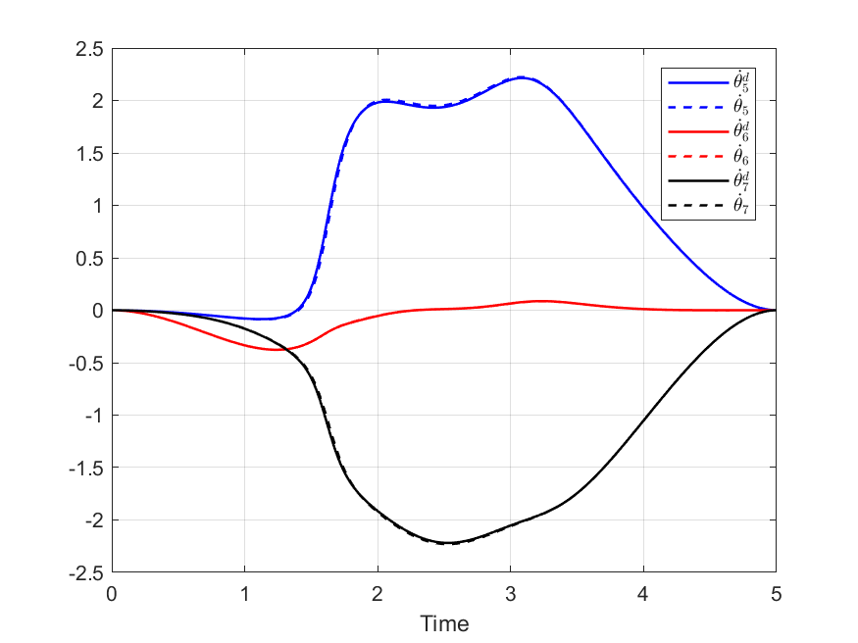 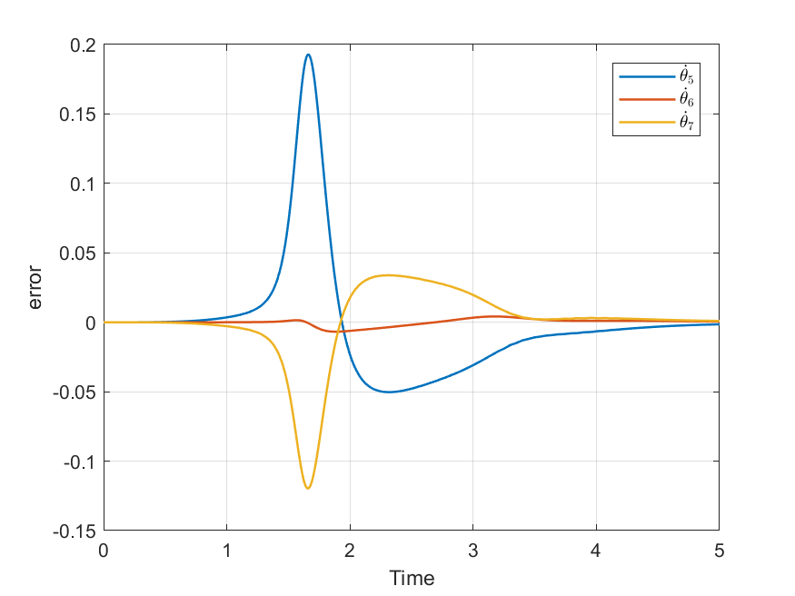

The input of the sliding controller is presented the figures below. The chattering still exist but it is much lower compared to case 1.

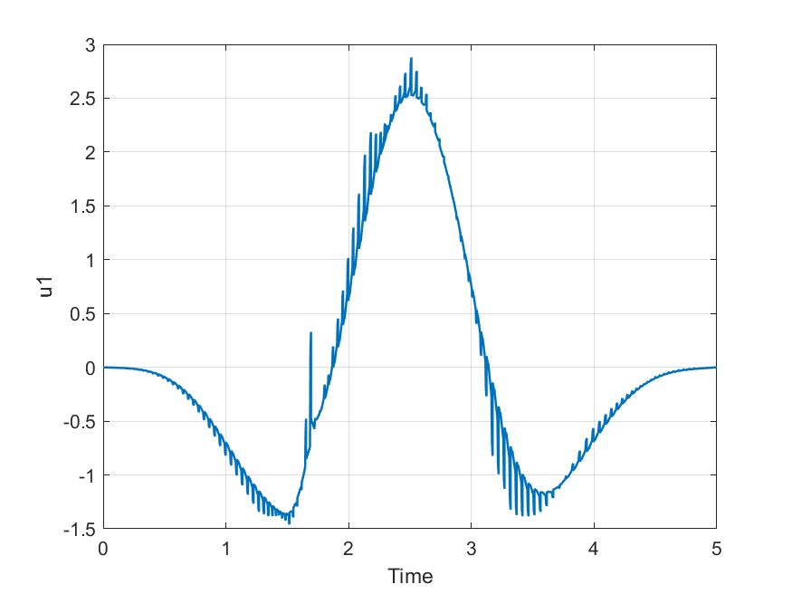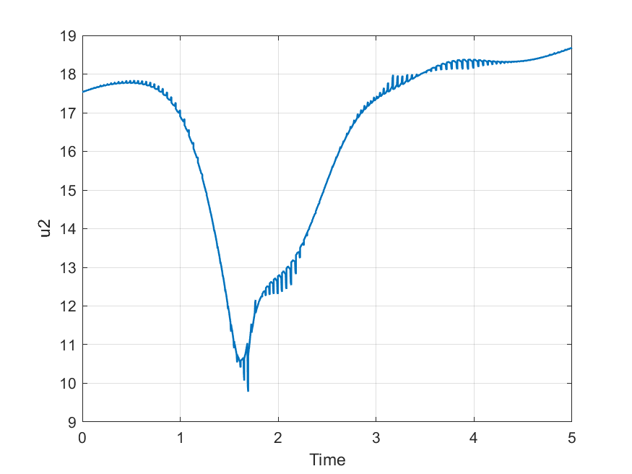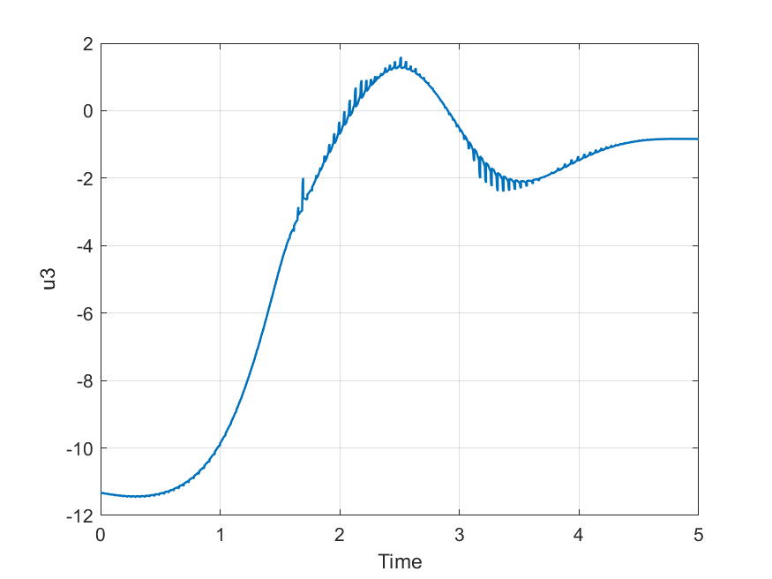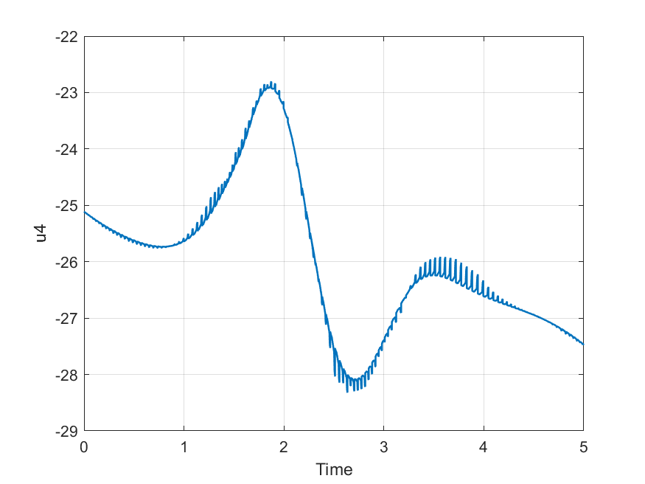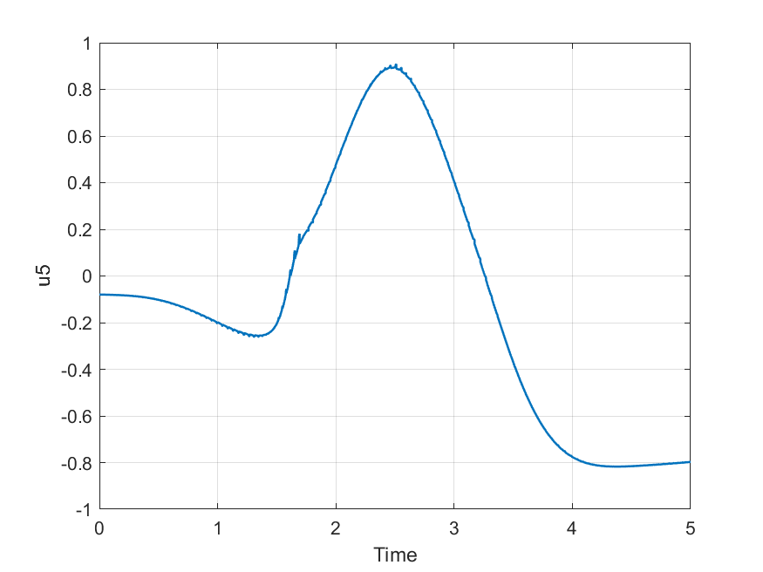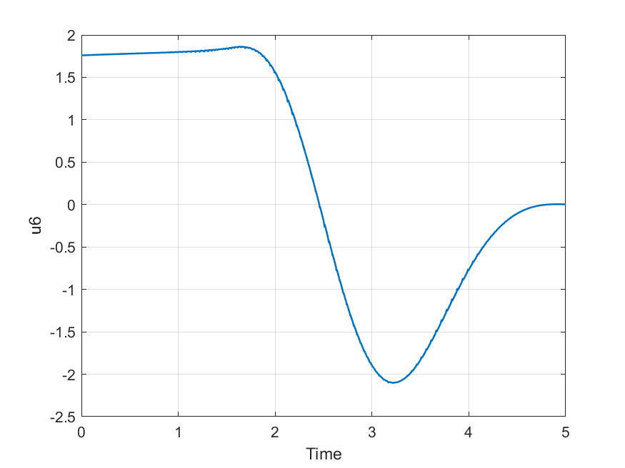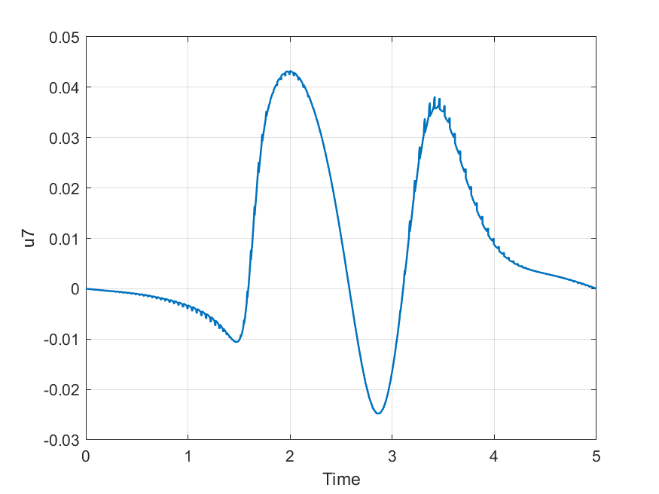

Finally, a comparison between the actual and the desired position and orientation of the end effector are shown below:

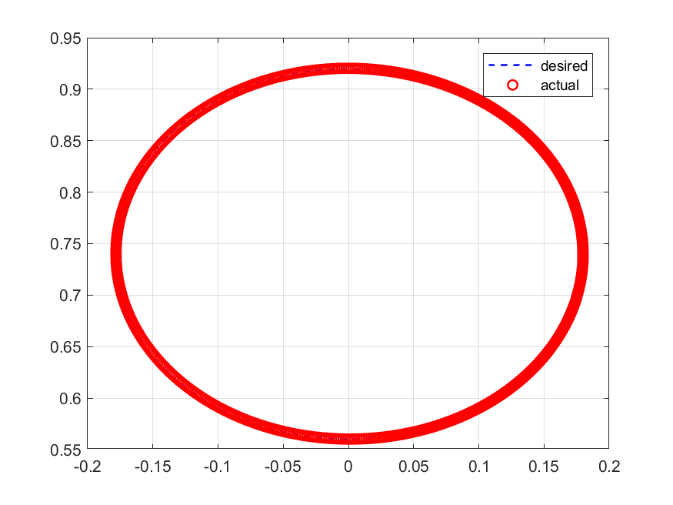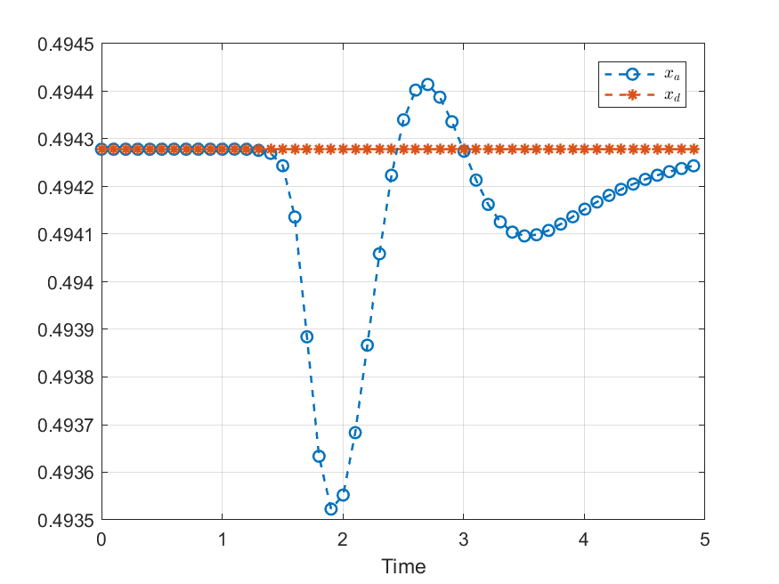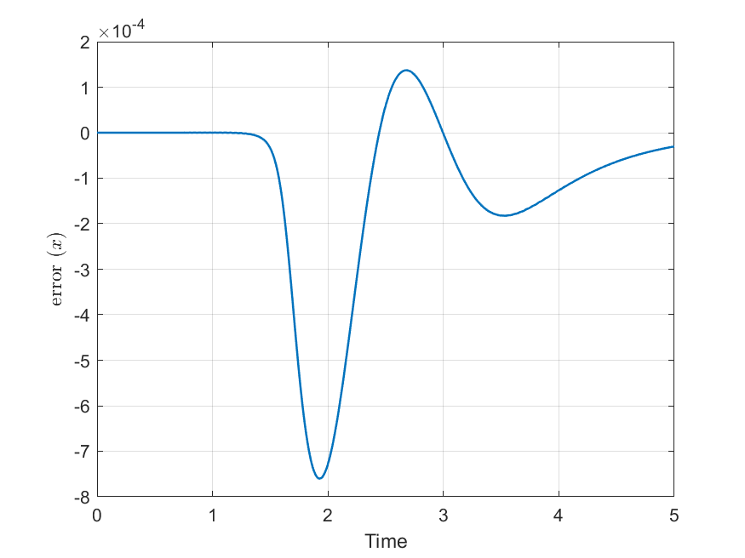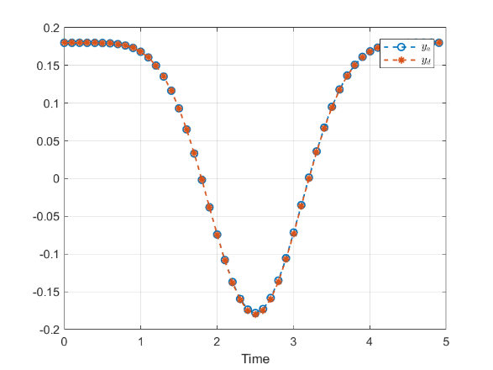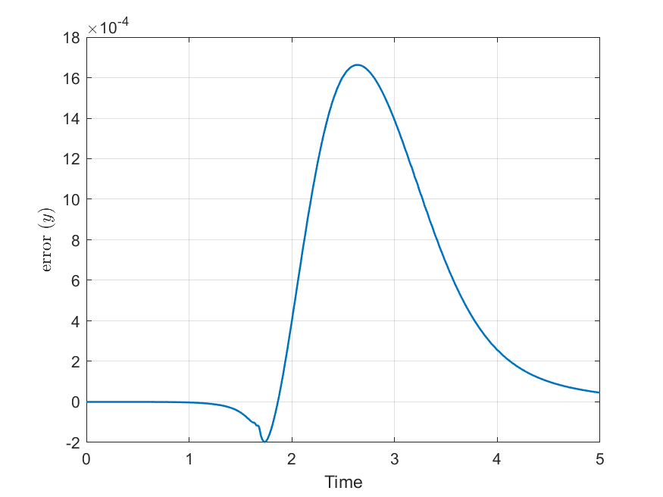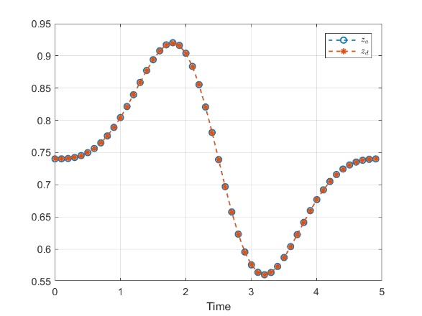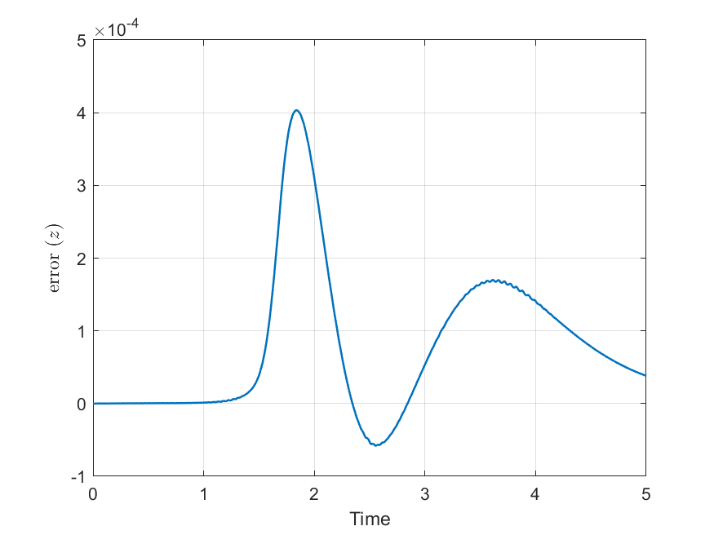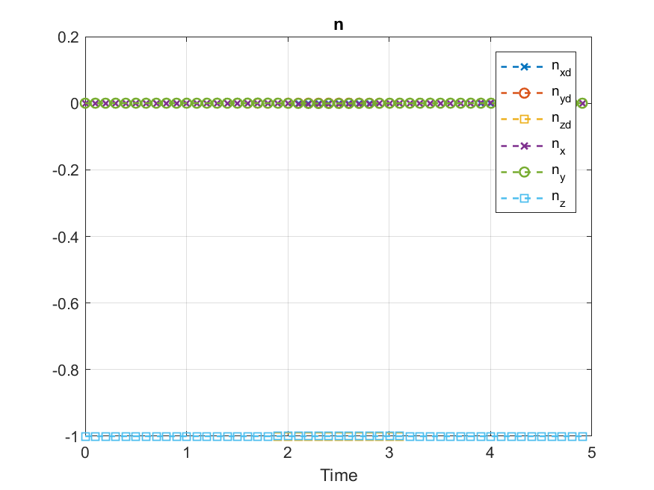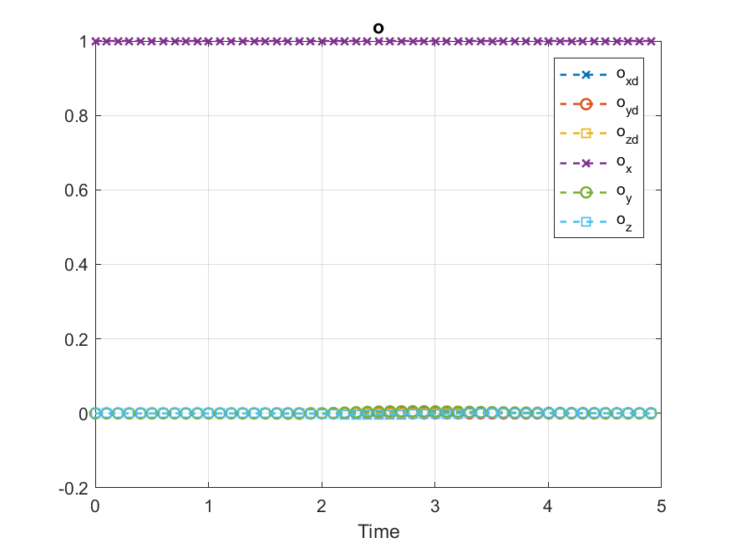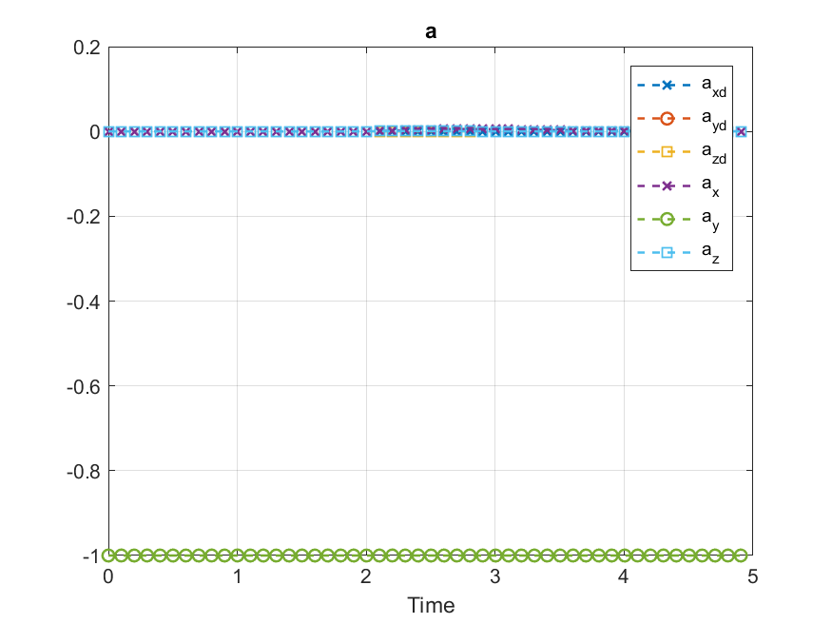

**Case 3: $$ϵ=0.7 λ=1.5 η=4$$**

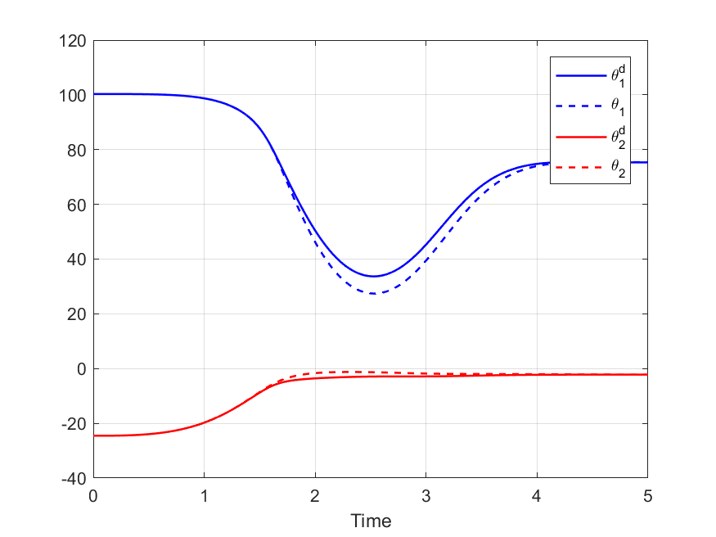 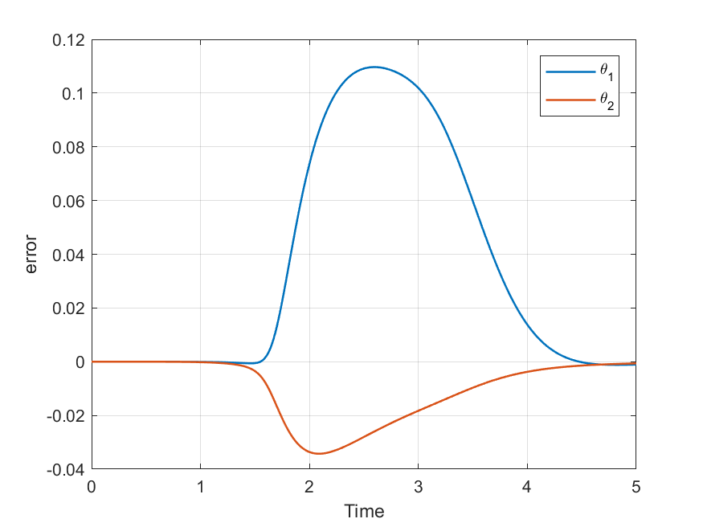

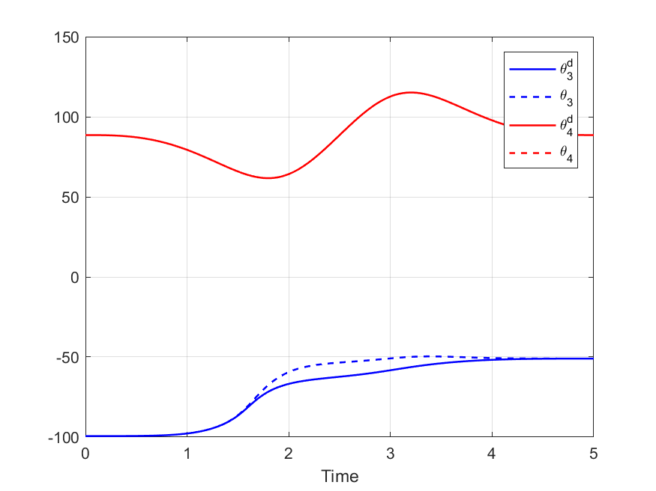 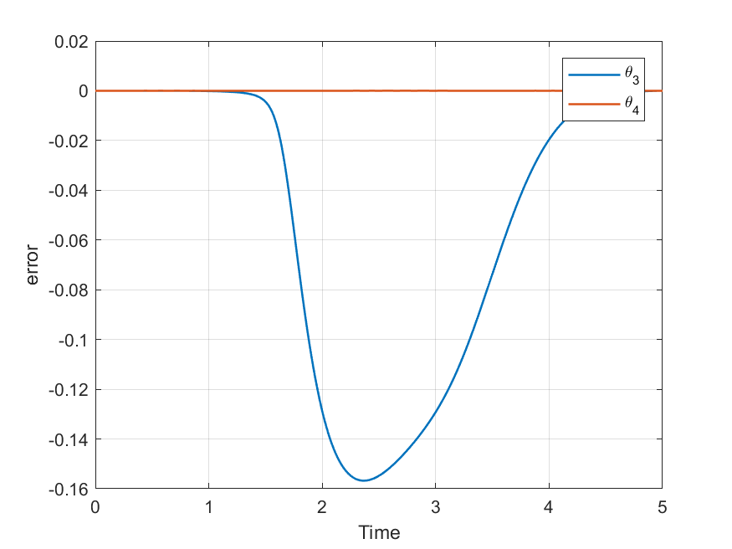

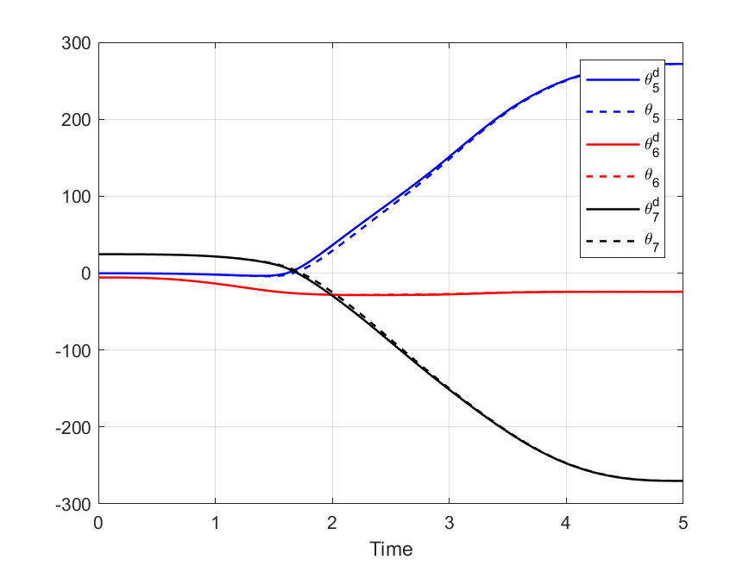 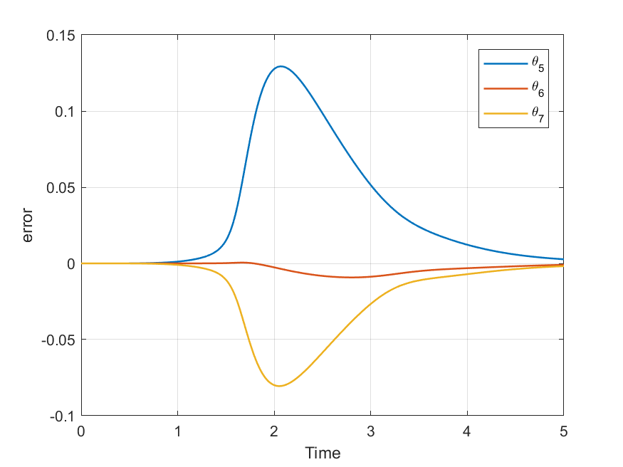

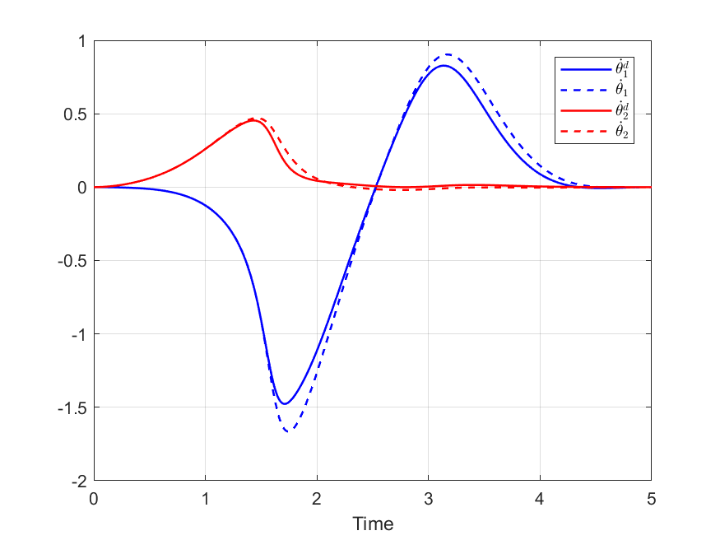 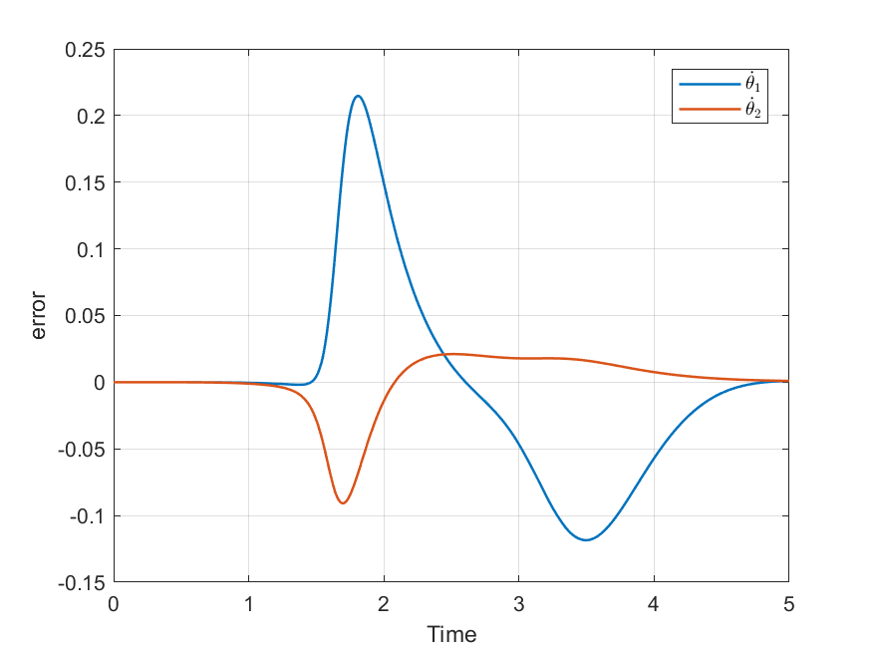

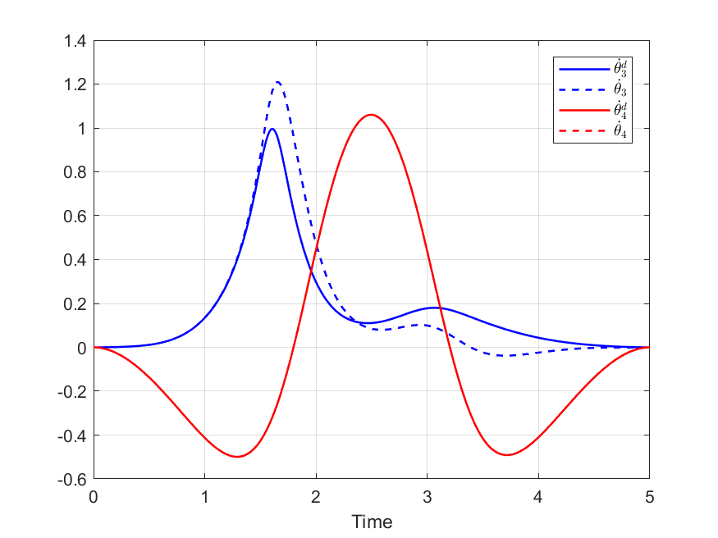 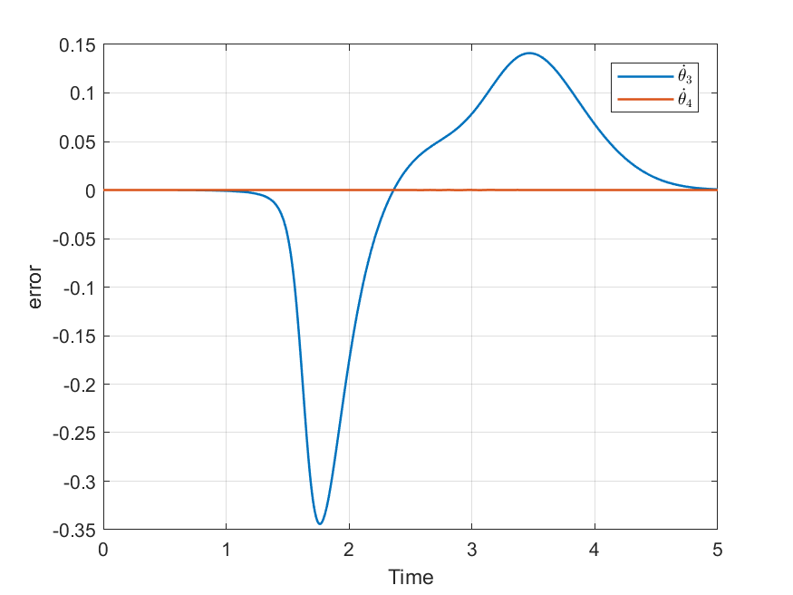

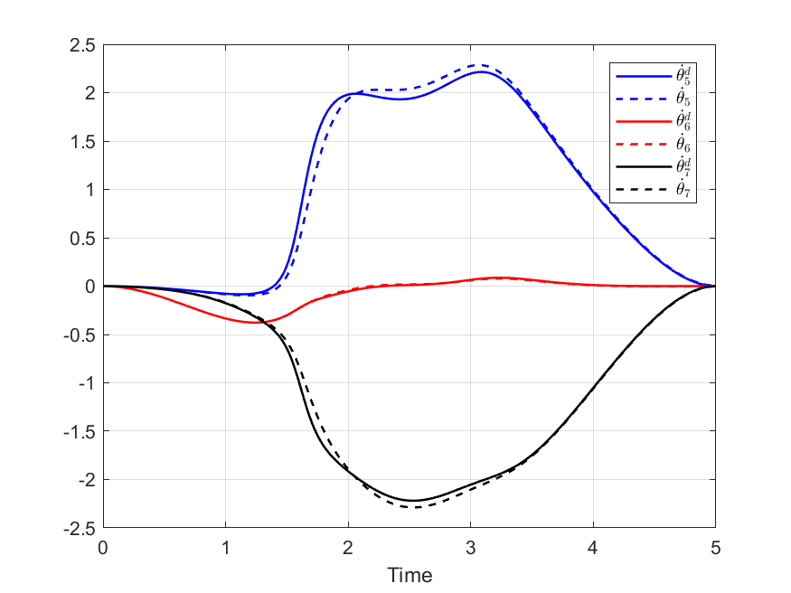 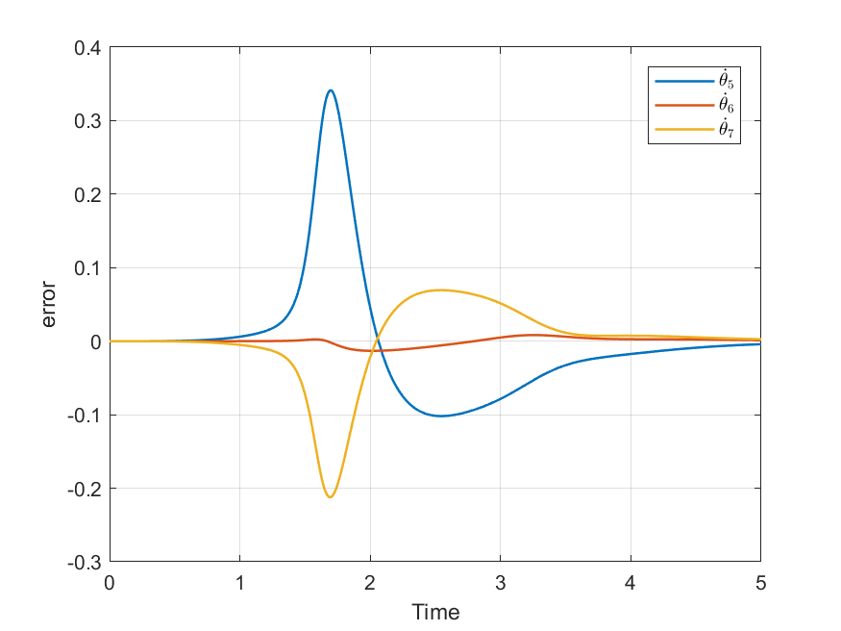

The input of the sliding controller is presented the figures below. The chattering still exist but it is much lower compared to case 2.

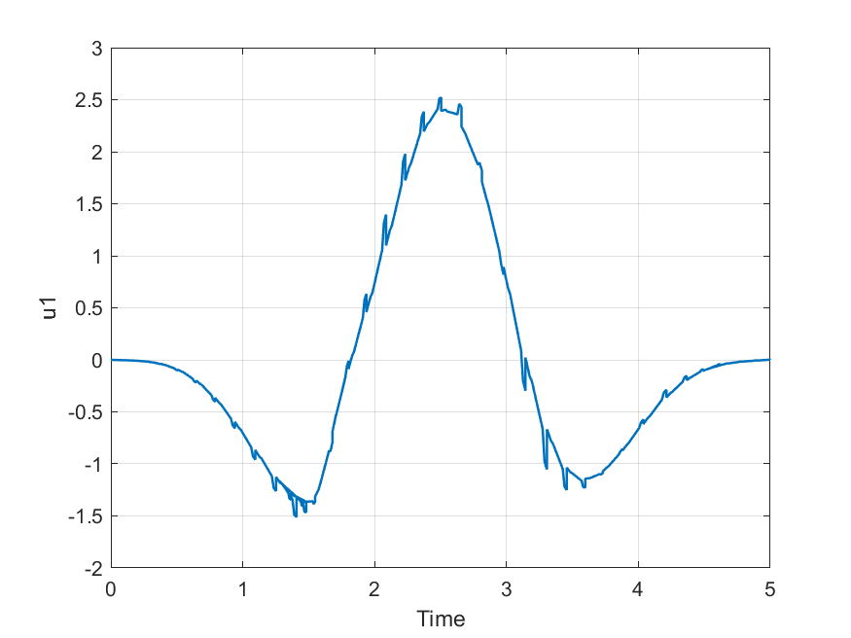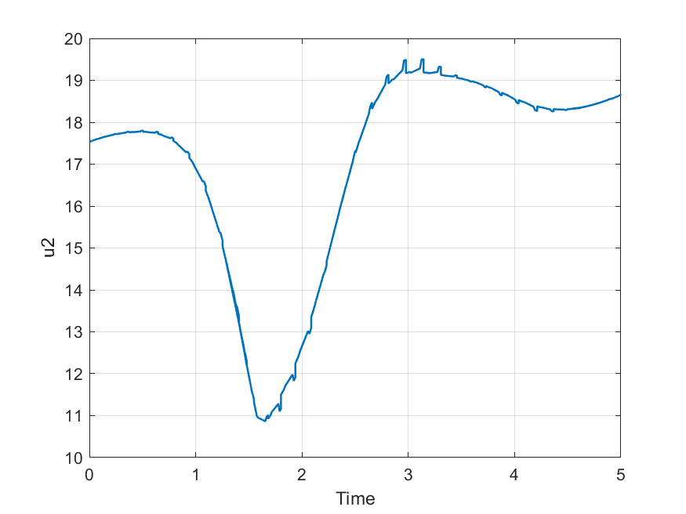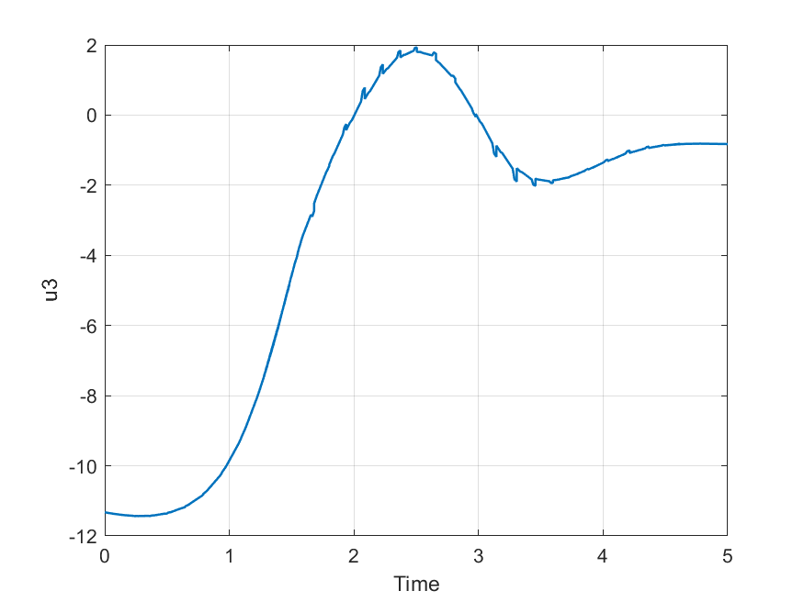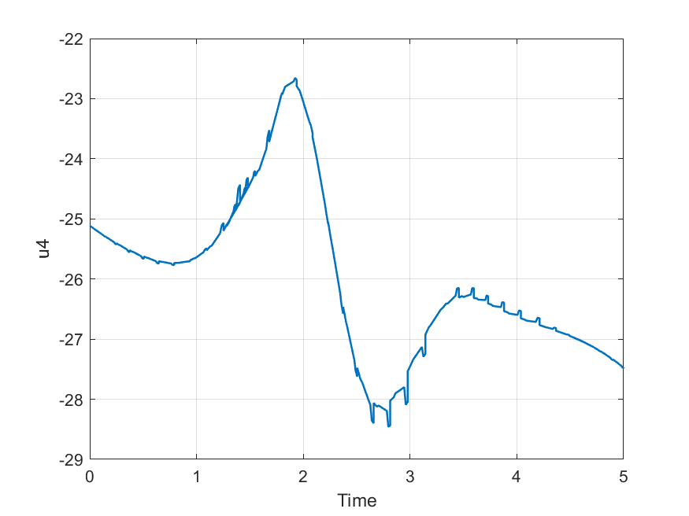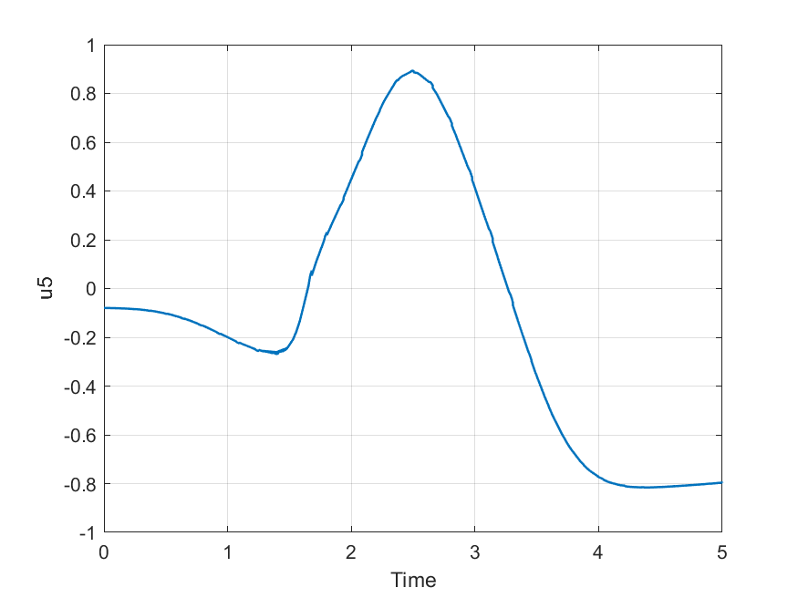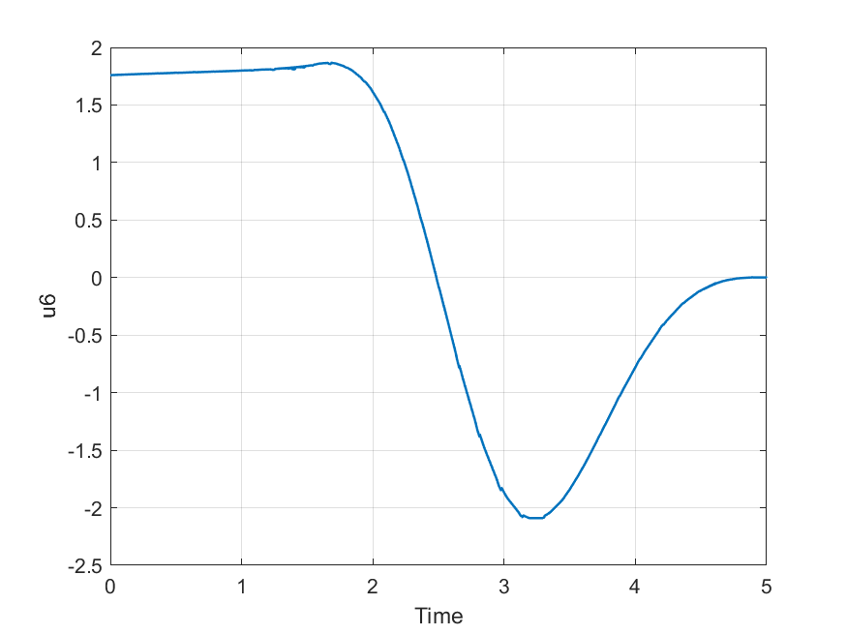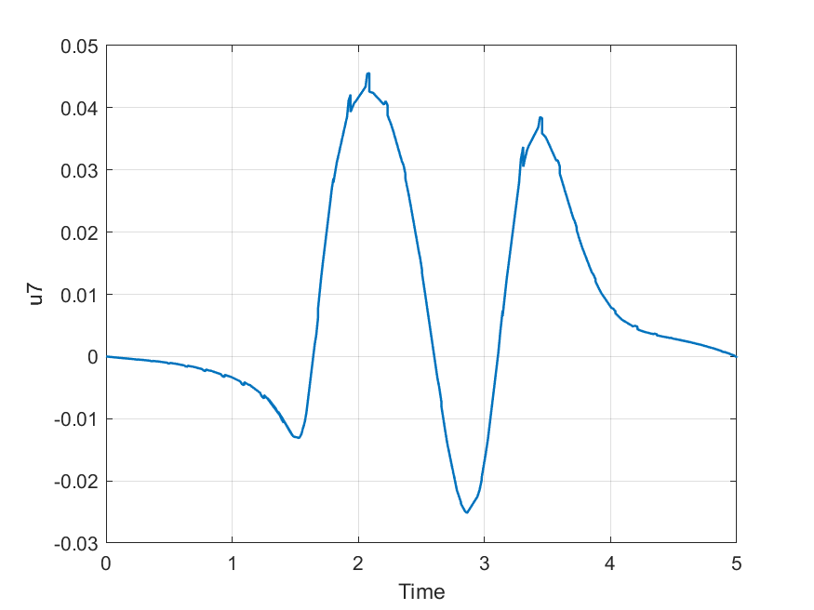

Finally, a comparison between the actual and the desired position and orientation of the end effector are shown below:

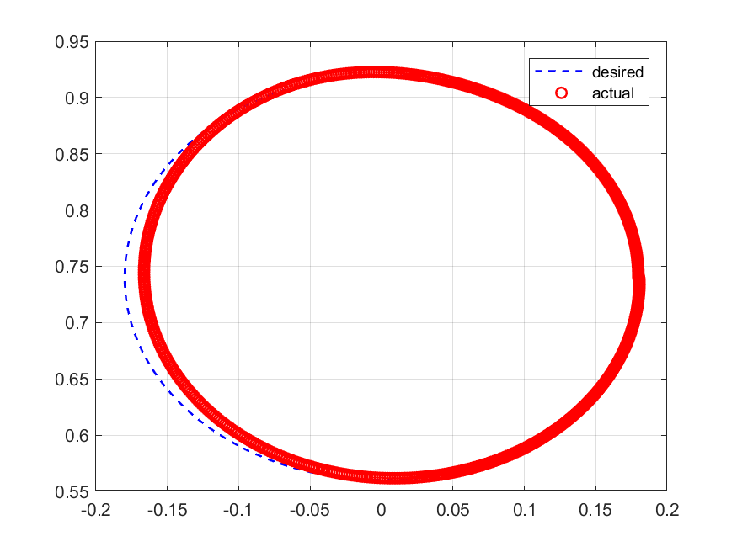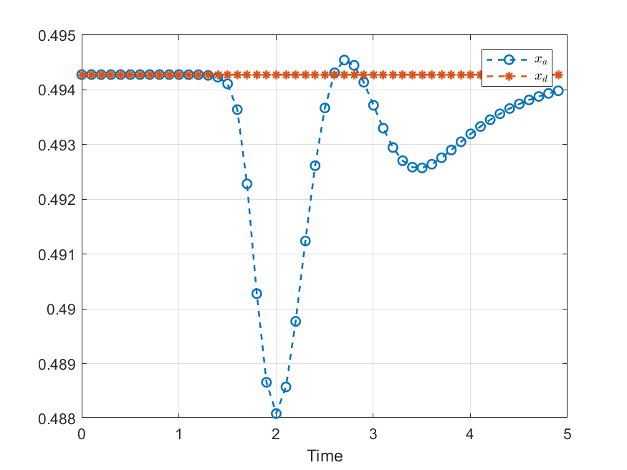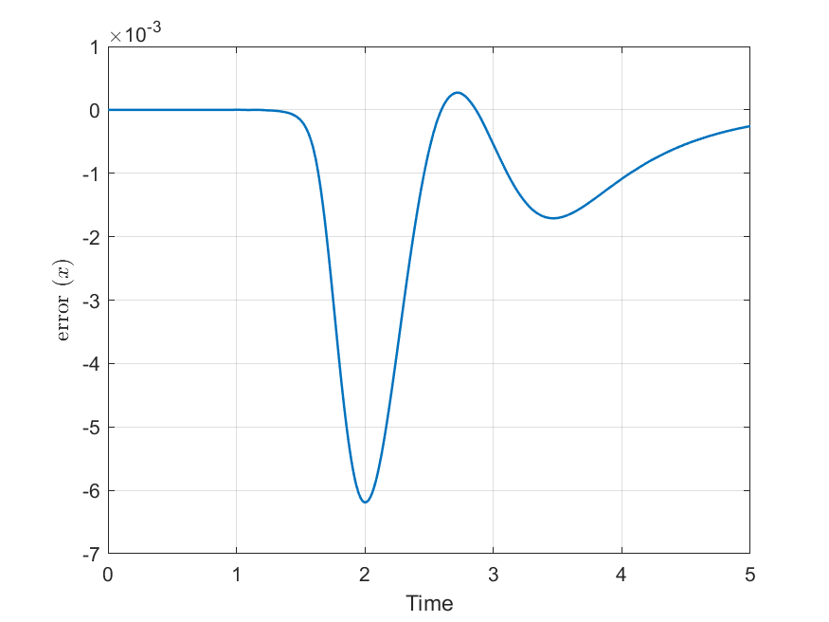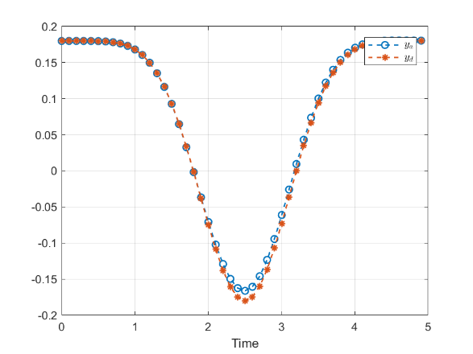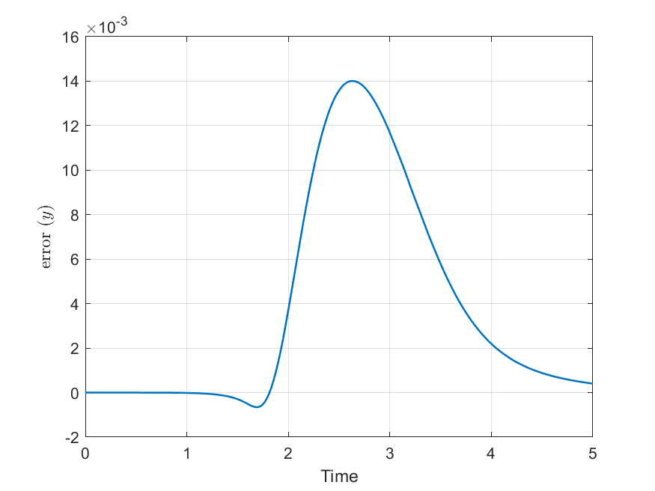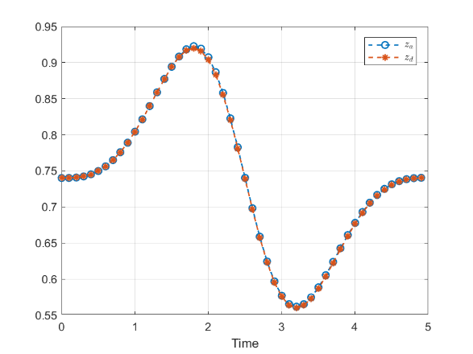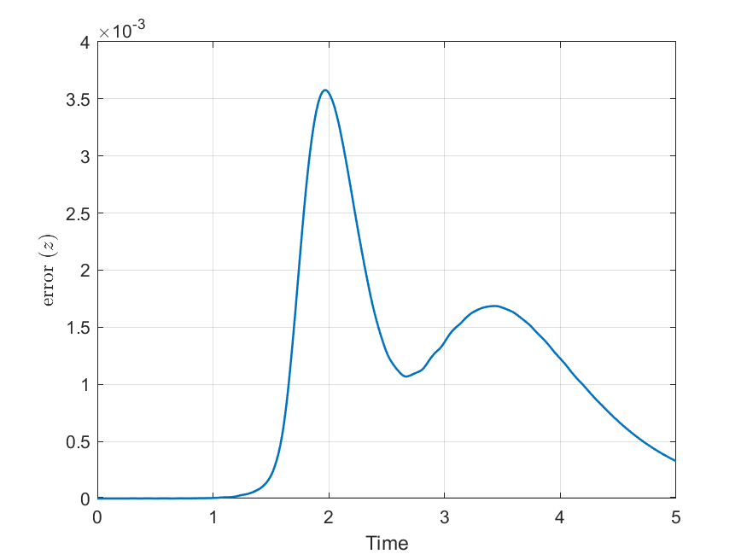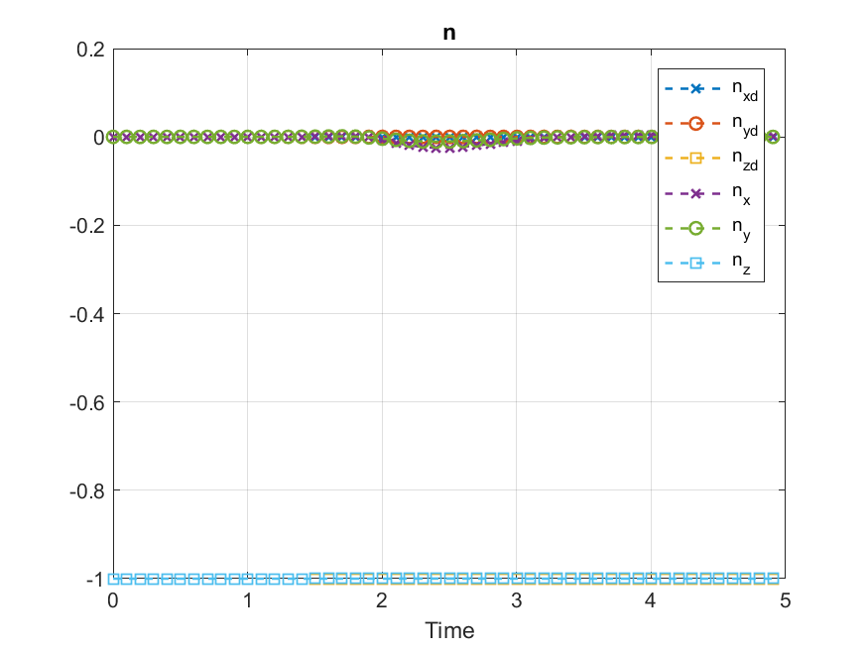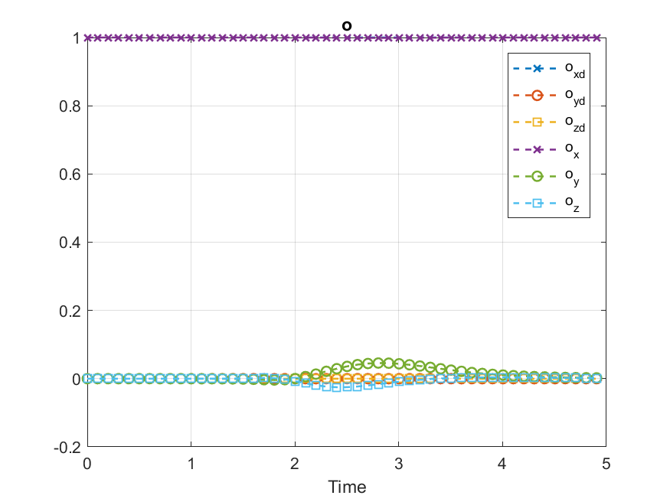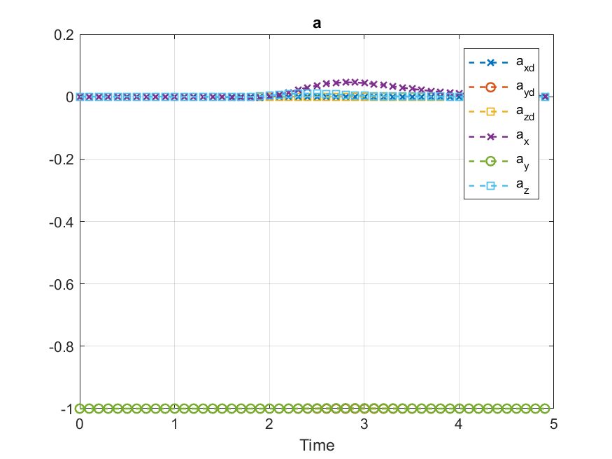

**Case 4: $$ϵ=5.0 λ=1.5 η=10$$**

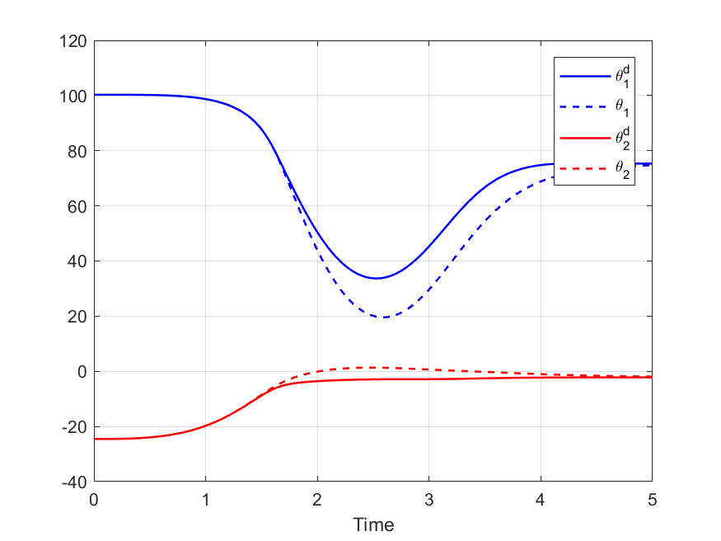 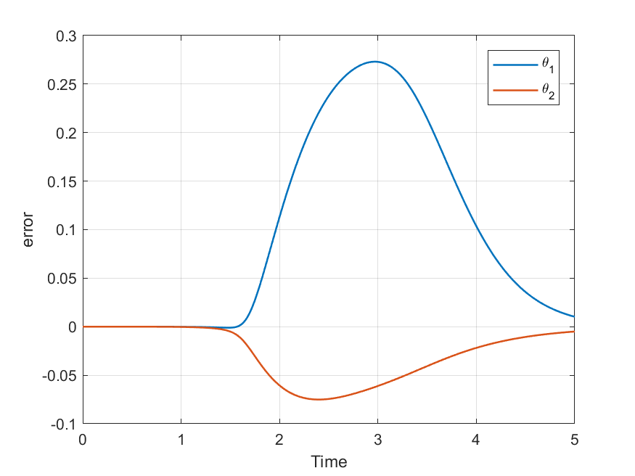

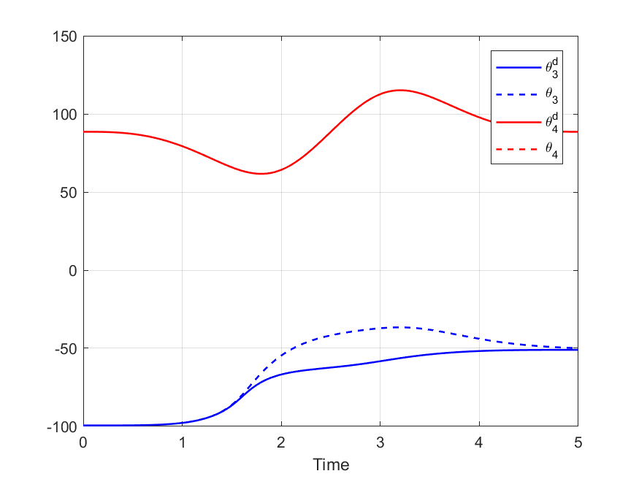 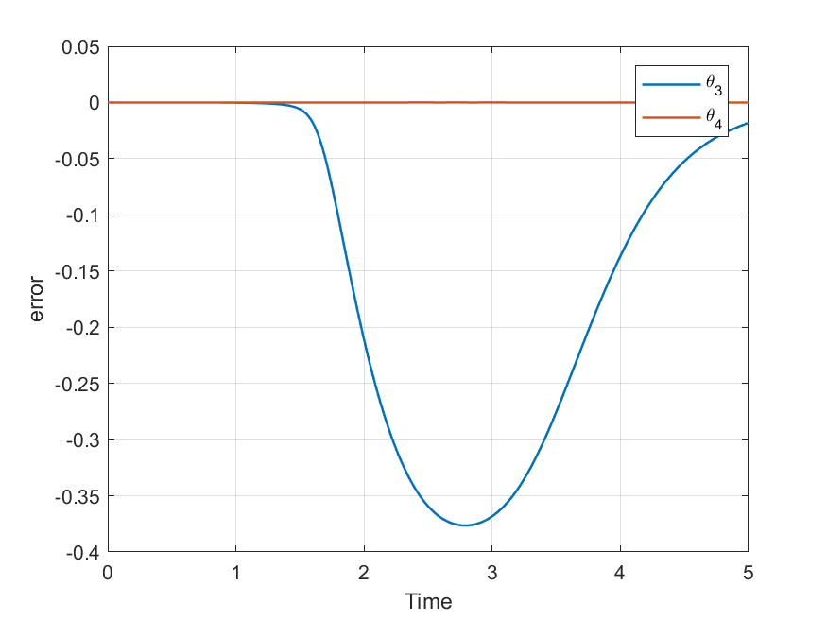

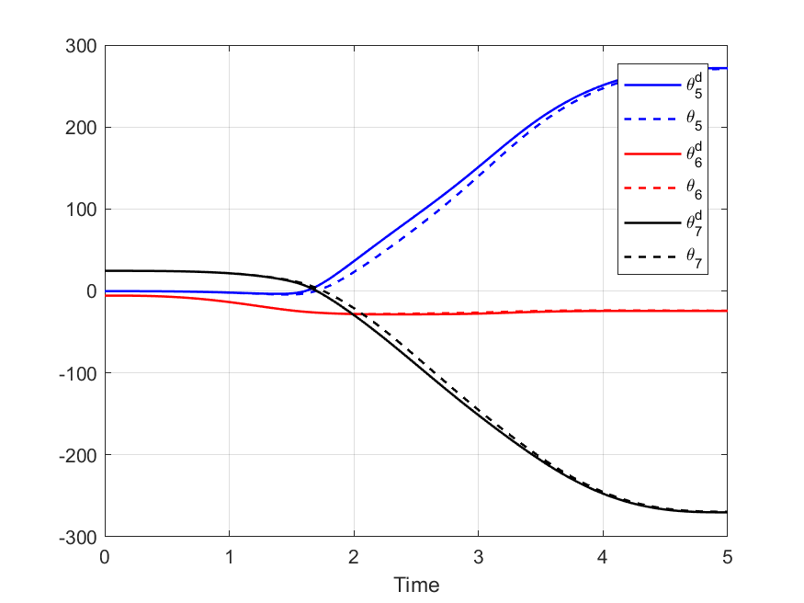 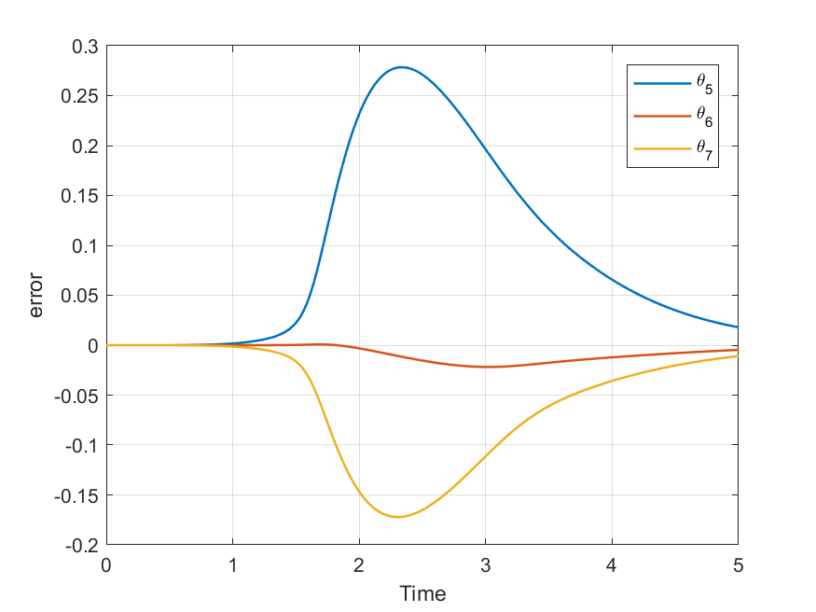

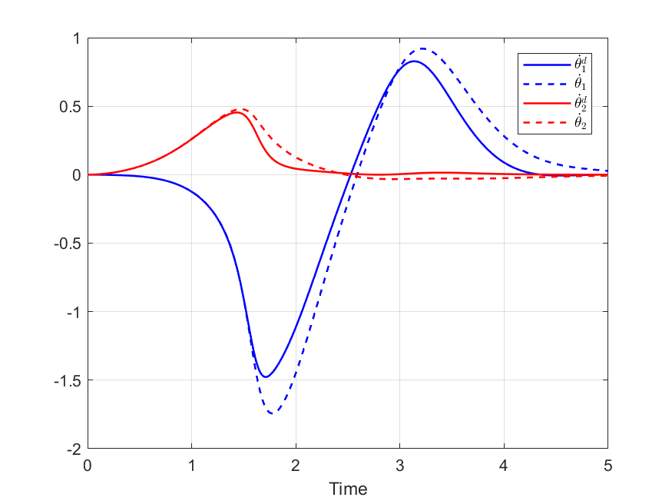 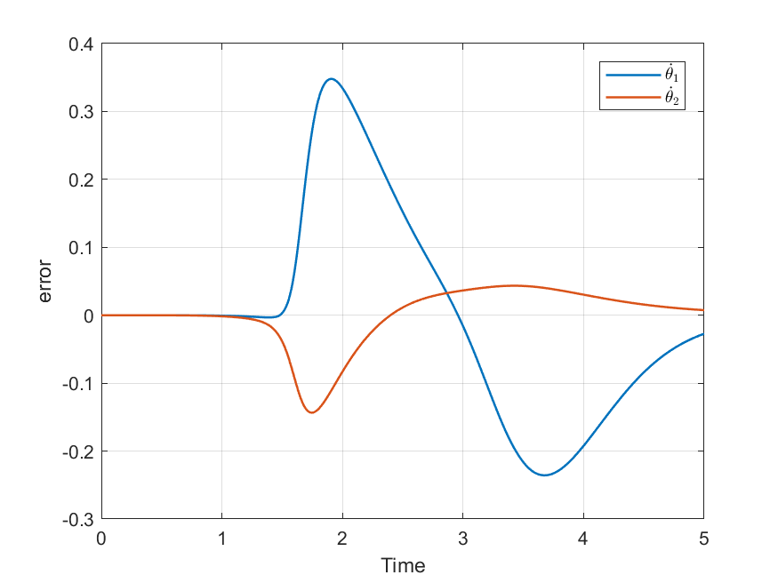

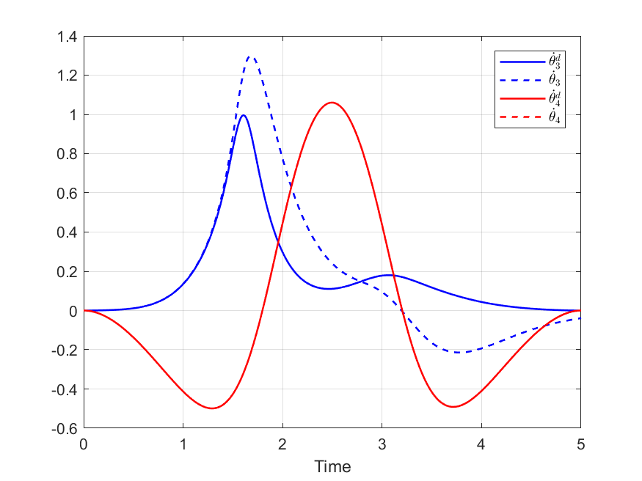 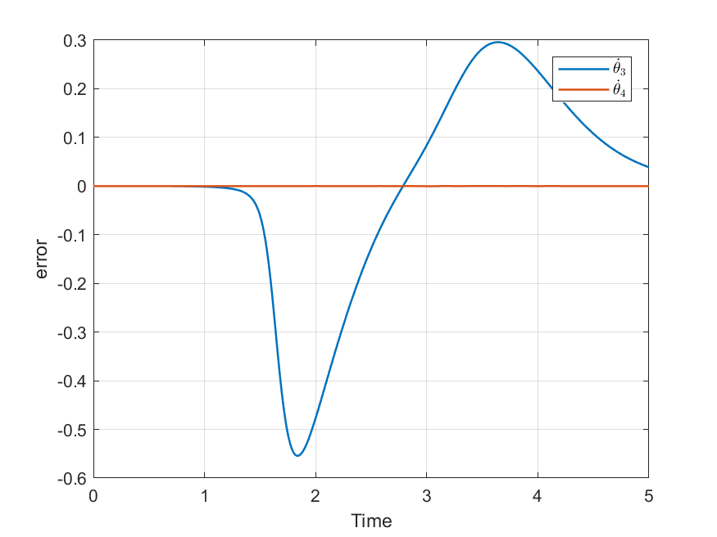

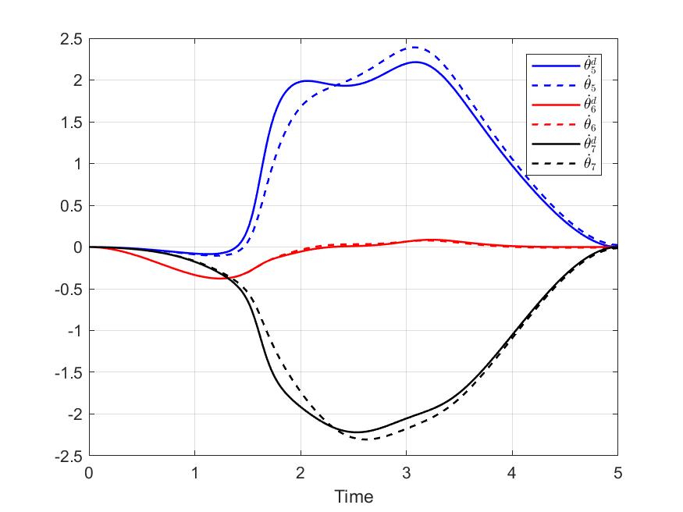 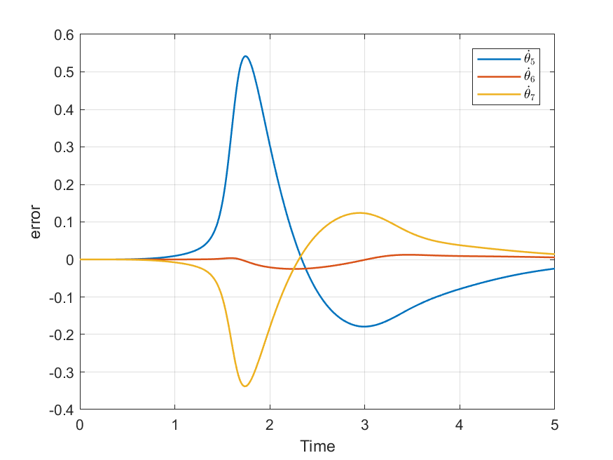

The input of the sliding controller is presented the figures below. The chattering still exist but it is much lower compared to case 3.

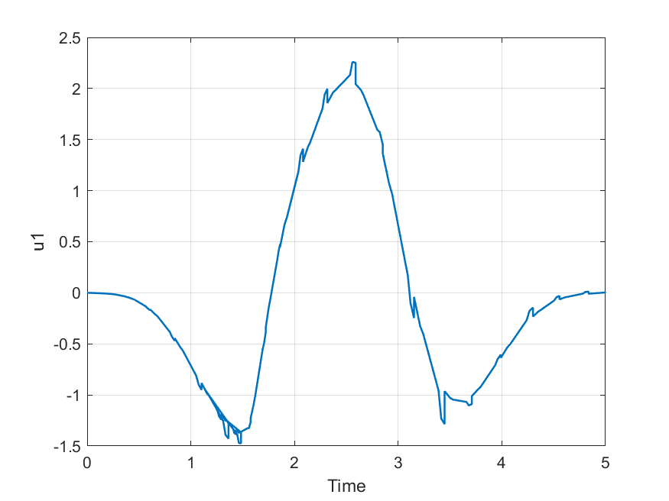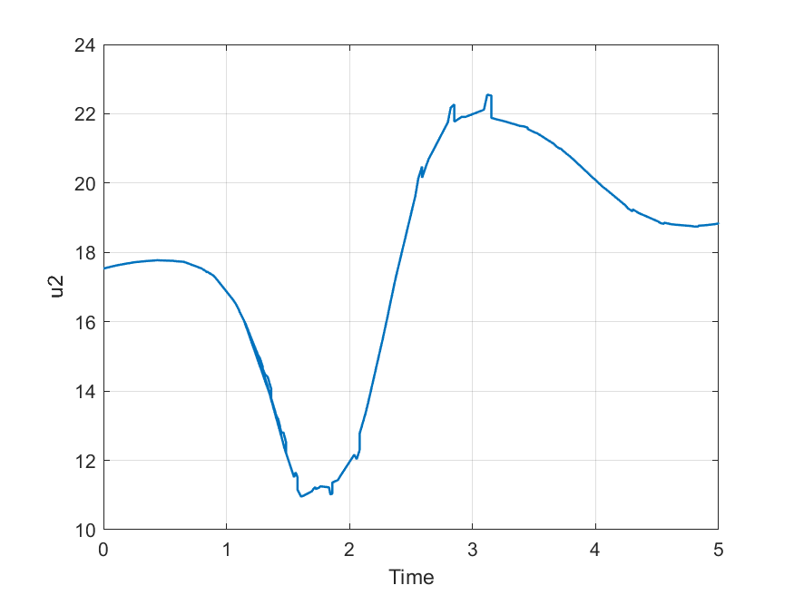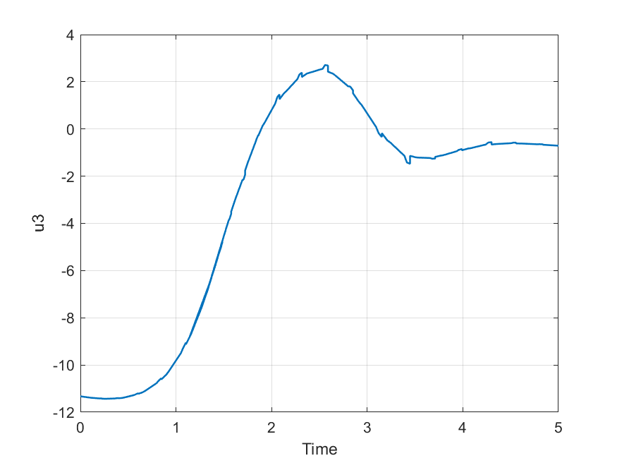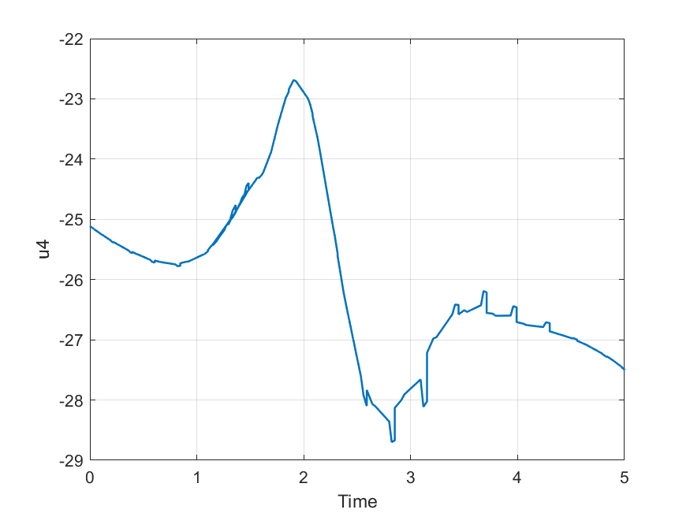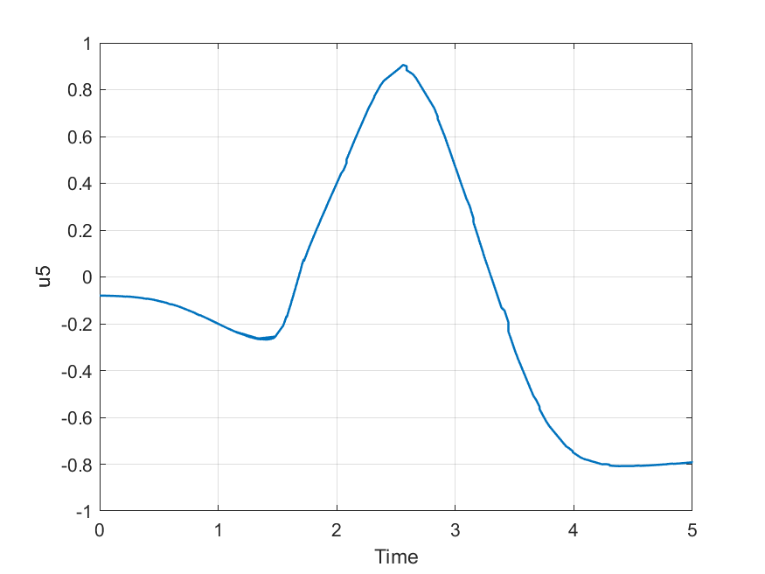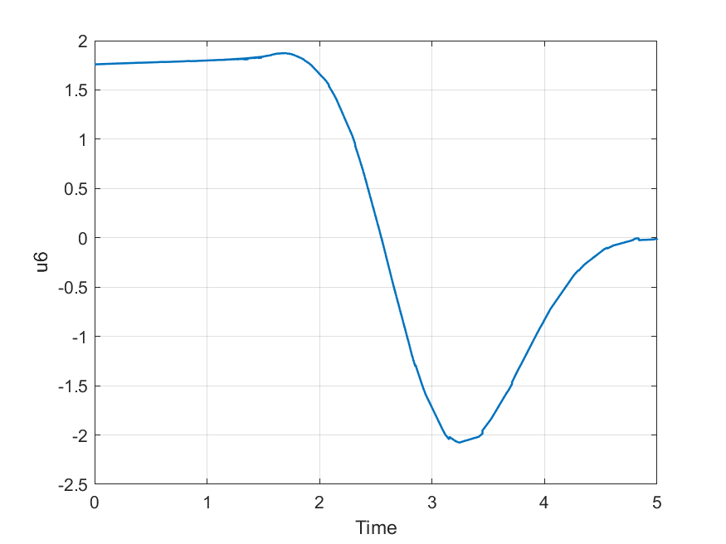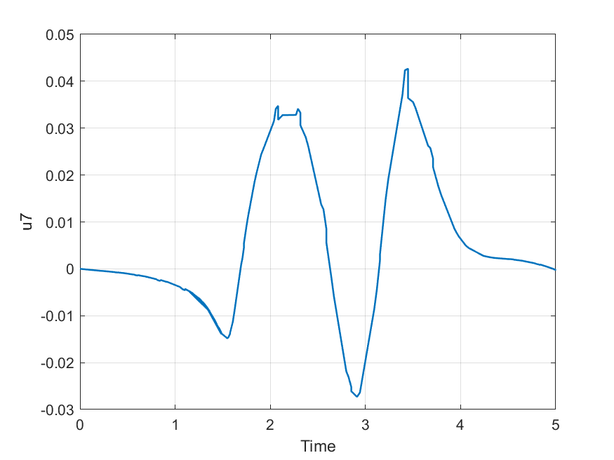

Finally, a comparison between the actual and the desired position and orientation of the end effector are shown below:

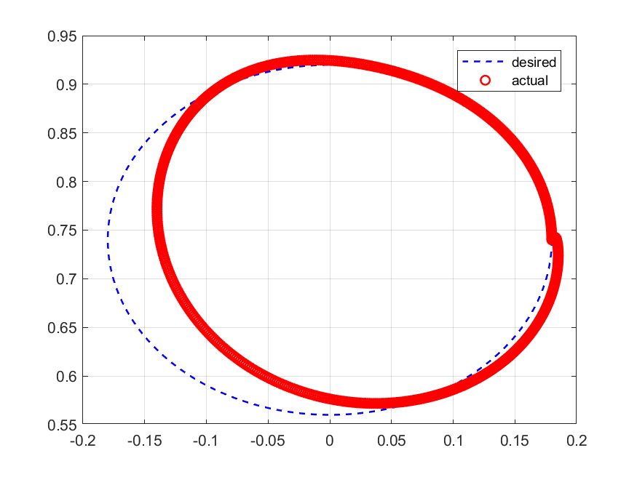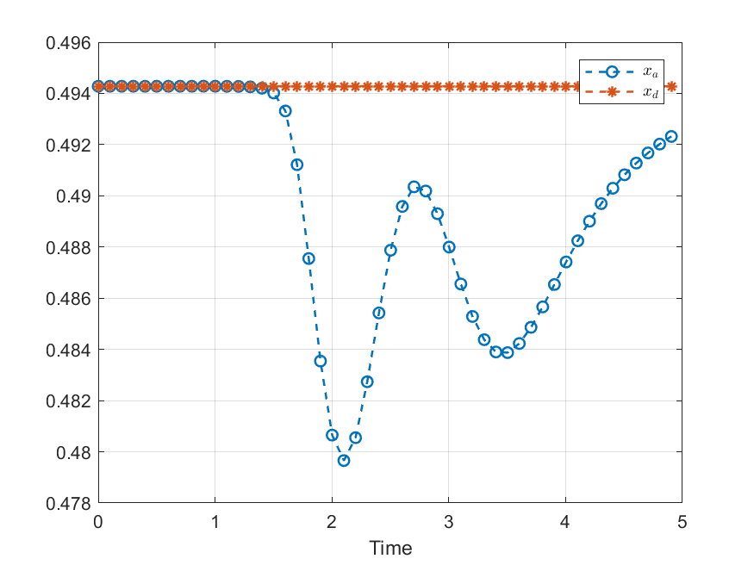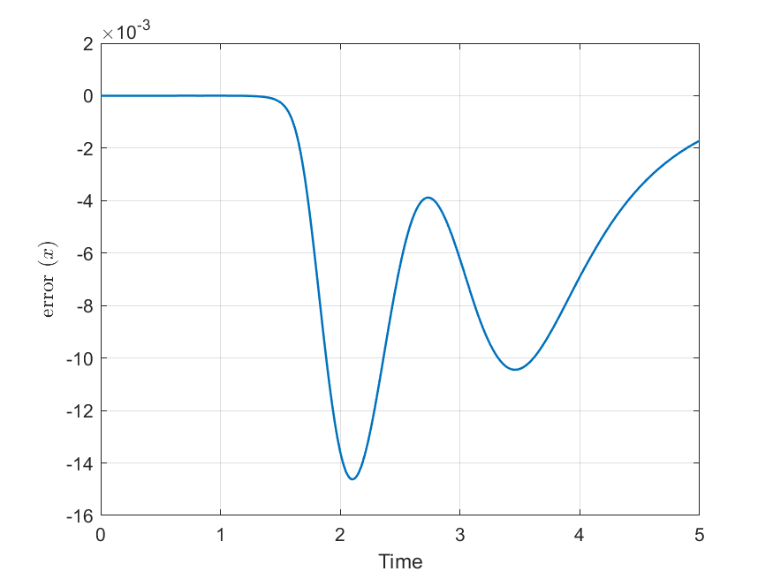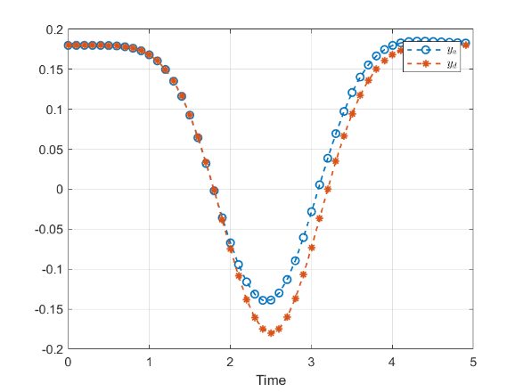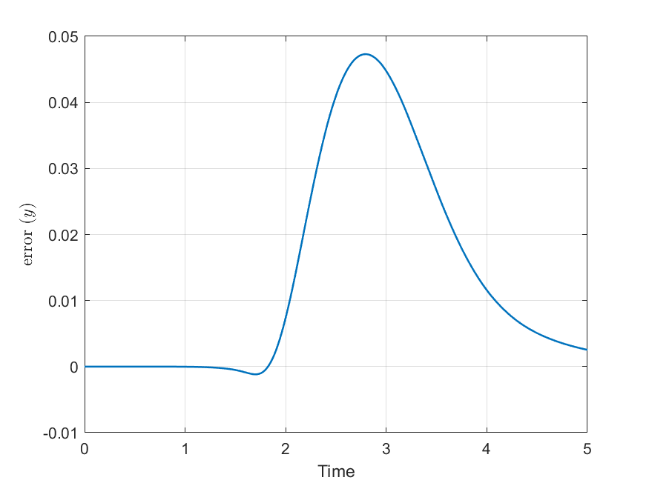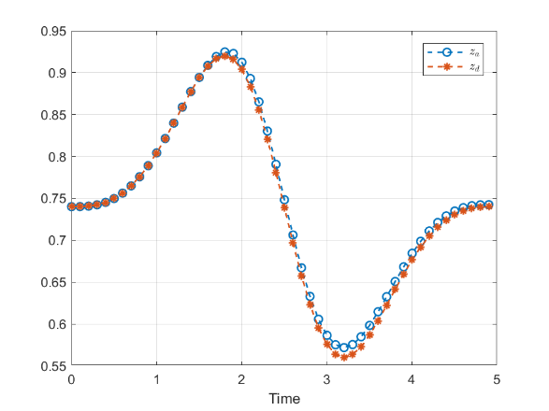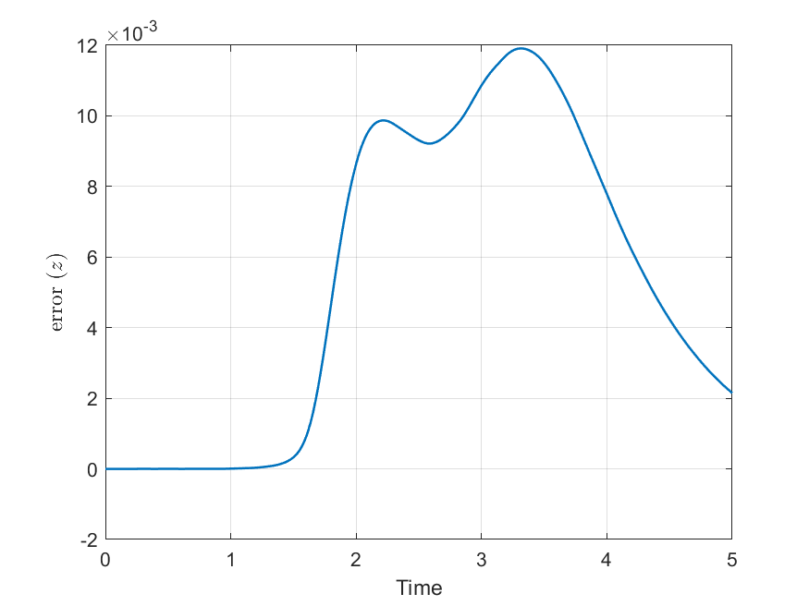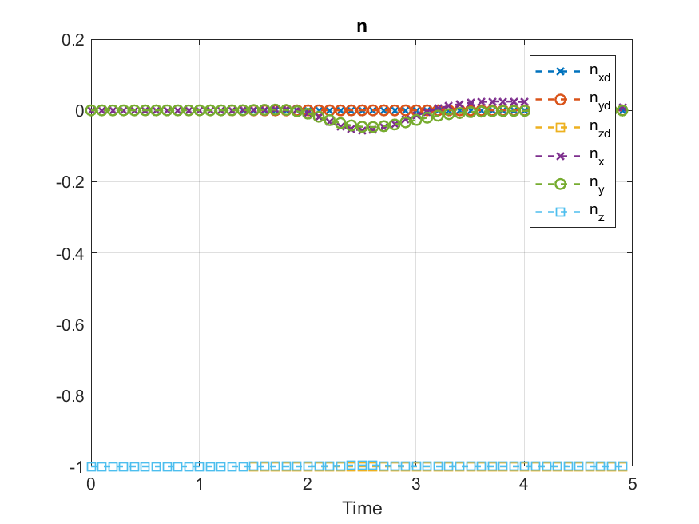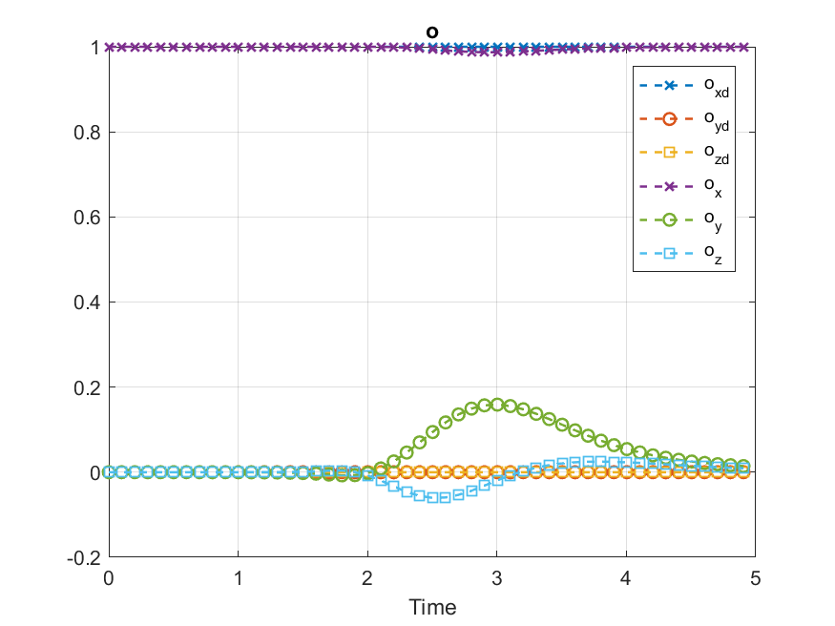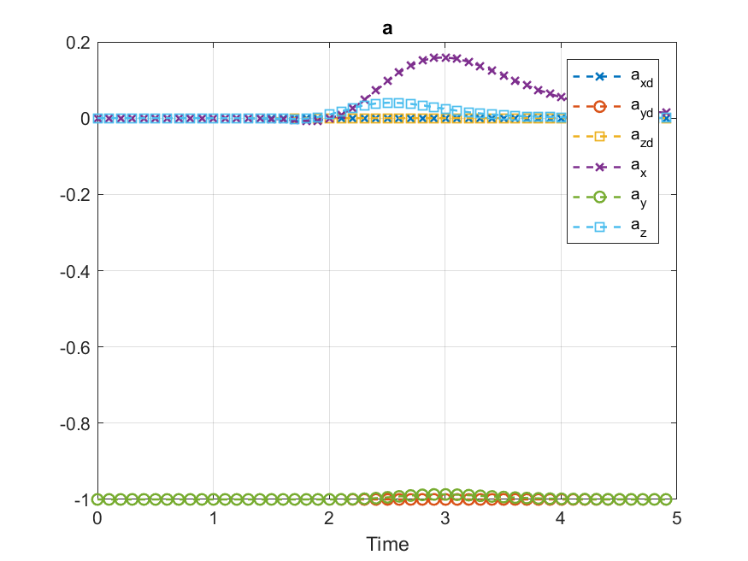

**Conclusion**

In this project, iiwa 7 R800 robotic arm (7 degree of freedom manipulator) was selected for modeling and control. The kinematic modeling was derived for any set of joint variable. The dynamical model was derived symbolically. Then a proposed trajectory was tested for singularity. A circular trajectory was then selected to be tracked by the end effector with a fixed orientation. Using the desired trajectory, an inverse solution was found for each joint variable along with the velocity and the acceleration. Finally, a sliding control was used to achieve the desired values. Error of each variable was compared. Results indicated a good tracking using the sliding control, however chattering problem was observed. Increasing $ϵ$ helped in eliminating the chattering problem to an acceptable extend but the error between the actual and desired was increased. Further investigation should consider: uncertainty, friction of joints, off diagonal mass moment of inertia.

**Appendix**

MATLAB Codes:

|  |
| --- |
| %% Solving the Inverse Kinematic problem for iiwa 7 arm manipulator  % Turki Haj Mohamad  % Villanova University  % 5/8/2018    %% cleaning  clear  clc  close all  tic  %% Desired path  plot_flag_cartesian = 1; %plot desired trajectory flag  plot_flag_joint = 1; %plot joint variables  traj_case =1; % selecting the desired trajectory, two options  folder_name = 'Figures_traj1'  fname1 = 'C:\Users\Admin\Dropbox (VCADS)\1SCH\Spring 2018\Robatics\Project term\iiwa 7\Matlab code\Desired_joints_inverse\';  fname = strcat(fname1,folder_name);  ifig = 0;  %% Desired Trajectory  Desired_creator;  %% Inverse Kinematics using Fsolve  Inverse_position    %% Inverse solution --> Forward solution  Forward_solution;    %% Inverse velocity and acceleration  Inverse_velocity; |
| %% Trajectory planning  % Turki Haj Mohamad  % Villanova University  % 5/8/2018  %% Initiating  global r xc yc zc a  DH_table  %% Trajectory specs  num_points = 1000;  t0 = 0; % start time  tf = 5; % final time  %% Trajectory options  if traj_case ==1  r = (L3+L4)*sin(20*pi/180); % radius  xc = (L3+L4)*cos(20*pi/180); % strat point X  yc = 0;  zc = L1+L2;  else  r = 0.2;  xc = (L3+L4); % strat point X  yc = -r;  zc = L1+L2;  end  %% Boundary Condition problem  % this equations to describe a circle, describing x and y using alpha  alpha_0 = 0; % initial angle  alpha_f = 2*pi; %final angle    alpha_dot0 = 0; % initial velocity  alpha_dotf = 0; %final velocity    alpha_ddot0 = 0; % initial acc.  alpha_ddotf = 0; %final acc.    a=coeff_poly5(t0,tf,alpha_0,alpha_f,alpha_dot0,alpha_dotf,alpha_ddot0,alpha_ddotf);  %% Desired end effector x,y,z and orientation  time = linspace(t0,tf,num_points);  disp_v = [1:20:length(time)];  % position  X = xdes(time);  Xdot = xdes_dot(time);  Xddot = xdes_ddot(time);    Y = ydes(a,time);  Ydot = ydes_dot(a,time);  Yddot = ydes_ddot(a,time);    Z = zdes(a,time);  Zdot = zdes_dot(a,time);  Zddot = zdes_ddot(a,time);      % orientation  nx = 0*ones(1,length(time));  ny = 0*ones(1,length(time));  nz = -1*ones(1,length(time));    ox = 1*ones(1,length(time));  oy = 0*ones(1,length(time));  oz = 0*ones(1,length(time));    ax = 0*ones(1,length(time));  ay = -1*ones(1,length(time));  az = 0*ones(1,length(time));    n_t = [nx;ny;nz];  o_t = [ox;oy;oz];  a_t = [ax;ay;az];    %% plotting and visulization  if plot_flag_cartesian == 1;  plot_desired  end |
| figure  plot3(X,Y,Z,'-k','linewidth',1.2)  xlabel('x_d'),ylabel('y_d'),zlabel('z_d')  grid on  ifig = ifig+1;  filename = strcat('fig',num2str(ifig));  saveas(gca, fullfile(fname, filename), 'png');      figure  plot(Y,Z,'-k','linewidth',1.2)  xlabel('y_d'),ylabel('z_d')  grid on  ifig = ifig+1;  filename = strcat('fig',num2str(ifig));  saveas(gca, fullfile(fname, filename), 'png');      figure  plot(time(disp_v),X(disp_v),'-','linewidth',1.2)  hold on  plot(time(disp_v),Xdot(disp_v),'--o','linewidth',1.2)  hold on  plot(time(disp_v),Xddot(disp_v),'--*','linewidth',1.2)  legend('position','velocity','acceleration')  xlabel('Time')  title('x_d')  grid on  ifig = ifig+1;  filename = strcat('fig',num2str(ifig));  saveas(gca, fullfile(fname, filename), 'png');    figure  plot(time(disp_v),Y(disp_v),'linewidth',1.2)  hold on  plot(time(disp_v),Ydot(disp_v),'--o','linewidth',1.2)  hold on  plot(time(disp_v),Yddot(disp_v),'--*','linewidth',1.2)  legend('position','velocity','acceleration')  xlabel('Time')  title('y_d')  grid on  ifig = ifig+1;  filename = strcat('fig',num2str(ifig));  saveas(gca, fullfile(fname, filename), 'png');      figure  plot(time(disp_v),Z(disp_v),'linewidth',1.2)  hold on  plot(time(disp_v),Zdot(disp_v),'--o','linewidth',1.2)  hold on  plot(time(disp_v),Zddot(disp_v),'--*','linewidth',1.2)  legend('position','velocity','acceleration')  xlabel('Time')  title('z_{d}')  grid on  ifig = ifig+1;  filename = strcat('fig',num2str(ifig));  saveas(gca, fullfile(fname, filename), 'png'); |
| % Initial guess assigning depending on the trajectory option  if traj_case ==1  theta0 = zeros(1,7);  theta0(1) = 20*pi/180;  theta0(4)=pi/2;  else  theta0 = zeros(1,7);  theta0(4)=pi/2;  end    Theta = zeros(7,length(time));    for i=1:length(time)  cost_value(:,i) = fcost4(theta0,X(i),Y(i),Z(i),n_t(:,i),o_t(:,i),a_t(:,i));  option = optimset('Algorithm','levenberg-marquardt');  fun = @(theta) fcost4(theta,X(i),Y(i),Z(i),n_t(:,i),o_t(:,i),a_t(:,i));  theta_new = fsolve(fun,theta0,option);  theta0 = theta_new;  Theta(:,i)=theta0;  end      toc  if plot_flag_joint ==1  plot_desired_joint  end |
| figure  plot(time,Theta(1,:)*180/pi,'b','linewidth',1.2)  hold on  plot(time,Theta(2,:)*180/pi,'r','linewidth',1.2)  grid on  legend('\theta_1','\theta_2')  ifig = ifig+1;  filename = strcat('fig',num2str(ifig));  saveas(gca, fullfile(fname, filename), 'png');      figure  plot(time,Theta(3,:)*180/pi,'b','linewidth',1.2)  hold on  plot(time,Theta(4,:)*180/pi,'r','linewidth',1.2)  grid on  legend('\theta_3','\theta_4')  ifig = ifig+1;  filename = strcat('fig',num2str(ifig));  saveas(gca, fullfile(fname, filename), 'png');      figure  plot(time,Theta(5,:)*180/pi,'b','linewidth',1.2)  hold on  plot(time,Theta(6,:)*180/pi,'r','linewidth',1.2)  hold on  plot(time,Theta(7,:)*180/pi,'k','linewidth',1.2)  grid on  legend('\theta_5','\theta_6','\theta_7')  ifig = ifig+1;  filename = strcat('fig',num2str(ifig));  saveas(gca, fullfile(fname, filename), 'png'); |
| pxd = zeros(1,length(time));  pyd = pxd;  pzd = pxd;    n_r = zeros(3,length(time));    o_r = n_r;    a_r = n_r;    for i=1:length(time)  v = Theta(:,i);  [pxd(i),pyd(i),pzd(i),n_r(:,i),o_r(:,i),a_r(:,i)] = ff_fun(v);  end    figure  plot(Y,Z,'b--','linewidth',1.2)  grid on  hold on  plot(pyd,pzd,'ro','linewidth',1.2)  legend('desired','actual')  ifig = ifig+1;  filename = strcat('fig',num2str(ifig));  saveas(gca, fullfile(fname, filename), 'png');    figure  plot(time(disp_v),pxd(disp_v),'--o','linewidth',1.2)  hold on  plot(time(disp_v),X(disp_v),'--*','linewidth',1.2)  grid on  hl = legend('$x_a$','$x_d$');  set(hl, 'Interpreter', 'latex');  ifig = ifig+1;  filename = strcat('fig',num2str(ifig));  saveas(gca, fullfile(fname, filename), 'png');    figure  plot(time(disp_v),pyd(disp_v),'--o','linewidth',1.2)  hold on  plot(time(disp_v),Y(disp_v),'--*','linewidth',1.2)  hl = legend('$y_a$','$y_d$');  set(hl, 'Interpreter', 'latex');  grid on  ifig = ifig+1;  filename = strcat('fig',num2str(ifig));  saveas(gca, fullfile(fname, filename), 'png');    figure  plot(time(disp_v),pzd(disp_v),'--o','linewidth',1.2)  hold on  plot(time(disp_v),Z(disp_v),'--*','linewidth',1.2)  grid on  hl = legend('$z_a$','$z_d$');  set(hl, 'Interpreter', 'latex');  ifig = ifig+1;  filename = strcat('fig',num2str(ifig));  saveas(gca, fullfile(fname, filename), 'png');        figure  plot(time(disp_v),n_t(1,disp_v)','--x','linewidth',1.2)  hold on  plot(time(disp_v),n_t(2,disp_v)','--o','linewidth',1.2)  hold on  plot(time(disp_v),n_t(3,disp_v)','--s','linewidth',1.2)  hold on  plot(time(disp_v),n_r(1,disp_v)','--x','linewidth',1.2)  hold on  plot(time(disp_v),n_r(2,disp_v)','--o','linewidth',1.2)  hold on  plot(time(disp_v),n_r(3,disp_v)','--s','linewidth',1.2)  legend('n_{xd}','n_{yd}','n_{zd}','n_x','n_y','n_z')  title('n')  grid on  ifig = ifig+1;  filename = strcat('fig',num2str(ifig));  saveas(gca, fullfile(fname, filename), 'png');    figure  plot(time(disp_v),o_t(1,disp_v)','--x','linewidth',1.2)  hold on  plot(time(disp_v),o_t(2,disp_v)','--o','linewidth',1.2)  hold on  plot(time(disp_v),o_t(3,disp_v)','--s','linewidth',1.2)  hold on  plot(time(disp_v),o_r(1,disp_v)','--x','linewidth',1.2)  hold on  plot(time(disp_v),o_r(2,disp_v)','--o','linewidth',1.2)  hold on  plot(time(disp_v),o_r(3,disp_v)','--s','linewidth',1.2)  legend('o_{xd}','o_{yd}','o_{zd}','o_x','o_y','o_z')  title('o')  grid on  ifig = ifig+1;  filename = strcat('fig',num2str(ifig));  saveas(gca, fullfile(fname, filename), 'png');    figure  plot(time(disp_v),a_t(1,disp_v)','--x','linewidth',1.2)  hold on  plot(time(disp_v),a_t(2,disp_v)','--o','linewidth',1.2)  hold on  plot(time(disp_v),a_t(3,disp_v)','--s','linewidth',1.2)  hold on  plot(time(disp_v),a_r(1,disp_v)','--x','linewidth',1.2)  hold on  plot(time(disp_v),a_r(2,disp_v)','--o','linewidth',1.2)  hold on  plot(time(disp_v),a_r(3,disp_v)','--s','linewidth',1.2)  legend('a_{xd}','a_{yd}','a_{zd}','a_x','a_y','a_z')  title('a')  grid on  ifig = ifig+1;  filename = strcat('fig',num2str(ifig));  saveas(gca, fullfile(fname, filename), 'png'); |
| Theta_dot = zeros(7,length(time));  Theta_ddot = zeros(7,length(time));  actual_vel = zeros(6,length(time));  actual_acc = zeros(6,length(time));        for i=1:length(time)  % Velocities  J = iwwa_J(Theta(:,i));  desired_velocity = [Xdot(i);Ydot(i);Zdot(i);0;0;0];  % Theta_dot(:,i) = pinv(J)*desired_velocity;  pinvmat = transpose(J)*inv(J*transpose(J));  Theta_dot(:,i) = pinvmat*desired_velocity;  v_det(i) = det(J*transpose(J));  % Acceleration  desired_acc = [Xddot(i);Yddot(i);Zddot(i);0;0;0];  Jdot = iwwa_Jdot(Theta(:,i),Theta_dot(:,i));  % Theta_ddot(:,i) = pinv(J)*(desired_acc-Jdot*Theta_dot(:,i));  Theta_ddot(:,i) = pinvmat*(desired_acc-Jdot*Theta_dot(:,i));  actual_vel(:,i) = J*Theta_dot(:,i);  actual_acc(:,i) = J*Theta_ddot(:,i) + Jdot *Theta_dot(:,i);  end      % using only Jv  % for i=1:length(time)  % % Velocities  % % J = iwwa_Jac(Theta(:,i));  % % Jv = J(1:3,:);  % Jv = iwwa_Jv(Theta(:,i));  % desired_velocity = [Xdot(i);Ydot(i);Zdot(i)];  % % Theta_dot(:,i) = pinv(Jv)*desired_velocity;  % pinvmat = transpose(Jv)*inv(Jv*transpose(Jv));  % Theta_dot(:,i) = pinvmat*desired_velocity;  %  % % Acceleration  % desired_acc = [Xddot(i);Yddot(i);Zddot(i)];  % Jvdot = iwwa_Jvdot(Theta(:,i),Theta_dot(:,i));  % % Theta_ddot(:,i) = pinv(Jv)*(desired_acc-Jvdot*Theta_dot(:,i));  % Theta_ddot(:,i) = pinvmat*(desired_acc-Jvdot*Theta_dot(:,i));  %  % actual_vel(:,i) = Jv*Theta_dot(:,i);  % actual_acc(:,i) = Jv*Theta_ddot(:,i) + Jvdot *Theta_dot(:,i);  % end    plot_desired_veolocity |
| figure  plot(time,Theta_dot(1,:),'.b','linewidth',1.2)  hold on  plot(time,Theta_dot(2,:),'.r','linewidth',1.2)  grid on  hl = legend('$\dot{\theta}_{1}$','$\dot{\theta}_{2}$');  set(hl, 'Interpreter', 'latex');  ifig = ifig+1;  filename = strcat('fig',num2str(ifig));  saveas(gca, fullfile(fname, filename), 'png');      figure  plot(time,Theta_dot(3,:),'.b','linewidth',1.2)  hold on  plot(time,Theta_dot(4,:),'.r','linewidth',1.2)  grid on  hl = legend('$\dot{\theta}_{3}$','$\dot{\theta}_{4}$');  set(hl, 'Interpreter', 'latex');  ifig = ifig+1;  filename = strcat('fig',num2str(ifig));  saveas(gca, fullfile(fname, filename), 'png');    figure  plot(time,Theta_dot(5,:),'.b','linewidth',1.2)  hold on  plot(time,Theta_dot(6,:),'.r','linewidth',1.2)  hold on  plot(time,Theta_dot(7,:),'.k','linewidth',1.2)  grid on  hl = legend('$\dot{\theta}_{5}$','$\dot{\theta}_{6}$','$\dot{\theta}_{7}$');  set(hl, 'Interpreter', 'latex');  ifig = ifig+1;  filename = strcat('fig',num2str(ifig));  saveas(gca, fullfile(fname, filename), 'png');      figure  plot(time,Theta_ddot(1,:),'.b','linewidth',1.2)  hold on  plot(time,Theta_ddot(2,:),'.r','linewidth',1.2)  grid on  hl = legend('$\ddot{\theta}_{1}$','$\ddot{\theta}_{2}$');  set(hl, 'Interpreter', 'latex');  ifig = ifig+1;  filename = strcat('fig',num2str(ifig));  saveas(gca, fullfile(fname, filename), 'png');    figure  plot(time,Theta_ddot(3,:),'.b','linewidth',1.2)  hold on  plot(time,Theta_ddot(4,:),'.r','linewidth',1.2)  grid on  hl = legend('$\ddot{\theta}_{3}$','$\ddot{\theta}_{4}$');  set(hl, 'Interpreter', 'latex');  ifig = ifig+1;  filename = strcat('fig',num2str(ifig));  saveas(gca, fullfile(fname, filename), 'png');    figure  plot(time,Theta_ddot(5,:),'.b','linewidth',1.2)  hold on  plot(time,Theta_ddot(6,:),'.r','linewidth',1.2)  hold on  plot(time,Theta_ddot(7,:),'.k','linewidth',1.2)  grid on  hl = legend('$\ddot{\theta}_{5}$','$\ddot{\theta}_{6}$','$\ddot{\theta}_{7}$');  set(hl, 'Interpreter', 'latex');  ifig = ifig+1;  filename = strcat('fig',num2str(ifig));  saveas(gca, fullfile(fname, filename), 'png');      figure  plot(time(disp_v),Xdot(disp_v),'--o','linewidth',1.2)  hold on  plot(time(disp_v),actual_vel(1,disp_v),'--*','linewidth',1.2)  grid on  hl = legend('$\dot{x}_{d}$','$\dot{x}_{a}$');  set(hl, 'Interpreter', 'latex');  ifig = ifig+1;  filename = strcat('fig',num2str(ifig));  saveas(gca, fullfile(fname, filename), 'png');    figure  plot(time(disp_v),Ydot(disp_v),'--o','linewidth',1.2)  hold on  plot(time(disp_v),actual_vel(2,disp_v),'--*','linewidth',1.2)  grid on  hl = legend('$\dot{y}_{d}$','$\dot{y}_{a}$');  set(hl, 'Interpreter', 'latex');  ifig = ifig+1;  filename = strcat('fig',num2str(ifig));  saveas(gca, fullfile(fname, filename), 'png');    figure  plot(time(disp_v),Zdot(disp_v),'--o','linewidth',1.2)  hold on  plot(time(disp_v),actual_vel(3,disp_v),'--*','linewidth',1.2)  grid on  hl = legend('$\dot{z}_{d}$','$\dot{z}_{a}$');  set(hl, 'Interpreter', 'latex');  ifig = ifig+1;  filename = strcat('fig',num2str(ifig));  saveas(gca, fullfile(fname, filename), 'png');    figure  plot(time(disp_v),Xddot(disp_v),'--o','linewidth',1.2)  hold on  plot(time(disp_v),actual_acc(1,disp_v),'--*','linewidth',1.2)  grid on  hl = legend('$\ddot{x}_{d}$','$\ddot{x}_{a}$');  set(hl, 'Interpreter', 'latex');  ifig = ifig+1;  filename = strcat('fig',num2str(ifig));  saveas(gca, fullfile(fname, filename), 'png');    figure  plot(time(disp_v),Yddot(disp_v),'--o','linewidth',1.2)  hold on  plot(time(disp_v),actual_acc(2,disp_v),'--*','linewidth',1.2)  grid on  hl = legend('$\ddot{y}_{d}$','$\ddot{y}_{a}$');  set(hl, 'Interpreter', 'latex');  ifig = ifig+1;  filename = strcat('fig',num2str(ifig));  saveas(gca, fullfile(fname, filename), 'png');    figure  plot(time(disp_v),Zddot(disp_v),'--o','linewidth',1.2)  hold on  plot(time(disp_v),actual_acc(3,disp_v),'--*','linewidth',1.2)  grid on  hl = legend('$\ddot{z}_{d}$','$\ddot{z}_{a}$');  set(hl, 'Interpreter', 'latex');  ifig = ifig+1;  filename = strcat('fig',num2str(ifig));  saveas(gca, fullfile(fname, filename), 'png'); |
| function J = iwwa_J(v)    th1 = v(1);  th2 = v(2);  th3 = v(3);  th4 = v(4);  th5 = v(5);  th6 = v(6);  th7 = v(7);  L1 = 0.34;  L2 = 0.4;  L3 = 0.4;  L4 = 0.126;    J = [ L2*sin(th1)*sin(th2) - L3*(sin(th4)*(cos(th1)*sin(th3) + cos(th2)*cos(th3)*sin(th1)) - cos(th4)*sin(th1)*sin(th2)) - L4*(cos(th6)*(sin(th4)*(cos(th1)*sin(th3) + cos(th2)*cos(th3)*sin(th1)) - cos(th4)*sin(th1)*sin(th2)) - sin(th6)*(cos(th5)*(cos(th4)*(cos(th1)*sin(th3) + cos(th2)*cos(th3)*sin(th1)) + sin(th1)*sin(th2)*sin(th4)) + sin(th5)*(cos(th1)*cos(th3) - cos(th2)*sin(th1)*sin(th3)))), - L4*(cos(th1)*sin(th6)*(sin(th2)*sin(th3)*sin(th5) + cos(th2)*cos(th5)*sin(th4) - cos(th3)*cos(th4)*cos(th5)*sin(th2)) + cos(th1)*cos(th6)*(cos(th2)*cos(th4) + cos(th3)*sin(th2)*sin(th4))) - L2*cos(th1)*cos(th2) - L3*cos(th1)*(cos(th2)*cos(th4) + cos(th3)*sin(th2)*sin(th4)), - L4*(sin(th6)*(sin(th5)*(sin(th1)*sin(th3) - cos(th1)*cos(th2)*cos(th3)) - cos(th4)*cos(th5)*(cos(th3)*sin(th1) + cos(th1)*cos(th2)*sin(th3))) + cos(th6)*sin(th4)*(cos(th3)*sin(th1) + cos(th1)*cos(th2)*sin(th3))) - L3*sin(th4)*(cos(th3)*sin(th1) + cos(th1)*cos(th2)*sin(th3)), - L4*(cos(th6)*(cos(th4)*(sin(th1)*sin(th3) - cos(th1)*cos(th2)*cos(th3)) - cos(th1)*sin(th2)*sin(th4)) + cos(th5)*sin(th6)*(sin(th4)*(sin(th1)*sin(th3) - cos(th1)*cos(th2)*cos(th3)) + cos(th1)*cos(th4)*sin(th2))) - L3*(cos(th4)*(sin(th1)*sin(th3) - cos(th1)*cos(th2)*cos(th3)) - cos(th1)*sin(th2)*sin(th4)), -L4*sin(th6)*(sin(th5)*(cos(th4)*(sin(th1)*sin(th3) - cos(th1)*cos(th2)*cos(th3)) - cos(th1)*sin(th2)*sin(th4)) - cos(th5)*(cos(th3)*sin(th1) + cos(th1)*cos(th2)*sin(th3))), L4*(sin(th6)*(sin(th4)*(sin(th1)*sin(th3) - cos(th1)*cos(th2)*cos(th3)) + cos(th1)*cos(th4)*sin(th2)) + cos(th6)*(cos(th5)*(cos(th4)*(sin(th1)*sin(th3) - cos(th1)*cos(th2)*cos(th3)) - cos(th1)*sin(th2)*sin(th4)) + sin(th5)*(cos(th3)*sin(th1) + cos(th1)*cos(th2)*sin(th3)))), 0;  - L4*(cos(th6)*(sin(th4)*(sin(th1)*sin(th3) - cos(th1)*cos(th2)*cos(th3)) + cos(th1)*cos(th4)*sin(th2)) - sin(th6)*(cos(th5)*(cos(th4)*(sin(th1)*sin(th3) - cos(th1)*cos(th2)*cos(th3)) - cos(th1)*sin(th2)*sin(th4)) + sin(th5)*(cos(th3)*sin(th1) + cos(th1)*cos(th2)*sin(th3)))) - L3*(sin(th4)*(sin(th1)*sin(th3) - cos(th1)*cos(th2)*cos(th3)) + cos(th1)*cos(th4)*sin(th2)) - L2*cos(th1)*sin(th2), - L4*(sin(th1)*sin(th6)*(sin(th2)*sin(th3)*sin(th5) + cos(th2)*cos(th5)*sin(th4) - cos(th3)*cos(th4)*cos(th5)*sin(th2)) + cos(th6)*sin(th1)*(cos(th2)*cos(th4) + cos(th3)*sin(th2)*sin(th4))) - L3*sin(th1)*(cos(th2)*cos(th4) + cos(th3)*sin(th2)*sin(th4)) - L2*cos(th2)*sin(th1), L4*(sin(th6)*(sin(th5)*(cos(th1)*sin(th3) + cos(th2)*cos(th3)*sin(th1)) - cos(th4)*cos(th5)*(cos(th1)*cos(th3) - cos(th2)*sin(th1)*sin(th3))) + cos(th6)*sin(th4)*(cos(th1)*cos(th3) - cos(th2)*sin(th1)*sin(th3))) + L3*sin(th4)*(cos(th1)*cos(th3) - cos(th2)*sin(th1)*sin(th3)), L4*(cos(th6)*(cos(th4)*(cos(th1)*sin(th3) + cos(th2)*cos(th3)*sin(th1)) + sin(th1)*sin(th2)*sin(th4)) + cos(th5)*sin(th6)*(sin(th4)*(cos(th1)*sin(th3) + cos(th2)*cos(th3)*sin(th1)) - cos(th4)*sin(th1)*sin(th2))) + L3*(cos(th4)*(cos(th1)*sin(th3) + cos(th2)*cos(th3)*sin(th1)) + sin(th1)*sin(th2)*sin(th4)), L4*sin(th6)*(sin(th5)*(cos(th4)*(cos(th1)*sin(th3) + cos(th2)*cos(th3)*sin(th1)) + sin(th1)*sin(th2)*sin(th4)) - cos(th5)*(cos(th1)*cos(th3) - cos(th2)*sin(th1)*sin(th3))), -L4*(sin(th6)*(sin(th4)*(cos(th1)*sin(th3) + cos(th2)*cos(th3)*sin(th1)) - cos(th4)*sin(th1)*sin(th2)) + cos(th6)*(cos(th5)*(cos(th4)*(cos(th1)*sin(th3) + cos(th2)*cos(th3)*sin(th1)) + sin(th1)*sin(th2)*sin(th4)) + sin(th5)*(cos(th1)*cos(th3) - cos(th2)*sin(th1)*sin(th3)))), 0;  0, - L4*(sin(th6)*(cos(th5)*(sin(th2)*sin(th4) + cos(th2)*cos(th3)*cos(th4)) - cos(th2)*sin(th3)*sin(th5)) + cos(th6)*(cos(th4)*sin(th2) - cos(th2)*cos(th3)*sin(th4))) - L3*(cos(th4)*sin(th2) - cos(th2)*cos(th3)*sin(th4)) - L2*sin(th2), L4*(sin(th6)*(cos(th3)*sin(th2)*sin(th5) + cos(th4)*cos(th5)*sin(th2)*sin(th3)) - cos(th6)*sin(th2)*sin(th3)*sin(th4)) - L3*sin(th2)*sin(th3)*sin(th4), - L3*(cos(th2)*sin(th4) - cos(th3)*cos(th4)*sin(th2)) - L4*(cos(th6)*(cos(th2)*sin(th4) - cos(th3)*cos(th4)*sin(th2)) - cos(th5)*sin(th6)*(cos(th2)*cos(th4) + cos(th3)*sin(th2)*sin(th4))), -L4*sin(th6)*(sin(th5)*(cos(th2)*sin(th4) - cos(th3)*cos(th4)*sin(th2)) - cos(th5)*sin(th2)*sin(th3)), L4*(cos(th6)*(cos(th5)*(cos(th2)*sin(th4) - cos(th3)*cos(th4)*sin(th2)) + sin(th2)*sin(th3)*sin(th5)) - sin(th6)*(cos(th2)*cos(th4) + cos(th3)*sin(th2)*sin(th4))), 0;  0, sin(th1), -cos(th1)*sin(th2), - cos(th3)*sin(th1) - cos(th1)*cos(th2)*sin(th3), - sin(th4)*(sin(th1)*sin(th3) - cos(th1)*cos(th2)*cos(th3)) - cos(th1)*cos(th4)*sin(th2), cos(th5)*(cos(th3)*sin(th1) + cos(th1)*cos(th2)*sin(th3)) - sin(th5)*(cos(th4)*(sin(th1)*sin(th3) - cos(th1)*cos(th2)*cos(th3)) - cos(th1)*sin(th2)*sin(th4)), sin(th6)*(cos(th5)*(cos(th4)*(sin(th1)*sin(th3) - cos(th1)*cos(th2)*cos(th3)) - cos(th1)*sin(th2)*sin(th4)) + sin(th5)*(cos(th3)*sin(th1) + cos(th1)*cos(th2)*sin(th3))) - cos(th6)*(sin(th4)*(sin(th1)*sin(th3) - cos(th1)*cos(th2)*cos(th3)) + cos(th1)*cos(th4)*sin(th2));  0, -cos(th1), -sin(th1)*sin(th2), cos(th1)*cos(th3) - cos(th2)*sin(th1)*sin(th3), sin(th4)*(cos(th1)*sin(th3) + cos(th2)*cos(th3)*sin(th1)) - cos(th4)*sin(th1)*sin(th2), sin(th5)*(cos(th4)*(cos(th1)*sin(th3) + cos(th2)*cos(th3)*sin(th1)) + sin(th1)*sin(th2)*sin(th4)) - cos(th5)*(cos(th1)*cos(th3) - cos(th2)*sin(th1)*sin(th3)), cos(th6)*(sin(th4)*(cos(th1)*sin(th3) + cos(th2)*cos(th3)*sin(th1)) - cos(th4)*sin(th1)*sin(th2)) - sin(th6)*(cos(th5)*(cos(th4)*(cos(th1)*sin(th3) + cos(th2)*cos(th3)*sin(th1)) + sin(th1)*sin(th2)*sin(th4)) + sin(th5)*(cos(th1)*cos(th3) - cos(th2)*sin(th1)*sin(th3)));  1, 0, cos(th2), -sin(th2)*sin(th3), cos(th2)*cos(th4) + cos(th3)*sin(th2)*sin(th4), cos(th5)*sin(th2)*sin(th3) - sin(th5)*(cos(th2)*sin(th4) - cos(th3)*cos(th4)*sin(th2)), sin(th6)*(cos(th5)*(cos(th2)*sin(th4) - cos(th3)*cos(th4)*sin(th2)) + sin(th2)*sin(th3)*sin(th5)) + cos(th6)*(cos(th2)*cos(th4) + cos(th3)*sin(th2)*sin(th4))]; |
| function Jdot = iwwa_Jdot(v,vdot)    th1 = v(1);  th2 = v(2);  th3 = v(3);  th4 = v(4);  th5 = v(5);  th6 = v(6);  th7 = v(7);    th1dot = vdot(1);  th2dot = vdot(2);  th3dot = vdot(3);  th4dot = vdot(4);  th5dot = vdot(5);  th6dot = vdot(6);  th7dot = vdot(7);    L1 = 0.34;  L2 = 0.4;  L3 = 0.4;  L4 = 0.126;      Jdot = [ th2dot*(L4*(sin(th6)*(cos(th5)*(cos(th2)*sin(th1)*sin(th4) - cos(th3)*cos(th4)*sin(th1)*sin(th2)) + sin(th1)*sin(th2)*sin(th3)*sin(th5)) + cos(th6)*(cos(th2)*cos(th4)*sin(th1) + cos(th3)*sin(th1)*sin(th2)*sin(th4))) + L3*(cos(th2)*cos(th4)*sin(th1) + cos(th3)*sin(th1)*sin(th2)*sin(th4)) + L2*cos(th2)*sin(th1)) + th1dot*(L4*(cos(th6)*(sin(th4)*(sin(th1)*sin(th3) - cos(th1)*cos(th2)*cos(th3)) + cos(th1)*cos(th4)*sin(th2)) - sin(th6)*(cos(th5)*(cos(th4)*(sin(th1)*sin(th3) - cos(th1)*cos(th2)*cos(th3)) - cos(th1)*sin(th2)*sin(th4)) + sin(th5)*(cos(th3)*sin(th1) + cos(th1)*cos(th2)*sin(th3)))) + L3*(sin(th4)*(sin(th1)*sin(th3) - cos(th1)*cos(th2)*cos(th3)) + cos(th1)*cos(th4)*sin(th2)) + L2*cos(th1)*sin(th2)) - th4dot*(L4*(cos(th6)*(cos(th4)*(cos(th1)*sin(th3) + cos(th2)*cos(th3)*sin(th1)) + sin(th1)*sin(th2)*sin(th4)) + cos(th5)*sin(th6)*(sin(th4)*(cos(th1)*sin(th3) + cos(th2)*cos(th3)*sin(th1)) - cos(th4)*sin(th1)*sin(th2))) + L3*(cos(th4)*(cos(th1)*sin(th3) + cos(th2)*cos(th3)*sin(th1)) + sin(th1)*sin(th2)*sin(th4))) - th3dot*(L4*(sin(th6)*(sin(th5)*(cos(th1)*sin(th3) + cos(th2)*cos(th3)*sin(th1)) - cos(th4)*cos(th5)*(cos(th1)*cos(th3) - cos(th2)*sin(th1)*sin(th3))) + cos(th6)*sin(th4)*(cos(th1)*cos(th3) - cos(th2)*sin(th1)*sin(th3))) + L3*sin(th4)*(cos(th1)*cos(th3) - cos(th2)*sin(th1)*sin(th3))) + L4*th6dot*(sin(th6)*(sin(th4)*(cos(th1)*sin(th3) + cos(th2)*cos(th3)*sin(th1)) - cos(th4)*sin(th1)*sin(th2)) + cos(th6)*(cos(th5)*(cos(th4)*(cos(th1)*sin(th3) + cos(th2)*cos(th3)*sin(th1)) + sin(th1)*sin(th2)*sin(th4)) + sin(th5)*(cos(th1)*cos(th3) - cos(th2)*sin(th1)*sin(th3)))) - L4*th5dot*sin(th6)*(sin(th5)*(cos(th4)*(cos(th1)*sin(th3) + cos(th2)*cos(th3)*sin(th1)) + sin(th1)*sin(th2)*sin(th4)) - cos(th5)*(cos(th1)*cos(th3) - cos(th2)*sin(th1)*sin(th3))), th2dot*(L4*(cos(th1)*sin(th6)*(cos(th5)*sin(th2)*sin(th4) - cos(th2)*sin(th3)*sin(th5) + cos(th2)*cos(th3)*cos(th4)*cos(th5)) + cos(th1)*cos(th6)*(cos(th4)*sin(th2) - cos(th2)*cos(th3)*sin(th4))) + L2*cos(th1)*sin(th2) + L3*cos(th1)*(cos(th4)*sin(th2) - cos(th2)*cos(th3)*sin(th4))) - th3dot*(L4*(cos(th1)*sin(th6)*(cos(th3)*sin(th2)*sin(th5) + cos(th4)*cos(th5)*sin(th2)*sin(th3)) - cos(th1)*cos(th6)*sin(th2)*sin(th3)*sin(th4)) - L3*cos(th1)*sin(th2)*sin(th3)*sin(th4)) + th1dot*(L4*(sin(th1)*sin(th6)*(sin(th2)*sin(th3)*sin(th5) + cos(th2)*cos(th5)*sin(th4) - cos(th3)*cos(th4)*cos(th5)*sin(th2)) + cos(th6)*sin(th1)*(cos(th2)*cos(th4) + cos(th3)*sin(th2)*sin(th4))) + L3*sin(th1)*(cos(th2)*cos(th4) + cos(th3)*sin(th2)*sin(th4)) + L2*cos(th2)*sin(th1)) - th4dot*(L4*(cos(th1)*sin(th6)*(cos(th2)*cos(th4)*cos(th5) + cos(th3)*cos(th5)*sin(th2)*sin(th4)) - cos(th1)*cos(th6)*(cos(th2)*sin(th4) - cos(th3)*cos(th4)*sin(th2))) - L3*cos(th1)*(cos(th2)*sin(th4) - cos(th3)*cos(th4)*sin(th2))) - L4*th6dot*(cos(th1)*cos(th6)*(sin(th2)*sin(th3)*sin(th5) + cos(th2)*cos(th5)*sin(th4) - cos(th3)*cos(th4)*cos(th5)*sin(th2)) - cos(th1)*sin(th6)*(cos(th2)*cos(th4) + cos(th3)*sin(th2)*sin(th4))) - L4*th5dot*cos(th1)*sin(th6)*(cos(th5)*sin(th2)*sin(th3) - cos(th2)*sin(th4)*sin(th5) + cos(th3)*cos(th4)*sin(th2)*sin(th5)), - th4dot*(L4*(cos(th4)*cos(th6)*(cos(th3)*sin(th1) + cos(th1)*cos(th2)*sin(th3)) + cos(th5)*sin(th4)*sin(th6)*(cos(th3)*sin(th1) + cos(th1)*cos(th2)*sin(th3))) + L3*cos(th4)*(cos(th3)*sin(th1) + cos(th1)*cos(th2)*sin(th3))) - th2dot*(L4*(sin(th6)*(cos(th1)*cos(th3)*sin(th2)*sin(th5) + cos(th1)*cos(th4)*cos(th5)*sin(th2)*sin(th3)) - cos(th1)*cos(th6)*sin(th2)*sin(th3)*sin(th4)) - L3*cos(th1)*sin(th2)*sin(th3)*sin(th4)) - th1dot*(L4*(sin(th6)*(sin(th5)*(cos(th1)*sin(th3) + cos(th2)*cos(th3)*sin(th1)) - cos(th4)*cos(th5)*(cos(th1)*cos(th3) - cos(th2)*sin(th1)*sin(th3))) + cos(th6)*sin(th4)*(cos(th1)*cos(th3) - cos(th2)*sin(th1)*sin(th3))) + L3*sin(th4)*(cos(th1)*cos(th3) - cos(th2)*sin(th1)*sin(th3))) - th3dot*(L4*(sin(th6)*(sin(th5)*(cos(th3)*sin(th1) + cos(th1)*cos(th2)*sin(th3)) + cos(th4)*cos(th5)*(sin(th1)*sin(th3) - cos(th1)*cos(th2)*cos(th3))) - cos(th6)*sin(th4)*(sin(th1)*sin(th3) - cos(th1)*cos(th2)*cos(th3))) - L3*sin(th4)*(sin(th1)*sin(th3) - cos(th1)*cos(th2)*cos(th3))) - L4*th6dot*(cos(th6)*(sin(th5)*(sin(th1)*sin(th3) - cos(th1)*cos(th2)*cos(th3)) - cos(th4)*cos(th5)*(cos(th3)*sin(th1) + cos(th1)*cos(th2)*sin(th3))) - sin(th4)*sin(th6)*(cos(th3)*sin(th1) + cos(th1)*cos(th2)*sin(th3))) - L4*th5dot*sin(th6)*(cos(th5)*(sin(th1)*sin(th3) - cos(th1)*cos(th2)*cos(th3)) + cos(th4)*sin(th5)*(cos(th3)*sin(th1) + cos(th1)*cos(th2)*sin(th3))), th4dot*(L4*(cos(th6)*(sin(th4)*(sin(th1)*sin(th3) - cos(th1)*cos(th2)*cos(th3)) + cos(th1)*cos(th4)*sin(th2)) - cos(th5)*sin(th6)*(cos(th4)*(sin(th1)*sin(th3) - cos(th1)*cos(th2)*cos(th3)) - cos(th1)*sin(th2)*sin(th4))) + L3*(sin(th4)*(sin(th1)*sin(th3) - cos(th1)*cos(th2)*cos(th3)) + cos(th1)*cos(th4)*sin(th2))) - th3dot*(L4*(cos(th4)*cos(th6)*(cos(th3)*sin(th1) + cos(th1)*cos(th2)*sin(th3)) + cos(th5)*sin(th4)*sin(th6)*(cos(th3)*sin(th1) + cos(th1)*cos(th2)*sin(th3))) + L3*cos(th4)*(cos(th3)*sin(th1) + cos(th1)*cos(th2)*sin(th3))) - th1dot*(L4*(cos(th6)*(cos(th4)*(cos(th1)*sin(th3) + cos(th2)*cos(th3)*sin(th1)) + sin(th1)*sin(th2)*sin(th4)) + cos(th5)*sin(th6)*(sin(th4)*(cos(th1)*sin(th3) + cos(th2)*cos(th3)*sin(th1)) - cos(th4)*sin(th1)*sin(th2))) + L3*(cos(th4)*(cos(th1)*sin(th3) + cos(th2)*cos(th3)*sin(th1)) + sin(th1)*sin(th2)*sin(th4))) + th2dot*(L4*(cos(th6)*(cos(th1)*cos(th2)*sin(th4) - cos(th1)*cos(th3)*cos(th4)*sin(th2)) - cos(th5)*sin(th6)*(cos(th1)*cos(th2)*cos(th4) + cos(th1)*cos(th3)*sin(th2)*sin(th4))) + L3*(cos(th1)*cos(th2)*sin(th4) - cos(th1)*cos(th3)*cos(th4)*sin(th2))) + L4*th6dot*(sin(th6)*(cos(th4)*(sin(th1)*sin(th3) - cos(th1)*cos(th2)*cos(th3)) - cos(th1)*sin(th2)*sin(th4)) - cos(th5)*cos(th6)*(sin(th4)*(sin(th1)*sin(th3) - cos(th1)*cos(th2)*cos(th3)) + cos(th1)*cos(th4)*sin(th2))) + L4*th5dot*sin(th5)*sin(th6)*(sin(th4)*(sin(th1)*sin(th3) - cos(th1)*cos(th2)*cos(th3)) + cos(th1)*cos(th4)*sin(th2)), L4*th2dot*sin(th6)*(sin(th5)*(cos(th1)*cos(th2)*sin(th4) - cos(th1)*cos(th3)*cos(th4)*sin(th2)) - cos(th1)*cos(th5)*sin(th2)*sin(th3)) - L4*th5dot*sin(th6)*(cos(th5)*(cos(th4)*(sin(th1)*sin(th3) - cos(th1)*cos(th2)*cos(th3)) - cos(th1)*sin(th2)*sin(th4)) + sin(th5)*(cos(th3)*sin(th1) + cos(th1)*cos(th2)*sin(th3))) - L4*th1dot*sin(th6)*(sin(th5)*(cos(th4)*(cos(th1)*sin(th3) + cos(th2)*cos(th3)*sin(th1)) + sin(th1)*sin(th2)*sin(th4)) - cos(th5)*(cos(th1)*cos(th3) - cos(th2)*sin(th1)*sin(th3))) - L4*th3dot*sin(th6)*(cos(th5)*(sin(th1)*sin(th3) - cos(th1)*cos(th2)*cos(th3)) + cos(th4)*sin(th5)*(cos(th3)*sin(th1) + cos(th1)*cos(th2)*sin(th3))) - L4*th6dot*cos(th6)*(sin(th5)*(cos(th4)*(sin(th1)*sin(th3) - cos(th1)*cos(th2)*cos(th3)) - cos(th1)*sin(th2)*sin(th4)) - cos(th5)*(cos(th3)*sin(th1) + cos(th1)*cos(th2)*sin(th3))) + L4*th4dot*sin(th5)*sin(th6)*(sin(th4)*(sin(th1)*sin(th3) - cos(th1)*cos(th2)*cos(th3)) + cos(th1)*cos(th4)*sin(th2)), L4*th6dot*(cos(th6)*(sin(th4)*(sin(th1)*sin(th3) - cos(th1)*cos(th2)*cos(th3)) + cos(th1)*cos(th4)*sin(th2)) - sin(th6)*(cos(th5)*(cos(th4)*(sin(th1)*sin(th3) - cos(th1)*cos(th2)*cos(th3)) - cos(th1)*sin(th2)*sin(th4)) + sin(th5)*(cos(th3)*sin(th1) + cos(th1)*cos(th2)*sin(th3)))) + L4*th1dot*(sin(th6)*(sin(th4)*(cos(th1)*sin(th3) + cos(th2)*cos(th3)*sin(th1)) - cos(th4)*sin(th1)*sin(th2)) + cos(th6)*(cos(th5)*(cos(th4)*(cos(th1)*sin(th3) + cos(th2)*cos(th3)*sin(th1)) + sin(th1)*sin(th2)*sin(th4)) + sin(th5)*(cos(th1)*cos(th3) - cos(th2)*sin(th1)*sin(th3)))) + L4*th2dot*(sin(th6)*(cos(th1)*cos(th2)*cos(th4) + cos(th1)*cos(th3)*sin(th2)*sin(th4)) - cos(th6)*(cos(th5)*(cos(th1)*cos(th2)*sin(th4) - cos(th1)*cos(th3)*cos(th4)*sin(th2)) + cos(th1)*sin(th2)*sin(th3)*sin(th5))) - L4*th3dot*(cos(th6)*(sin(th5)*(sin(th1)*sin(th3) - cos(th1)*cos(th2)*cos(th3)) - cos(th4)*cos(th5)*(cos(th3)*sin(th1) + cos(th1)*cos(th2)*sin(th3))) - sin(th4)*sin(th6)*(cos(th3)*sin(th1) + cos(th1)*cos(th2)*sin(th3))) + L4*th4dot*(sin(th6)*(cos(th4)*(sin(th1)*sin(th3) - cos(th1)*cos(th2)*cos(th3)) - cos(th1)*sin(th2)*sin(th4)) - cos(th5)*cos(th6)*(sin(th4)*(sin(th1)*sin(th3) - cos(th1)*cos(th2)*cos(th3)) + cos(th1)*cos(th4)*sin(th2))) - L4*th5dot*cos(th6)*(sin(th5)*(cos(th4)*(sin(th1)*sin(th3) - cos(th1)*cos(th2)*cos(th3)) - cos(th1)*sin(th2)*sin(th4)) - cos(th5)*(cos(th3)*sin(th1) + cos(th1)*cos(th2)*sin(th3))), 0;  L4*th6dot*(sin(th6)*(sin(th4)*(sin(th1)*sin(th3) - cos(th1)*cos(th2)*cos(th3)) + cos(th1)*cos(th4)*sin(th2)) + cos(th6)*(cos(th5)*(cos(th4)*(sin(th1)*sin(th3) - cos(th1)*cos(th2)*cos(th3)) - cos(th1)*sin(th2)*sin(th4)) + sin(th5)*(cos(th3)*sin(th1) + cos(th1)*cos(th2)*sin(th3)))) - th1dot*(L4*(cos(th6)*(sin(th4)*(cos(th1)*sin(th3) + cos(th2)*cos(th3)*sin(th1)) - cos(th4)*sin(th1)*sin(th2)) - sin(th6)*(cos(th5)*(cos(th4)*(cos(th1)*sin(th3) + cos(th2)*cos(th3)*sin(th1)) + sin(th1)*sin(th2)*sin(th4)) + sin(th5)*(cos(th1)*cos(th3) - cos(th2)*sin(th1)*sin(th3)))) + L3*(sin(th4)*(cos(th1)*sin(th3) + cos(th2)*cos(th3)*sin(th1)) - cos(th4)*sin(th1)*sin(th2)) - L2*sin(th1)*sin(th2)) - th2dot*(L4*(cos(th6)*(cos(th1)*cos(th2)*cos(th4) + cos(th1)*cos(th3)*sin(th2)*sin(th4)) + sin(th6)*(cos(th5)*(cos(th1)*cos(th2)*sin(th4) - cos(th1)*cos(th3)*cos(th4)*sin(th2)) + cos(th1)*sin(th2)*sin(th3)*sin(th5))) + L3*(cos(th1)*cos(th2)*cos(th4) + cos(th1)*cos(th3)*sin(th2)*sin(th4)) + L2*cos(th1)*cos(th2)) - th3dot*(L4*(sin(th6)*(sin(th5)*(sin(th1)*sin(th3) - cos(th1)*cos(th2)*cos(th3)) - cos(th4)*cos(th5)*(cos(th3)*sin(th1) + cos(th1)*cos(th2)*sin(th3))) + cos(th6)*sin(th4)*(cos(th3)*sin(th1) + cos(th1)*cos(th2)*sin(th3))) + L3*sin(th4)*(cos(th3)*sin(th1) + cos(th1)*cos(th2)*sin(th3))) - th4dot*(L4*(cos(th6)*(cos(th4)*(sin(th1)*sin(th3) - cos(th1)*cos(th2)*cos(th3)) - cos(th1)*sin(th2)*sin(th4)) + cos(th5)*sin(th6)*(sin(th4)*(sin(th1)*sin(th3) - cos(th1)*cos(th2)*cos(th3)) + cos(th1)*cos(th4)*sin(th2))) + L3*(cos(th4)*(sin(th1)*sin(th3) - cos(th1)*cos(th2)*cos(th3)) - cos(th1)*sin(th2)*sin(th4))) - L4*th5dot*sin(th6)*(sin(th5)*(cos(th4)*(sin(th1)*sin(th3) - cos(th1)*cos(th2)*cos(th3)) - cos(th1)*sin(th2)*sin(th4)) - cos(th5)*(cos(th3)*sin(th1) + cos(th1)*cos(th2)*sin(th3))), th2dot*(L4*(sin(th1)*sin(th6)*(cos(th5)*sin(th2)*sin(th4) - cos(th2)*sin(th3)*sin(th5) + cos(th2)*cos(th3)*cos(th4)*cos(th5)) + cos(th6)*sin(th1)*(cos(th4)*sin(th2) - cos(th2)*cos(th3)*sin(th4))) + L3*sin(th1)*(cos(th4)*sin(th2) - cos(th2)*cos(th3)*sin(th4)) + L2*sin(th1)*sin(th2)) - th1dot*(L4*(cos(th1)*sin(th6)*(sin(th2)*sin(th3)*sin(th5) + cos(th2)*cos(th5)*sin(th4) - cos(th3)*cos(th4)*cos(th5)*sin(th2)) + cos(th1)*cos(th6)*(cos(th2)*cos(th4) + cos(th3)*sin(th2)*sin(th4))) + L2*cos(th1)*cos(th2) + L3*cos(th1)*(cos(th2)*cos(th4) + cos(th3)*sin(th2)*sin(th4))) - th4dot*(L4*(sin(th1)*sin(th6)*(cos(th2)*cos(th4)*cos(th5) + cos(th3)*cos(th5)*sin(th2)*sin(th4)) - cos(th6)*sin(th1)*(cos(th2)*sin(th4) - cos(th3)*cos(th4)*sin(th2))) - L3*sin(th1)*(cos(th2)*sin(th4) - cos(th3)*cos(th4)*sin(th2))) - th3dot*(L4*(sin(th1)*sin(th6)*(cos(th3)*sin(th2)*sin(th5) + cos(th4)*cos(th5)*sin(th2)*sin(th3)) - cos(th6)*sin(th1)*sin(th2)*sin(th3)*sin(th4)) - L3*sin(th1)*sin(th2)*sin(th3)*sin(th4)) - L4*th6dot*(cos(th6)*sin(th1)*(sin(th2)*sin(th3)*sin(th5) + cos(th2)*cos(th5)*sin(th4) - cos(th3)*cos(th4)*cos(th5)*sin(th2)) - sin(th1)*sin(th6)*(cos(th2)*cos(th4) + cos(th3)*sin(th2)*sin(th4))) - L4*th5dot*sin(th1)*sin(th6)*(cos(th5)*sin(th2)*sin(th3) - cos(th2)*sin(th4)*sin(th5) + cos(th3)*cos(th4)*sin(th2)*sin(th5)), th4dot*(L4*(cos(th4)*cos(th6)*(cos(th1)*cos(th3) - cos(th2)*sin(th1)*sin(th3)) + cos(th5)*sin(th4)*sin(th6)*(cos(th1)*cos(th3) - cos(th2)*sin(th1)*sin(th3))) + L3*cos(th4)*(cos(th1)*cos(th3) - cos(th2)*sin(th1)*sin(th3))) - th2dot*(L4*(sin(th6)*(cos(th3)*sin(th1)*sin(th2)*sin(th5) + cos(th4)*cos(th5)*sin(th1)*sin(th2)*sin(th3)) - cos(th6)*sin(th1)*sin(th2)*sin(th3)*sin(th4)) - L3*sin(th1)*sin(th2)*sin(th3)*sin(th4)) - th1dot*(L4*(sin(th6)*(sin(th5)*(sin(th1)*sin(th3) - cos(th1)*cos(th2)*cos(th3)) - cos(th4)*cos(th5)*(cos(th3)*sin(th1) + cos(th1)*cos(th2)*sin(th3))) + cos(th6)*sin(th4)*(cos(th3)*sin(th1) + cos(th1)*cos(th2)*sin(th3))) + L3*sin(th4)*(cos(th3)*sin(th1) + cos(th1)*cos(th2)*sin(th3))) + th3dot*(L4*(sin(th6)*(sin(th5)*(cos(th1)*cos(th3) - cos(th2)*sin(th1)*sin(th3)) + cos(th4)*cos(th5)*(cos(th1)*sin(th3) + cos(th2)*cos(th3)*sin(th1))) - cos(th6)*sin(th4)*(cos(th1)*sin(th3) + cos(th2)*cos(th3)*sin(th1))) - L3*sin(th4)*(cos(th1)*sin(th3) + cos(th2)*cos(th3)*sin(th1))) + L4*th6dot*(cos(th6)*(sin(th5)*(cos(th1)*sin(th3) + cos(th2)*cos(th3)*sin(th1)) - cos(th4)*cos(th5)*(cos(th1)*cos(th3) - cos(th2)*sin(th1)*sin(th3))) - sin(th4)*sin(th6)*(cos(th1)*cos(th3) - cos(th2)*sin(th1)*sin(th3))) + L4*th5dot*sin(th6)*(cos(th5)*(cos(th1)*sin(th3) + cos(th2)*cos(th3)*sin(th1)) + cos(th4)*sin(th5)*(cos(th1)*cos(th3) - cos(th2)*sin(th1)*sin(th3))), th2dot*(L4*(cos(th6)*(cos(th2)*sin(th1)*sin(th4) - cos(th3)*cos(th4)*sin(th1)*sin(th2)) - cos(th5)*sin(th6)*(cos(th2)*cos(th4)*sin(th1) + cos(th3)*sin(th1)*sin(th2)*sin(th4))) + L3*(cos(th2)*sin(th1)*sin(th4) - cos(th3)*cos(th4)*sin(th1)*sin(th2))) + th3dot*(L4*(cos(th4)*cos(th6)*(cos(th1)*cos(th3) - cos(th2)*sin(th1)*sin(th3)) + cos(th5)*sin(th4)*sin(th6)*(cos(th1)*cos(th3) - cos(th2)*sin(th1)*sin(th3))) + L3*cos(th4)*(cos(th1)*cos(th3) - cos(th2)*sin(th1)*sin(th3))) - th1dot*(L4*(cos(th6)*(cos(th4)*(sin(th1)*sin(th3) - cos(th1)*cos(th2)*cos(th3)) - cos(th1)*sin(th2)*sin(th4)) + cos(th5)*sin(th6)*(sin(th4)*(sin(th1)*sin(th3) - cos(th1)*cos(th2)*cos(th3)) + cos(th1)*cos(th4)*sin(th2))) + L3*(cos(th4)*(sin(th1)*sin(th3) - cos(th1)*cos(th2)*cos(th3)) - cos(th1)*sin(th2)*sin(th4))) - th4dot*(L4*(cos(th6)*(sin(th4)*(cos(th1)*sin(th3) + cos(th2)*cos(th3)*sin(th1)) - cos(th4)*sin(th1)*sin(th2)) - cos(th5)*sin(th6)*(cos(th4)*(cos(th1)*sin(th3) + cos(th2)*cos(th3)*sin(th1)) + sin(th1)*sin(th2)*sin(th4))) + L3*(sin(th4)*(cos(th1)*sin(th3) + cos(th2)*cos(th3)*sin(th1)) - cos(th4)*sin(th1)*sin(th2))) - L4*th6dot*(sin(th6)*(cos(th4)*(cos(th1)*sin(th3) + cos(th2)*cos(th3)*sin(th1)) + sin(th1)*sin(th2)*sin(th4)) - cos(th5)*cos(th6)*(sin(th4)*(cos(th1)*sin(th3) + cos(th2)*cos(th3)*sin(th1)) - cos(th4)*sin(th1)*sin(th2))) - L4*th5dot*sin(th5)*sin(th6)*(sin(th4)*(cos(th1)*sin(th3) + cos(th2)*cos(th3)*sin(th1)) - cos(th4)*sin(th1)*sin(th2)), L4*th6dot*cos(th6)*(sin(th5)*(cos(th4)*(cos(th1)*sin(th3) + cos(th2)*cos(th3)*sin(th1)) + sin(th1)*sin(th2)*sin(th4)) - cos(th5)*(cos(th1)*cos(th3) - cos(th2)*sin(th1)*sin(th3))) - L4*th1dot*sin(th6)*(sin(th5)*(cos(th4)*(sin(th1)*sin(th3) - cos(th1)*cos(th2)*cos(th3)) - cos(th1)*sin(th2)*sin(th4)) - cos(th5)*(cos(th3)*sin(th1) + cos(th1)*cos(th2)*sin(th3))) + L4*th5dot*sin(th6)*(cos(th5)*(cos(th4)*(cos(th1)*sin(th3) + cos(th2)*cos(th3)*sin(th1)) + sin(th1)*sin(th2)*sin(th4)) + sin(th5)*(cos(th1)*cos(th3) - cos(th2)*sin(th1)*sin(th3))) + L4*th3dot*sin(th6)*(cos(th5)*(cos(th1)*sin(th3) + cos(th2)*cos(th3)*sin(th1)) + cos(th4)*sin(th5)*(cos(th1)*cos(th3) - cos(th2)*sin(th1)*sin(th3))) + L4*th2dot*sin(th6)*(sin(th5)*(cos(th2)*sin(th1)*sin(th4) - cos(th3)*cos(th4)*sin(th1)*sin(th2)) - cos(th5)*sin(th1)*sin(th2)*sin(th3)) - L4*th4dot*sin(th5)*sin(th6)*(sin(th4)*(cos(th1)*sin(th3) + cos(th2)*cos(th3)*sin(th1)) - cos(th4)*sin(th1)*sin(th2)), L4*th1dot*(sin(th6)*(sin(th4)*(sin(th1)*sin(th3) - cos(th1)*cos(th2)*cos(th3)) + cos(th1)*cos(th4)*sin(th2)) + cos(th6)*(cos(th5)*(cos(th4)*(sin(th1)*sin(th3) - cos(th1)*cos(th2)*cos(th3)) - cos(th1)*sin(th2)*sin(th4)) + sin(th5)*(cos(th3)*sin(th1) + cos(th1)*cos(th2)*sin(th3)))) - L4*th2dot*(cos(th6)*(cos(th5)*(cos(th2)*sin(th1)*sin(th4) - cos(th3)*cos(th4)*sin(th1)*sin(th2)) + sin(th1)*sin(th2)*sin(th3)*sin(th5)) - sin(th6)*(cos(th2)*cos(th4)*sin(th1) + cos(th3)*sin(th1)*sin(th2)*sin(th4))) - L4*th4dot*(sin(th6)*(cos(th4)*(cos(th1)*sin(th3) + cos(th2)*cos(th3)*sin(th1)) + sin(th1)*sin(th2)*sin(th4)) - cos(th5)*cos(th6)*(sin(th4)*(cos(th1)*sin(th3) + cos(th2)*cos(th3)*sin(th1)) - cos(th4)*sin(th1)*sin(th2))) - L4*th6dot*(cos(th6)*(sin(th4)*(cos(th1)*sin(th3) + cos(th2)*cos(th3)*sin(th1)) - cos(th4)*sin(th1)*sin(th2)) - sin(th6)*(cos(th5)*(cos(th4)*(cos(th1)*sin(th3) + cos(th2)*cos(th3)*sin(th1)) + sin(th1)*sin(th2)*sin(th4)) + sin(th5)*(cos(th1)*cos(th3) - cos(th2)*sin(th1)*sin(th3)))) + L4*th3dot*(cos(th6)*(sin(th5)*(cos(th1)*sin(th3) + cos(th2)*cos(th3)*sin(th1)) - cos(th4)*cos(th5)*(cos(th1)*cos(th3) - cos(th2)*sin(th1)*sin(th3))) - sin(th4)*sin(th6)*(cos(th1)*cos(th3) - cos(th2)*sin(th1)*sin(th3))) + L4*th5dot*cos(th6)*(sin(th5)*(cos(th4)*(cos(th1)*sin(th3) + cos(th2)*cos(th3)*sin(th1)) + sin(th1)*sin(th2)*sin(th4)) - cos(th5)*(cos(th1)*cos(th3) - cos(th2)*sin(th1)*sin(th3))), 0;  0, th4dot*(L3*(sin(th2)*sin(th4) + cos(th2)*cos(th3)*cos(th4)) + L4*(cos(th6)*(sin(th2)*sin(th4) + cos(th2)*cos(th3)*cos(th4)) - cos(th5)*sin(th6)*(cos(th4)*sin(th2) - cos(th2)*cos(th3)*sin(th4)))) + th3dot*(L4*(sin(th6)*(cos(th2)*cos(th3)*sin(th5) + cos(th2)*cos(th4)*cos(th5)*sin(th3)) - cos(th2)*cos(th6)*sin(th3)*sin(th4)) - L3*cos(th2)*sin(th3)*sin(th4)) - th2dot*(L3*(cos(th2)*cos(th4) + cos(th3)*sin(th2)*sin(th4)) + L4*(sin(th6)*(cos(th5)*(cos(th2)*sin(th4) - cos(th3)*cos(th4)*sin(th2)) + sin(th2)*sin(th3)*sin(th5)) + cos(th6)*(cos(th2)*cos(th4) + cos(th3)*sin(th2)*sin(th4))) + L2*cos(th2)) - L4*th6dot*(cos(th6)*(cos(th5)*(sin(th2)*sin(th4) + cos(th2)*cos(th3)*cos(th4)) - cos(th2)*sin(th3)*sin(th5)) - sin(th6)*(cos(th4)*sin(th2) - cos(th2)*cos(th3)*sin(th4))) + L4*th5dot*sin(th6)*(sin(th5)*(sin(th2)*sin(th4) + cos(th2)*cos(th3)*cos(th4)) + cos(th2)*cos(th5)*sin(th3)), th2dot*(L4*(sin(th6)*(cos(th2)*cos(th3)*sin(th5) + cos(th2)*cos(th4)*cos(th5)*sin(th3)) - cos(th2)*cos(th6)*sin(th3)*sin(th4)) - L3*cos(th2)*sin(th3)*sin(th4)) - th4dot*(L4*(cos(th4)*cos(th6)*sin(th2)*sin(th3) + cos(th5)*sin(th2)*sin(th3)*sin(th4)*sin(th6)) + L3*cos(th4)*sin(th2)*sin(th3)) - th3dot*(L4*(sin(th6)*(sin(th2)*sin(th3)*sin(th5) - cos(th3)*cos(th4)*cos(th5)*sin(th2)) + cos(th3)*cos(th6)*sin(th2)*sin(th4)) + L3*cos(th3)*sin(th2)*sin(th4)) + L4*th6dot*(cos(th6)*(cos(th3)*sin(th2)*sin(th5) + cos(th4)*cos(th5)*sin(th2)*sin(th3)) + sin(th2)*sin(th3)*sin(th4)*sin(th6)) + L4*th5dot*sin(th6)*(cos(th3)*cos(th5)*sin(th2) - cos(th4)*sin(th2)*sin(th3)*sin(th5)), th2dot*(L3*(sin(th2)*sin(th4) + cos(th2)*cos(th3)*cos(th4)) + L4*(cos(th6)*(sin(th2)*sin(th4) + cos(th2)*cos(th3)*cos(th4)) - cos(th5)*sin(th6)*(cos(th4)*sin(th2) - cos(th2)*cos(th3)*sin(th4)))) - th3dot*(L4*(cos(th4)*cos(th6)*sin(th2)*sin(th3) + cos(th5)*sin(th2)*sin(th3)*sin(th4)*sin(th6)) + L3*cos(th4)*sin(th2)*sin(th3)) - th4dot*(L3*(cos(th2)*cos(th4) + cos(th3)*sin(th2)*sin(th4)) + L4*(cos(th6)*(cos(th2)*cos(th4) + cos(th3)*sin(th2)*sin(th4)) + cos(th5)*sin(th6)*(cos(th2)*sin(th4) - cos(th3)*cos(th4)*sin(th2)))) + L4*th6dot*(sin(th6)*(cos(th2)*sin(th4) - cos(th3)*cos(th4)*sin(th2)) + cos(th5)*cos(th6)*(cos(th2)*cos(th4) + cos(th3)*sin(th2)*sin(th4))) - L4*th5dot*sin(th5)*sin(th6)*(cos(th2)*cos(th4) + cos(th3)*sin(th2)*sin(th4)), L4*th2dot*sin(th6)*(sin(th5)*(sin(th2)*sin(th4) + cos(th2)*cos(th3)*cos(th4)) + cos(th2)*cos(th5)*sin(th3)) - L4*th6dot*cos(th6)*(sin(th5)*(cos(th2)*sin(th4) - cos(th3)*cos(th4)*sin(th2)) - cos(th5)*sin(th2)*sin(th3)) - L4*th5dot*sin(th6)*(cos(th5)*(cos(th2)*sin(th4) - cos(th3)*cos(th4)*sin(th2)) + sin(th2)*sin(th3)*sin(th5)) + L4*th3dot*sin(th6)*(cos(th3)*cos(th5)*sin(th2) - cos(th4)*sin(th2)*sin(th3)*sin(th5)) - L4*th4dot*sin(th5)*sin(th6)*(cos(th2)*cos(th4) + cos(th3)*sin(th2)*sin(th4)), L4*th4dot*(sin(th6)*(cos(th2)*sin(th4) - cos(th3)*cos(th4)*sin(th2)) + cos(th5)*cos(th6)*(cos(th2)*cos(th4) + cos(th3)*sin(th2)*sin(th4))) - L4*th6dot*(sin(th6)*(cos(th5)*(cos(th2)*sin(th4) - cos(th3)*cos(th4)*sin(th2)) + sin(th2)*sin(th3)*sin(th5)) + cos(th6)*(cos(th2)*cos(th4) + cos(th3)*sin(th2)*sin(th4))) - L4*th2dot*(cos(th6)*(cos(th5)*(sin(th2)*sin(th4) + cos(th2)*cos(th3)*cos(th4)) - cos(th2)*sin(th3)*sin(th5)) - sin(th6)*(cos(th4)*sin(th2) - cos(th2)*cos(th3)*sin(th4))) + L4*th3dot*(cos(th6)*(cos(th3)*sin(th2)*sin(th5) + cos(th4)*cos(th5)*sin(th2)*sin(th3)) + sin(th2)*sin(th3)*sin(th4)*sin(th6)) - L4*th5dot*cos(th6)*(sin(th5)*(cos(th2)*sin(th4) - cos(th3)*cos(th4)*sin(th2)) - cos(th5)*sin(th2)*sin(th3)), 0;  0, th1dot*cos(th1), th1dot*sin(th1)*sin(th2) - th2dot*cos(th1)*cos(th2), th3dot*(sin(th1)*sin(th3) - cos(th1)*cos(th2)*cos(th3)) - th1dot*(cos(th1)*cos(th3) - cos(th2)*sin(th1)*sin(th3)) + th2dot*cos(th1)*sin(th2)*sin(th3), - th4dot*(cos(th4)*(sin(th1)*sin(th3) - cos(th1)*cos(th2)*cos(th3)) - cos(th1)*sin(th2)*sin(th4)) - th1dot*(sin(th4)*(cos(th1)*sin(th3) + cos(th2)*cos(th3)*sin(th1)) - cos(th4)*sin(th1)*sin(th2)) - th2dot*(cos(th1)*cos(th2)*cos(th4) + cos(th1)*cos(th3)*sin(th2)*sin(th4)) - th3dot*sin(th4)*(cos(th3)*sin(th1) + cos(th1)*cos(th2)*sin(th3)), th2dot*(sin(th5)*(cos(th1)*cos(th2)*sin(th4) - cos(th1)*cos(th3)*cos(th4)*sin(th2)) - cos(th1)*cos(th5)*sin(th2)*sin(th3)) - th1dot*(sin(th5)*(cos(th4)*(cos(th1)*sin(th3) + cos(th2)*cos(th3)*sin(th1)) + sin(th1)*sin(th2)*sin(th4)) - cos(th5)*(cos(th1)*cos(th3) - cos(th2)*sin(th1)*sin(th3))) - th3dot*(cos(th5)*(sin(th1)*sin(th3) - cos(th1)*cos(th2)*cos(th3)) + cos(th4)*sin(th5)*(cos(th3)*sin(th1) + cos(th1)*cos(th2)*sin(th3))) - th5dot*(cos(th5)*(cos(th4)*(sin(th1)*sin(th3) - cos(th1)*cos(th2)*cos(th3)) - cos(th1)*sin(th2)*sin(th4)) + sin(th5)*(cos(th3)*sin(th1) + cos(th1)*cos(th2)*sin(th3))) + th4dot*sin(th5)*(sin(th4)*(sin(th1)*sin(th3) - cos(th1)*cos(th2)*cos(th3)) + cos(th1)*cos(th4)*sin(th2)), th6dot*(sin(th6)*(sin(th4)*(sin(th1)*sin(th3) - cos(th1)*cos(th2)*cos(th3)) + cos(th1)*cos(th4)*sin(th2)) + cos(th6)*(cos(th5)*(cos(th4)*(sin(th1)*sin(th3) - cos(th1)*cos(th2)*cos(th3)) - cos(th1)*sin(th2)*sin(th4)) + sin(th5)*(cos(th3)*sin(th1) + cos(th1)*cos(th2)*sin(th3)))) - th1dot*(cos(th6)*(sin(th4)*(cos(th1)*sin(th3) + cos(th2)*cos(th3)*sin(th1)) - cos(th4)*sin(th1)*sin(th2)) - sin(th6)*(cos(th5)*(cos(th4)*(cos(th1)*sin(th3) + cos(th2)*cos(th3)*sin(th1)) + sin(th1)*sin(th2)*sin(th4)) + sin(th5)*(cos(th1)*cos(th3) - cos(th2)*sin(th1)*sin(th3)))) - th2dot*(cos(th6)*(cos(th1)*cos(th2)*cos(th4) + cos(th1)*cos(th3)*sin(th2)*sin(th4)) + sin(th6)*(cos(th5)*(cos(th1)*cos(th2)*sin(th4) - cos(th1)*cos(th3)*cos(th4)*sin(th2)) + cos(th1)*sin(th2)*sin(th3)*sin(th5))) - th3dot*(sin(th6)*(sin(th5)*(sin(th1)*sin(th3) - cos(th1)*cos(th2)*cos(th3)) - cos(th4)*cos(th5)*(cos(th3)*sin(th1) + cos(th1)*cos(th2)*sin(th3))) + cos(th6)*sin(th4)*(cos(th3)*sin(th1) + cos(th1)*cos(th2)*sin(th3))) - th4dot*(cos(th6)*(cos(th4)*(sin(th1)*sin(th3) - cos(th1)*cos(th2)*cos(th3)) - cos(th1)*sin(th2)*sin(th4)) + cos(th5)*sin(th6)*(sin(th4)*(sin(th1)*sin(th3) - cos(th1)*cos(th2)*cos(th3)) + cos(th1)*cos(th4)*sin(th2))) - th5dot*sin(th6)*(sin(th5)*(cos(th4)*(sin(th1)*sin(th3) - cos(th1)*cos(th2)*cos(th3)) - cos(th1)*sin(th2)*sin(th4)) - cos(th5)*(cos(th3)*sin(th1) + cos(th1)*cos(th2)*sin(th3)));  0, th1dot*sin(th1), - th1dot*cos(th1)*sin(th2) - th2dot*cos(th2)*sin(th1), th2dot*sin(th1)*sin(th2)*sin(th3) - th3dot*(cos(th1)*sin(th3) + cos(th2)*cos(th3)*sin(th1)) - th1dot*(cos(th3)*sin(th1) + cos(th1)*cos(th2)*sin(th3)), th4dot*(cos(th4)*(cos(th1)*sin(th3) + cos(th2)*cos(th3)*sin(th1)) + sin(th1)*sin(th2)*sin(th4)) - th1dot*(sin(th4)*(sin(th1)*sin(th3) - cos(th1)*cos(th2)*cos(th3)) + cos(th1)*cos(th4)*sin(th2)) - th2dot*(cos(th2)*cos(th4)*sin(th1) + cos(th3)*sin(th1)*sin(th2)*sin(th4)) + th3dot*sin(th4)*(cos(th1)*cos(th3) - cos(th2)*sin(th1)*sin(th3)), th5dot*(cos(th5)*(cos(th4)*(cos(th1)*sin(th3) + cos(th2)*cos(th3)*sin(th1)) + sin(th1)*sin(th2)*sin(th4)) + sin(th5)*(cos(th1)*cos(th3) - cos(th2)*sin(th1)*sin(th3))) - th1dot*(sin(th5)*(cos(th4)*(sin(th1)*sin(th3) - cos(th1)*cos(th2)*cos(th3)) - cos(th1)*sin(th2)*sin(th4)) - cos(th5)*(cos(th3)*sin(th1) + cos(th1)*cos(th2)*sin(th3))) + th3dot*(cos(th5)*(cos(th1)*sin(th3) + cos(th2)*cos(th3)*sin(th1)) + cos(th4)*sin(th5)*(cos(th1)*cos(th3) - cos(th2)*sin(th1)*sin(th3))) + th2dot*(sin(th5)*(cos(th2)*sin(th1)*sin(th4) - cos(th3)*cos(th4)*sin(th1)*sin(th2)) - cos(th5)*sin(th1)*sin(th2)*sin(th3)) - th4dot*sin(th5)*(sin(th4)*(cos(th1)*sin(th3) + cos(th2)*cos(th3)*sin(th1)) - cos(th4)*sin(th1)*sin(th2)), th3dot*(sin(th6)*(sin(th5)*(cos(th1)*sin(th3) + cos(th2)*cos(th3)*sin(th1)) - cos(th4)*cos(th5)*(cos(th1)*cos(th3) - cos(th2)*sin(th1)*sin(th3))) + cos(th6)*sin(th4)*(cos(th1)*cos(th3) - cos(th2)*sin(th1)*sin(th3))) - th6dot*(sin(th6)*(sin(th4)*(cos(th1)*sin(th3) + cos(th2)*cos(th3)*sin(th1)) - cos(th4)*sin(th1)*sin(th2)) + cos(th6)*(cos(th5)*(cos(th4)*(cos(th1)*sin(th3) + cos(th2)*cos(th3)*sin(th1)) + sin(th1)*sin(th2)*sin(th4)) + sin(th5)*(cos(th1)*cos(th3) - cos(th2)*sin(th1)*sin(th3)))) - th1dot*(cos(th6)*(sin(th4)*(sin(th1)*sin(th3) - cos(th1)*cos(th2)*cos(th3)) + cos(th1)*cos(th4)*sin(th2)) - sin(th6)*(cos(th5)*(cos(th4)*(sin(th1)*sin(th3) - cos(th1)*cos(th2)*cos(th3)) - cos(th1)*sin(th2)*sin(th4)) + sin(th5)*(cos(th3)*sin(th1) + cos(th1)*cos(th2)*sin(th3)))) + th4dot*(cos(th6)*(cos(th4)*(cos(th1)*sin(th3) + cos(th2)*cos(th3)*sin(th1)) + sin(th1)*sin(th2)*sin(th4)) + cos(th5)*sin(th6)*(sin(th4)*(cos(th1)*sin(th3) + cos(th2)*cos(th3)*sin(th1)) - cos(th4)*sin(th1)*sin(th2))) - th2dot*(sin(th6)*(cos(th5)*(cos(th2)*sin(th1)*sin(th4) - cos(th3)*cos(th4)*sin(th1)*sin(th2)) + sin(th1)*sin(th2)*sin(th3)*sin(th5)) + cos(th6)*(cos(th2)*cos(th4)*sin(th1) + cos(th3)*sin(th1)*sin(th2)*sin(th4))) + th5dot*sin(th6)*(sin(th5)*(cos(th4)*(cos(th1)*sin(th3) + cos(th2)*cos(th3)*sin(th1)) + sin(th1)*sin(th2)*sin(th4)) - cos(th5)*(cos(th1)*cos(th3) - cos(th2)*sin(th1)*sin(th3)));  0, 0, -th2dot*sin(th2), - th2dot*cos(th2)*sin(th3) - th3dot*cos(th3)*sin(th2), - th2dot*(cos(th4)*sin(th2) - cos(th2)*cos(th3)*sin(th4)) - th4dot*(cos(th2)*sin(th4) - cos(th3)*cos(th4)*sin(th2)) - th3dot*sin(th2)*sin(th3)*sin(th4), th3dot*(cos(th3)*cos(th5)*sin(th2) - cos(th4)*sin(th2)*sin(th3)*sin(th5)) + th2dot*(sin(th5)*(sin(th2)*sin(th4) + cos(th2)*cos(th3)*cos(th4)) + cos(th2)*cos(th5)*sin(th3)) - th5dot*(cos(th5)*(cos(th2)*sin(th4) - cos(th3)*cos(th4)*sin(th2)) + sin(th2)*sin(th3)*sin(th5)) - th4dot*sin(th5)*(cos(th2)*cos(th4) + cos(th3)*sin(th2)*sin(th4)), th6dot*(cos(th6)*(cos(th5)*(cos(th2)*sin(th4) - cos(th3)*cos(th4)*sin(th2)) + sin(th2)*sin(th3)*sin(th5)) - sin(th6)*(cos(th2)*cos(th4) + cos(th3)*sin(th2)*sin(th4))) - th2dot*(sin(th6)*(cos(th5)*(sin(th2)*sin(th4) + cos(th2)*cos(th3)*cos(th4)) - cos(th2)*sin(th3)*sin(th5)) + cos(th6)*(cos(th4)*sin(th2) - cos(th2)*cos(th3)*sin(th4))) - th4dot*(cos(th6)*(cos(th2)*sin(th4) - cos(th3)*cos(th4)*sin(th2)) - cos(th5)*sin(th6)*(cos(th2)*cos(th4) + cos(th3)*sin(th2)*sin(th4))) + th3dot*(sin(th6)*(cos(th3)*sin(th2)*sin(th5) + cos(th4)*cos(th5)*sin(th2)*sin(th3)) - cos(th6)*sin(th2)*sin(th3)*sin(th4)) - th5dot*sin(th6)*(sin(th5)*(cos(th2)*sin(th4) - cos(th3)*cos(th4)*sin(th2)) - cos(th5)*sin(th2)*sin(th3))]; |
|  |
| function [px,py,pz,n_r,o_r,a_r] = ff_fun(v)    th1 = v(1);  th2 = v(2);  th3 = v(3);  th4 = v(4);  th5 = v(5);  th6 = v(6);  th7 = v(7);    L1 = 0.34;  L2 = 0.4;  L3 = 0.4;  L4 = 0.126;    T=[ sin(th7)*(sin(th5)*(cos(th4)*(sin(th1)*sin(th3) - cos(th1)*cos(th2)*cos(th3)) - cos(th1)*sin(th2)*sin(th4)) - cos(th5)*(cos(th3)*sin(th1) + cos(th1)*cos(th2)*sin(th3))) - cos(th7)*(sin(th6)*(sin(th4)*(sin(th1)*sin(th3) - cos(th1)*cos(th2)*cos(th3)) + cos(th1)*cos(th4)*sin(th2)) + cos(th6)*(cos(th5)*(cos(th4)*(sin(th1)*sin(th3) - cos(th1)*cos(th2)*cos(th3)) - cos(th1)*sin(th2)*sin(th4)) + sin(th5)*(cos(th3)*sin(th1) + cos(th1)*cos(th2)*sin(th3)))), sin(th6)*(cos(th5)*(cos(th4)*(sin(th1)*sin(th3) - cos(th1)*cos(th2)*cos(th3)) - cos(th1)*sin(th2)*sin(th4)) + sin(th5)*(cos(th3)*sin(th1) + cos(th1)*cos(th2)*sin(th3))) - cos(th6)*(sin(th4)*(sin(th1)*sin(th3) - cos(th1)*cos(th2)*cos(th3)) + cos(th1)*cos(th4)*sin(th2)), - cos(th7)*(sin(th5)*(cos(th4)*(sin(th1)*sin(th3) - cos(th1)*cos(th2)*cos(th3)) - cos(th1)*sin(th2)*sin(th4)) - cos(th5)*(cos(th3)*sin(th1) + cos(th1)*cos(th2)*sin(th3))) - sin(th7)*(sin(th6)*(sin(th4)*(sin(th1)*sin(th3) - cos(th1)*cos(th2)*cos(th3)) + cos(th1)*cos(th4)*sin(th2)) + cos(th6)*(cos(th5)*(cos(th4)*(sin(th1)*sin(th3) - cos(th1)*cos(th2)*cos(th3)) - cos(th1)*sin(th2)*sin(th4)) + sin(th5)*(cos(th3)*sin(th1) + cos(th1)*cos(th2)*sin(th3)))), - L4*(cos(th6)*(sin(th4)*(sin(th1)*sin(th3) - cos(th1)*cos(th2)*cos(th3)) + cos(th1)*cos(th4)*sin(th2)) - sin(th6)*(cos(th5)*(cos(th4)*(sin(th1)*sin(th3) - cos(th1)*cos(th2)*cos(th3)) - cos(th1)*sin(th2)*sin(th4)) + sin(th5)*(cos(th3)*sin(th1) + cos(th1)*cos(th2)*sin(th3)))) - L3*(sin(th4)*(sin(th1)*sin(th3) - cos(th1)*cos(th2)*cos(th3)) + cos(th1)*cos(th4)*sin(th2)) - L2*cos(th1)*sin(th2);  cos(th7)*(sin(th6)*(sin(th4)*(cos(th1)*sin(th3) + cos(th2)*cos(th3)*sin(th1)) - cos(th4)*sin(th1)*sin(th2)) + cos(th6)*(cos(th5)*(cos(th4)*(cos(th1)*sin(th3) + cos(th2)*cos(th3)*sin(th1)) + sin(th1)*sin(th2)*sin(th4)) + sin(th5)*(cos(th1)*cos(th3) - cos(th2)*sin(th1)*sin(th3)))) - sin(th7)*(sin(th5)*(cos(th4)*(cos(th1)*sin(th3) + cos(th2)*cos(th3)*sin(th1)) + sin(th1)*sin(th2)*sin(th4)) - cos(th5)*(cos(th1)*cos(th3) - cos(th2)*sin(th1)*sin(th3))), cos(th6)*(sin(th4)*(cos(th1)*sin(th3) + cos(th2)*cos(th3)*sin(th1)) - cos(th4)*sin(th1)*sin(th2)) - sin(th6)*(cos(th5)*(cos(th4)*(cos(th1)*sin(th3) + cos(th2)*cos(th3)*sin(th1)) + sin(th1)*sin(th2)*sin(th4)) + sin(th5)*(cos(th1)*cos(th3) - cos(th2)*sin(th1)*sin(th3))), cos(th7)*(sin(th5)*(cos(th4)*(cos(th1)*sin(th3) + cos(th2)*cos(th3)*sin(th1)) + sin(th1)*sin(th2)*sin(th4)) - cos(th5)*(cos(th1)*cos(th3) - cos(th2)*sin(th1)*sin(th3))) + sin(th7)*(sin(th6)*(sin(th4)*(cos(th1)*sin(th3) + cos(th2)*cos(th3)*sin(th1)) - cos(th4)*sin(th1)*sin(th2)) + cos(th6)*(cos(th5)*(cos(th4)*(cos(th1)*sin(th3) + cos(th2)*cos(th3)*sin(th1)) + sin(th1)*sin(th2)*sin(th4)) + sin(th5)*(cos(th1)*cos(th3) - cos(th2)*sin(th1)*sin(th3)))), L4*(cos(th6)*(sin(th4)*(cos(th1)*sin(th3) + cos(th2)*cos(th3)*sin(th1)) - cos(th4)*sin(th1)*sin(th2)) - sin(th6)*(cos(th5)*(cos(th4)*(cos(th1)*sin(th3) + cos(th2)*cos(th3)*sin(th1)) + sin(th1)*sin(th2)*sin(th4)) + sin(th5)*(cos(th1)*cos(th3) - cos(th2)*sin(th1)*sin(th3)))) + L3*(sin(th4)*(cos(th1)*sin(th3) + cos(th2)*cos(th3)*sin(th1)) - cos(th4)*sin(th1)*sin(th2)) - L2*sin(th1)*sin(th2);  sin(th7)*(sin(th5)*(cos(th2)*sin(th4) - cos(th3)*cos(th4)*sin(th2)) - cos(th5)*sin(th2)*sin(th3)) - cos(th7)*(cos(th6)*(cos(th5)*(cos(th2)*sin(th4) - cos(th3)*cos(th4)*sin(th2)) + sin(th2)*sin(th3)*sin(th5)) - sin(th6)*(cos(th2)*cos(th4) + cos(th3)*sin(th2)*sin(th4))), sin(th6)*(cos(th5)*(cos(th2)*sin(th4) - cos(th3)*cos(th4)*sin(th2)) + sin(th2)*sin(th3)*sin(th5)) + cos(th6)*(cos(th2)*cos(th4) + cos(th3)*sin(th2)*sin(th4)), - cos(th7)*(sin(th5)*(cos(th2)*sin(th4) - cos(th3)*cos(th4)*sin(th2)) - cos(th5)*sin(th2)*sin(th3)) - sin(th7)*(cos(th6)*(cos(th5)*(cos(th2)*sin(th4) - cos(th3)*cos(th4)*sin(th2)) + sin(th2)*sin(th3)*sin(th5)) - sin(th6)*(cos(th2)*cos(th4) + cos(th3)*sin(th2)*sin(th4))), L1 + L3*(cos(th2)*cos(th4) + cos(th3)*sin(th2)*sin(th4)) + L4*(sin(th6)*(cos(th5)*(cos(th2)*sin(th4) - cos(th3)*cos(th4)*sin(th2)) + sin(th2)*sin(th3)*sin(th5)) + cos(th6)*(cos(th2)*cos(th4) + cos(th3)*sin(th2)*sin(th4))) + L2*cos(th2)];  nx = T(1,1);  ny = T(2,1);  nz = T(3,1);    ox = T(1,2);  oy = T(2,2);  oz = T(3,2);    ax = T(1,3);  ay = T(2,3);  az = T(3,3);    px = T(1,4);  py = T(2,4);  pz = T(3,4);    n_r = [nx,ny,nz];  o_r = [ox;oy;oz];  a_r = [ax;ay;az]; |
| function y = fcost4(v,px,py,pz,n_t,o_t,a_t)    th1 = v(1);  th2 = v(2);  th3 = v(3);  th4 = v(4);  th5 = v(5);  th6 = v(6);  th7 = v(7);    L1 = 0.34;  L2 = 0.4;  L3 = 0.4;  L4 = 0.126;      T_07 = [sin(th7)*(sin(th5)*(cos(th4)*(sin(th1)*sin(th3) - cos(th1)*cos(th2)*cos(th3)) - cos(th1)*sin(th2)*sin(th4)) - cos(th5)*(cos(th3)*sin(th1) + cos(th1)*cos(th2)*sin(th3))) - cos(th7)*(sin(th6)*(sin(th4)*(sin(th1)*sin(th3) - cos(th1)*cos(th2)*cos(th3)) + cos(th1)*cos(th4)*sin(th2)) + cos(th6)*(cos(th5)*(cos(th4)*(sin(th1)*sin(th3) - cos(th1)*cos(th2)*cos(th3)) - cos(th1)*sin(th2)*sin(th4)) + sin(th5)*(cos(th3)*sin(th1) + cos(th1)*cos(th2)*sin(th3)))), sin(th6)*(cos(th5)*(cos(th4)*(sin(th1)*sin(th3) - cos(th1)*cos(th2)*cos(th3)) - cos(th1)*sin(th2)*sin(th4)) + sin(th5)*(cos(th3)*sin(th1) + cos(th1)*cos(th2)*sin(th3))) - cos(th6)*(sin(th4)*(sin(th1)*sin(th3) - cos(th1)*cos(th2)*cos(th3)) + cos(th1)*cos(th4)*sin(th2)), - cos(th7)*(sin(th5)*(cos(th4)*(sin(th1)*sin(th3) - cos(th1)*cos(th2)*cos(th3)) - cos(th1)*sin(th2)*sin(th4)) - cos(th5)*(cos(th3)*sin(th1) + cos(th1)*cos(th2)*sin(th3))) - sin(th7)*(sin(th6)*(sin(th4)*(sin(th1)*sin(th3) - cos(th1)*cos(th2)*cos(th3)) + cos(th1)*cos(th4)*sin(th2)) + cos(th6)*(cos(th5)*(cos(th4)*(sin(th1)*sin(th3) - cos(th1)*cos(th2)*cos(th3)) - cos(th1)*sin(th2)*sin(th4)) + sin(th5)*(cos(th3)*sin(th1) + cos(th1)*cos(th2)*sin(th3)))), - L4*(cos(th6)*(sin(th4)*(sin(th1)*sin(th3) - cos(th1)*cos(th2)*cos(th3)) + cos(th1)*cos(th4)*sin(th2)) - sin(th6)*(cos(th5)*(cos(th4)*(sin(th1)*sin(th3) - cos(th1)*cos(th2)*cos(th3)) - cos(th1)*sin(th2)*sin(th4)) + sin(th5)*(cos(th3)*sin(th1) + cos(th1)*cos(th2)*sin(th3)))) - L3*(sin(th4)*(sin(th1)*sin(th3) - cos(th1)*cos(th2)*cos(th3)) + cos(th1)*cos(th4)*sin(th2)) - L2*cos(th1)*sin(th2);  cos(th7)*(sin(th6)*(sin(th4)*(cos(th1)*sin(th3) + cos(th2)*cos(th3)*sin(th1)) - cos(th4)*sin(th1)*sin(th2)) + cos(th6)*(cos(th5)*(cos(th4)*(cos(th1)*sin(th3) + cos(th2)*cos(th3)*sin(th1)) + sin(th1)*sin(th2)*sin(th4)) + sin(th5)*(cos(th1)*cos(th3) - cos(th2)*sin(th1)*sin(th3)))) - sin(th7)*(sin(th5)*(cos(th4)*(cos(th1)*sin(th3) + cos(th2)*cos(th3)*sin(th1)) + sin(th1)*sin(th2)*sin(th4)) - cos(th5)*(cos(th1)*cos(th3) - cos(th2)*sin(th1)*sin(th3))), cos(th6)*(sin(th4)*(cos(th1)*sin(th3) + cos(th2)*cos(th3)*sin(th1)) - cos(th4)*sin(th1)*sin(th2)) - sin(th6)*(cos(th5)*(cos(th4)*(cos(th1)*sin(th3) + cos(th2)*cos(th3)*sin(th1)) + sin(th1)*sin(th2)*sin(th4)) + sin(th5)*(cos(th1)*cos(th3) - cos(th2)*sin(th1)*sin(th3))), cos(th7)*(sin(th5)*(cos(th4)*(cos(th1)*sin(th3) + cos(th2)*cos(th3)*sin(th1)) + sin(th1)*sin(th2)*sin(th4)) - cos(th5)*(cos(th1)*cos(th3) - cos(th2)*sin(th1)*sin(th3))) + sin(th7)*(sin(th6)*(sin(th4)*(cos(th1)*sin(th3) + cos(th2)*cos(th3)*sin(th1)) - cos(th4)*sin(th1)*sin(th2)) + cos(th6)*(cos(th5)*(cos(th4)*(cos(th1)*sin(th3) + cos(th2)*cos(th3)*sin(th1)) + sin(th1)*sin(th2)*sin(th4)) + sin(th5)*(cos(th1)*cos(th3) - cos(th2)*sin(th1)*sin(th3)))), L4*(cos(th6)*(sin(th4)*(cos(th1)*sin(th3) + cos(th2)*cos(th3)*sin(th1)) - cos(th4)*sin(th1)*sin(th2)) - sin(th6)*(cos(th5)*(cos(th4)*(cos(th1)*sin(th3) + cos(th2)*cos(th3)*sin(th1)) + sin(th1)*sin(th2)*sin(th4)) + sin(th5)*(cos(th1)*cos(th3) - cos(th2)*sin(th1)*sin(th3)))) + L3*(sin(th4)*(cos(th1)*sin(th3) + cos(th2)*cos(th3)*sin(th1)) - cos(th4)*sin(th1)*sin(th2)) - L2*sin(th1)*sin(th2);  sin(th7)*(sin(th5)*(cos(th2)*sin(th4) - cos(th3)*cos(th4)*sin(th2)) - cos(th5)*sin(th2)*sin(th3)) - cos(th7)*(cos(th6)*(cos(th5)*(cos(th2)*sin(th4) - cos(th3)*cos(th4)*sin(th2)) + sin(th2)*sin(th3)*sin(th5)) - sin(th6)*(cos(th2)*cos(th4) + cos(th3)*sin(th2)*sin(th4))), sin(th6)*(cos(th5)*(cos(th2)*sin(th4) - cos(th3)*cos(th4)*sin(th2)) + sin(th2)*sin(th3)*sin(th5)) + cos(th6)*(cos(th2)*cos(th4) + cos(th3)*sin(th2)*sin(th4)), - cos(th7)*(sin(th5)*(cos(th2)*sin(th4) - cos(th3)*cos(th4)*sin(th2)) - cos(th5)*sin(th2)*sin(th3)) - sin(th7)*(cos(th6)*(cos(th5)*(cos(th2)*sin(th4) - cos(th3)*cos(th4)*sin(th2)) + sin(th2)*sin(th3)*sin(th5)) - sin(th6)*(cos(th2)*cos(th4) + cos(th3)*sin(th2)*sin(th4))), L1 + L3*(cos(th2)*cos(th4) + cos(th3)*sin(th2)*sin(th4)) + L4*(sin(th6)*(cos(th5)*(cos(th2)*sin(th4) - cos(th3)*cos(th4)*sin(th2)) + sin(th2)*sin(th3)*sin(th5)) + cos(th6)*(cos(th2)*cos(th4) + cos(th3)*sin(th2)*sin(th4))) + L2*cos(th2);  0, 0, 0, 1];  nx = n_t(1);  ny = n_t(2);  nz = n_t(3);    ox = o_t(1);  oy = o_t(2);  oz = o_t(3);    ax = a_t(1);  ay = a_t(2);  az = a_t(3);    % desired position  y(1) = T_07(1,4)-px;  y(2) = T_07(2,4)-py;  y(3) = T_07(3,4)-pz;    % desired orientation  y(4) = T_07(1,1)-nx;  y(5) = T_07(2,2)-oy;  y(6) = T_07(3,3)-az;  y(7) = T_07(2,1)-ny;  y(8) = T_07(3,1)-nz;  y(9) = T_07(1,2)-ox;  y(10) = T_07(3,2)-oz;  y(11) = T_07(1,3)-ax;  y(12) = T_07(2,3)-ay; |
| %% Kinematic Simulation of iiwa 7 R800    % load('Theta_star.mat')  % load('feed_results_net2.mat')  %% Loading DH table  DH_table  %% Defining Links  for ilink =1:7  L(ilink) = Link(DH_iiwa7(ilink,:));  end    Rob = SerialLink(L); % creating the robot    Rob.name = 'iiwa 7 R800'; % to add name    %% Animation    k=0;  axis tight manual  ax = gca;  ax.NextPlot = 'replaceChildren';      v = VideoWriter('sim_robot.avi');  open(v);  for j=1:10:length(time)  k=k+1;  joints_angles = Theta(:,j);  Rob.plot(joints_angles')  hold on  axp = plot3(pxd(j),pyd(j),pzd(j),'xr')  axis([-1 1 -1 1 -1 1])  pause(0.25)  videoM(k) = getframe(gcf);  writeVideo(v,videoM(k));  end |
| %% symbolic program for equations of motion  clear; clc; close all    syms g m1 m2 m3 m4 m5 m6 m7  syms Ixx1 Iyy1 Izz1 Ixy1 Iyz1 Izx1  syms Ixx2 Iyy2 Izz2 Ixy2 Iyz2 Izx2  syms Ixx3 Iyy3 Izz3 Ixy3 Iyz3 Izx3  syms Ixx4 Iyy4 Izz4 Ixy4 Iyz4 Izx4  syms Ixx5 Iyy5 Izz5 Ixy5 Iyz5 Izx5  syms Ixx6 Iyy6 Izz6 Ixy6 Iyz6 Izx6  syms Ixx7 Iyy7 Izz7 Ixy7 Iyz7 Izx7        syms th1 th2 th3 th4 th5 th6 th7  syms th1dot th2dot th3dot th4dot th5dot th6dot th7dot  syms L1 L2 L3 L4  %% DH matrices  Forward_solution  % Inertia_parameters  % T_2c1=[eye(3),[rx(1);ry(1);rz(1)];[0,0,0,1]];  % Tnc(:,:,1)=T_02*T_2c1;  center_mass_tranformation  Tnc(:,:,1) =T_01*T_11c;  Tnc(:,:,2) = T_02*T_22c;  Tnc(:,:,3) = T_03*T_33c;  Tnc(:,:,4) = T_04*T_44c;  Tnc(:,:,5) = T_05*T_55c;  Tnc(:,:,6)= T_06*T_66c;  Tnc(:,:,7)= T_07*T_77c;    %% change this always  g = [0;0;g]; %the gravitational vector in the ditrection of z0 in this example.  q = [th1; th2;th3;th4;th5;th6;th7];  ru = ones(1,7);  qdot = [th1dot;th2dot;th3dot;th4dot;th5dot;th6dot;th7dot];  dof = 7; % Number of DOF  mass = [m1;m2;m3;m4;m5;m6;m7];    % for iI = 1:dof  % I(1,1,iI) = Ixx(iI);  % I(2,2,iI) = Iyy(iI);  % I(3,4,iI) = Izz(iI);  %  % I(1,2,iI) = Ixy(iI);  % I(2,1,iI) = Ixy(iI);  %  % I(2,3,iI) = Iyz(iI);  % I(3,2,iI) = Iyz(iI);  %  % I(1,3,iI) = Izx(iI);  % I(3,1,iI) = Izx(iI);  % end  D = [Ixx1 Iyy1 Izz1 Ixy1 Iyz1 Izx1;  Ixx2 Iyy2 Izz2 Ixy2 Iyz2 Izx2;  Ixx3 Iyy3 Izz3 Ixy3 Iyz3 Izx3;  Ixx4 Iyy4 Izz4 Ixy4 Iyz4 Izx4;  Ixx5 Iyy5 Izz5 Ixy5 Iyz5 Izx5;  Ixx6 Iyy6 Izz6 Ixy6 Iyz6 Izx6;  Ixx7 Iyy7 Izz7 Ixy7 Iyz7 Izx7];    Ixx = D(:,1);  Iyy = D(:,2);  Izz = D(:,3);  Ixy = D(:,4);  Iyz = D(:,5);  Izx = D(:,6);  for iI = 1:dof  I(1,1,iI) = Ixx(iI);  I(2,2,iI) = Iyy(iI);  I(3,3,iI) = Izz(iI);    I(1,2,iI) = Ixy(iI);  I(2,1,iI) = Ixy(iI);    I(2,3,iI) = Iyz(iI);  I(3,2,iI) = Iyz(iI);    I(1,3,iI) = Izx(iI);  I(3,1,iI) = Izx(iI);  end      %% angular velocity vectors  z0 = [0; 0; 1];  ru0 = ru(1);  w01 = ru0*z0*qdot(1:1);  wii = transpose(Tn(1:3,1:3,1))*w01;  ruz =[ru0*z0];    for i=2:dof  z = Tnc(1:3,3,i);  rui = ru(i);  ruz = [ruz,rui*z];  w0i = ruz*qdot(1:i);  wii(:,i) = transpose(Tn(1:3,1:3,i))*w0i;  end      %% linear velocity vectors  rdot = sym(zeros(3,dof));  for idof=1:dof  for i =1:idof  rdot(:,idof) = rdot(:,idof) + diff(Tnc(1:3,4,idof),q(i))*qdot(i);  end  end    %% potential energy due to gravity  P=sym(0);  for idof =1:dof  P = P+ mass(idof)*transpose(g)*Tnc(1:3,4,idof);  end    %% kinetic energy    K=sym(0);  for idof =1:dof  K = K +1/2* mass(idof)*transpose(rdot(:,idof))*rdot(:,idof) + 1/2*(transpose(wii(:,idof))*I(:,:,idof)*wii(:,idof));  end  %% Equations of motion  phi = sym(zeros(dof,1));  c = sym(zeros(dof,1));  M = sym(zeros(dof));  for i=1:dof  phi(i,1) = diff(P,q(i));  c(i,1) = -diff(K,q(i));  dK_dqdot = diff(K,qdot(i));  for j=1:dof  M(i,j) = diff(dK_dqdot,qdot(j));  c(i,1) = c(i,1) + diff(dK_dqdot,q(j))*qdot(j);  end  end  % M = simplify(M);  % c = simplify(c);  % phi = simplify(phi);  M2 = char(M);  fileID = fopen('M_mat.txt','w');  fprintf(fileID,'%s',M2);  fclose(fileID);      c2 = char(c);  fileID = fopen('c_mat.txt','w');  fprintf(fileID,'%s',c2);  fclose(fileID);    phi2 = char(phi);  fileID = fopen('phi_mat.txt','w');  fprintf(fileID,'%s',phi2);  fclose(fileID); |
| %%% HW7 PD control%%%  clear; clc; close all  %Initial conditions  tic  %  global fname ifig save_flag  folder_name = 'Figures_point6'  fname1 = 'C:\Users\Turki\Dropbox (VCADS)\1SCH\Spring 2018\Robatics\Project term\iiwa 7\Matlab code\Sliding Control\iiwa real trajectory with poly coef - Copy\';  fname = strcat(fname1,folder_name);  ifig = 0;  save_flag = 1;    % integration  clear global u ode_indx eta eps lambda ts tt  global u ode_indx eta eps lambda tt iper tf  iper =1;  ode_indx = 0;  eta = 10;  eps = 2;  lambda = 1.5 ;        % t0 = 0;  % tfin = 5; % total simulation time  % tspan = [t0 tfin]; %time span    dof = 7;  load('desired_trajectory_joints3.mat')  tf = time(end);  x0(1:dof) = Theta(:,1);  x0(dof+1:2*dof) = Theta_dot(:,1);      [t, x] = ode45('fun_ode2',time,x0);      toc  plot_results  plot_input  Forward_solution |
| % HW6 derivative equations  % x = [theta1; d2; theta1_dot; d2_dot];  % xder =x_dot =[theta1_dot; d2_dot; theta1_ddot; d2_ddot];  function xder = fun_ode2(t,x)  global u ode_indx tt iper tf  ode_indx = ode_indx +1;  tt(ode_indx) = t;  dof = 7;  ns = dof*2;        th1 = x(1);  th2 = x(2);  th3 = x(3);  th4 = x(4);  th5 = x(5);  th6 = x(6);  th7 = x(7);    th1dot = x(1+7);  th2dot = x(2+7);  th3dot = x(3+7);  th4dot = x(4+7);  th5dot = x(5+7);  th6dot = x(6+7);  th7dot = x(7+7);    %define M c phi  iiwa_mat;  % iiwa_mat2;    %desired_trajectory  % desired_case = 2;  % desired_pathes;  % load('desired_trajectory_joints.mat');  % load('poly_coef3.mat')  % for i=1:7  % q_des(i,1) =polyval(Q_theta(i,:),t) ;  % qdot_des(i,1) =polyval(Q_theta_dot(i,:),t) ;  % qddot_des(i,1) =polyval(Q_theta_ddot(i,:),t) ;  % end  load('desired_trajectory_joints3.mat')  q_des(1,1) = interp1(time,Theta(1,:),t);  q_des(2,1) = interp1(time,Theta(2,:),t);  q_des(3,1) = interp1(time,Theta(3,:),t);  q_des(4,1) = interp1(time,Theta(4,:),t);  q_des(5,1) = interp1(time,Theta(5,:),t);  q_des(6,1) = interp1(time,Theta(6,:),t);  q_des(7,1) = interp1(time,Theta(7,:),t);    qdot_des(1,1) = interp1(time,Theta_dot(1,:),t);  qdot_des(2,1) = interp1(time,Theta_dot(2,:),t);  qdot_des(3,1) = interp1(time,Theta_dot(3,:),t);  qdot_des(4,1) = interp1(time,Theta_dot(4,:),t);  qdot_des(5,1) = interp1(time,Theta_dot(5,:),t);  qdot_des(6,1) = interp1(time,Theta_dot(6,:),t);  qdot_des(7,1) = interp1(time,Theta_dot(7,:),t);    qddot_des(1,1) = interp1(time,Theta_ddot(1,:),t);  qddot_des(2,1) = interp1(time,Theta_ddot(2,:),t);  qddot_des(3,1) = interp1(time,Theta_ddot(3,:),t);  qddot_des(4,1) = interp1(time,Theta_ddot(4,:),t);  qddot_des(5,1) = interp1(time,Theta_ddot(5,:),t);  qddot_des(6,1) = interp1(time,Theta_ddot(6,:),t);  qddot_des(7,1) = interp1(time,Theta_ddot(7,:),t);      % define controller  % sliding_control;  sliding_control2;      % Actuator forces/torques  xdd = M\(-c-phi-B.*x(dof+1:ns)+u(:,ode_indx)); %accelerations  xder = [x(dof+1:ns); xdd]; %state time derivatives    perc = t/tf*100;  perc_d = [10:10:100];  if round(perc,0) ==perc_d(iper)  perc_Str = strcat(num2str(perc_d(iper)),'%');  display(perc_Str)  if iper<length(perc_d)  iper = iper+1;  else  iper = length(perc_d);  end  end  clear M c phi  %sliding mode control  %assume the only uncertainity is froction coefficient 0<=B<=2*B  global eta eps lambda    F = 2*B.*abs(x(dof+1:ns));  k = F + eta; %robsustness gain  s = x(dof+1:ns) - qdot_des + lambda*(x(1:dof)-q_des); %Surfaces  sr = qddot_des - lambda*(x(dof+1:ns)-qdot_des); %See notes  sw = k.*sign(s);    for i=1:dof  if abs(s(i)) <= eps  %sw(i) = k(i)*tanh(s(i)/eps); %hyper-tangent  sw(i) = k(i)*s(i)/eps; %saturation  end  end    global u  u(:,ode_indx) = c + phi + B.*x(dof+1:ns) + M*(sr - sw); |
|  |